



Database management system micro – project.

**-under the guaidance of**

**MohAMMAd ali sir.**

TOPIC :

Database of COVID-19 related Information.

**PRESENTED BY :**

|  |  |  |
| --- | --- | --- |
| SR.NO | ROLL NO : | NAME : |
| 1. | 19416 | Loladia Ayesha. |
| 2. | 19401 | Ansari Anam. |
| 3. | 19420 | Rakhangi Arisha. |
| 4. | 19428 | Shaikh Nusra. |



MAHARASHTRA STATE

BOARD OF TECHNICAL EDUCATION

CERTIFICATE

This is to certify that

Ms: ___________________________________________________________

Roll No: ______________ Enrollment No: ________________________

of Third Semester of Diploma in **Computer Engineering** of Institute

**M. H. Saboo Siddik Polytechnic** (Code **: 0002**) has completed their term work satisfactorily in course **Database Management System(22319)** for the academic year 2020 to 2021 as prescribed in the curriculum.

Place : Mumbai Date : .........................

Exam. Seat No : .........................

Subject Teacher. Head of the Department. Principal

**Seal of Institute**



MAHARASHTRA STATE

BOARD OF TECHNICAL EDUCATION

CERTIFICATE

This is to certify that

Ms: ___________________________________________________________

Roll No: ________________ Enrollment No: _____________________

of Third Semester of Diploma in **Computer Engineering** of Institute

**M. H. Saboo Siddik Polytechnic** (Code **: 0002**) has completed their term work satisfactorily in course **Database Management System(22319)** for the academic year 2020 to 2021 as prescribed in the curriculum.

Place : Mumbai Date : .........................

Exam. Seat No : .........................

Subject Teacher. Head of the Department. Principal

**Seal of Institute**



MAHARASHTRA STATE

BOARD OF TECHNICAL EDUCATION

CERTIFICATE

This is to certify that

Ms: ___________________________________________________________

Roll No: ________________ Enrollment No: _____________________

of Third Semester of Diploma in **Computer Engineering** of Institute

**M. H. Saboo Siddik Polytechnic** (Code **: 0002**) has completed their term work satisfactorily in course **Database Management System(22319)** for the academic year 2020 to 2021 as prescribed in the curriculum.

Place : Mumbai Date : .........................

Exam. Seat No : .........................

Subject Teacher. Head of the Department. Principal

**Seal of Institute**



MAHARASHTRA STATE

BOARD OF TECHNICAL EDUCATION

CERTIFICATE

This is to certify that

Ms: __________________________________________________________

Roll No: ________________ Enrollment No: _____________________

of Third Semester of Diploma in **Computer Engineering** of Institute

**M. H. Saboo Siddik Polytechnic** (Code **: 0002**) has completed their term work satisfactorily in course **Database Management System(22319)** for the academic year 2020 to 2021 as prescribed in the curriculum.

Place : Mumbai Date : .........................

Exam. Seat No : .........................

Subject Teacher. Head of the Department. Principal

**Seal of Institute**

**(NAME AND SIGNATURE OF FACULTY)**

**ANNEXURE**

**Evaluation sheet for the micro-project.**

**Academic year: 2020-21. Name of faculty: Mohammad Ali Sir.**

**Course: DMS. Course code: 22319. Semester: III.**

**Title of the project:**

**CO’s addressed by the micro-project:**

**A.____________________________________________________________________________**

**B.____________________________________________________________________________**

**Major learning outcomes achieved by the students by doing the project :**

**(a) Practical Outcomes: ______________________________________________________________________________________________________________________________________________________________________________________________________________________________________________________**

**(b) Unit outcomes in cognitive domain: ______________________________________________________________________________________________________________________________________________________________________________________________________________________________________________________**

**(c) Outcomes in effective domain: ______________________________________________________________________________________________________________________________________________________________________________________________________________________________________________________**

**Comments/ suggestions about teamwork/ leadership/ inter-personal communication (if any):**

|  |  |  |  |  |
| --- | --- | --- | --- | --- |
| **Roll No:** | **Student Name** | **Marks out of 6 for performance in group activity** | **Marks out of 4 for performance in oral or presentation** | **Total out of 10** |
| **19401** | **Ansari Anam** |  |  |  |
| **19416** | **Loladia Ayesha** |  |  |  |
| **19420** | **Rakhangi Arisha** |  |  |  |
| **19428** | **Shaikh Nusra** |  |  |  |

**NORMALIZATION IN DBMS**

**Normalization** is the process of organizing the data in the database. Normalization is used to minimize the redundancy from a relation or set of relations. It is also used to eliminate the undesirable characteristics like Insertion, Update and Deletion Anomalies. Normalization divides the larger table into the smaller table and links them using relationship. The words normalization and normal form refer to the structure of a database.

The normal form is used to reduce redundancy from the database table. Normalization also simplifies the database design so that it achieves the optimal structure composed of atomic elements (i.e. elements that cannot be broken down into smaller parts). By normalizing a database, you arrange the data into [tables](https://database.guide/what-is-a-table/) and [columns.](https://database.guide/what-is-a-column/) You ensure that each table contains only related data. If data is not directly related, you create a new table for that data.

The concept of normalization was first proposed by Edgar F. Codd in 1970, when he proposed the first normal form (1NF) in his paper [*A Relational Model of Data for Large Shared Data Banks*](https://dl.acm.org/citation.cfm?id=362685) (this is the paper in which he introduced the whole idea of relational databases).

Codd continued his work on normalization and defined the second normal form (2NF) and third normal form (3NF) in 1971.Codd then teamed up with Raymond F. Boyce to define the Boyce-Codd normal form (BCNF) in 1974.Ronald Fagin introduced the fourth normal form (4NF) in 1977.Fagin then introduced the fifth normal form (5NF) in 1979.

**Benefits of Normalization**

* Normalization increases clarity in organizing data in Databases.
* Minimizes data redundancy (duplicate data).
* Minimizes null values.
* Results in a more compact database (due to less data redundancy/null values).
* Minimizes/avoids data modification issues.
* The database structure is cleaner and easier to understand.
* Searching, sorting, and creating indexes can be faster, since tables are narrower, and more rows fit on a data page.

**NEED OF NORMALIZATION**

* To maintain data integrity
* To eliminate redundant data
* To eliminate data duplicacy
* To increase storage efficiency
* To produce a clear and understandable/readable database structure.
* To avoid anomalies(Update/delete/insert)

If database is not normalized, then insertion, updation and deletion anomalies occur. Anomalies are error-prone situation arising when we process the tables. There are three types of anomalies :

1. Insert Anomaly: An insert anomaly occurs when it is not possible to insert certain attributes into the database without the availability of other attributes. i.e We tried to insert data in a record that does not exist at all.
2. Update anomaly : If data items are scattered and are not linked to each other properly, then it could lead to ambiguos situations. For example, when we try to update one data item having its copies scattered over several places, a few instances get updated properly while a few others are left with old values. Such instances leave the database in an inconsistent state. This is called Update anomaly.
3. Delete Anomaly : This anomaly occurs when data of some attributes get lost because of deletion of data of other attributes in the same record.

**TYPES OF NORMAL FORM**



FIRST

NORMAL

FORM



SECOND

NORMAL

FORM

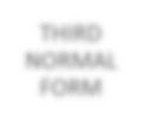

THIRD

NORMAL

FORM



BOYCE

-

CODD

NORMAL

FORM

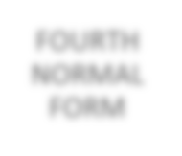

FOURTH

NORMAL

FORM

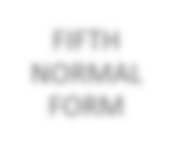

FIFTH

NORMAL

FORM

FUNCTIONAL DEPENDENCY :

Functional dependency (FD) is a set of constraints between two attributes in a relation. Functional dependency says that if two tuples have same values for attributes A1, A2,..., An, then those two tuples must have to have same values for attributes B1, B2, ..., Bn.

Functional dependency is represented by an arrow sign (→) that is, A→B, where A functionally determines B. The left-hand side attributes determine the values of attributes on the right-hand side.

The left-hand side of the FD is called the determinant, and the righthand side is the dependent. If A is the determinant and B is the dependent then we say that B is dependent on A and A functionally determines B.

A functional dependency A->B in a relation holds if two tuples having same value of attribute A also have same value for attribute B.

EG.1) In country_id table country_name is functionally dependent on c_id (i.e country id)

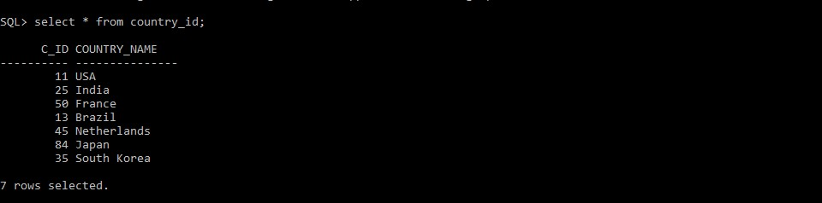

EG.2)In vaccine_creation_info table all the attributes are functionally dependent on primary key i.e vac_id

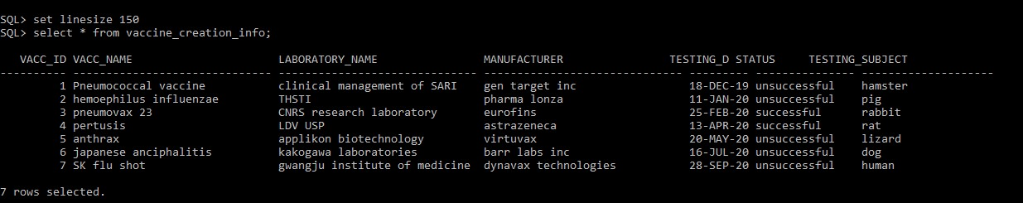

EG.3) In sid_india table state_name is functionally dependent on primary key i.e s_id (state id)

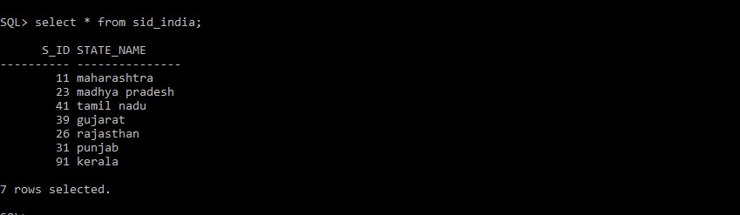

PARTIAL DEPENDENCY :

Partial Dependency occurs when a non-prime attribute is functionally dependent on part of a candidate key. i.e B is functionally dependent on A, and A is the part of multipart candidate key.

Eg. If there is a table with following attributes :

|  |  |  |  |
| --- | --- | --- | --- |
| C_id | country_name | Vac_id | Vacc_name |

In this case, country_name depends on c_id and vacc_name depends on vac_id. That means there exist a partial dependency in this table.

To remove this partial dependency we split the table as :

|  |  |  |
| --- | --- | --- |
| c_id | Country_name | Vac_id |

|  |  |
| --- | --- |
| vacc_id | vacc_name |

TRANSITIVE DEPENDENCY :

Consider attributes A, B, C.

If A functionally determines B (A->B) and B functionally Determines C (B->C) then there exist a transitive dependency i.e C is transitively dependent on A through B (A->C).

**FIRST NORMAL FORM (1NF) :**

According to first normal form, all the attributes in a relation must have atomic domains.

A domain is the set of all unique values which is permitted for an attribute. Atomic means that cannot be divided further.

RULES FOR FIRST NF:

* A relation will be in 1NF if it contain atomic values.
* an attribute of a table cannot hold multiple values. It must hold only single-valued attribute.
* First normal form disallows the multi-valued attribute, composite attribute, and their combinations.

EG.1) In countries table all the attributes are singlevalued and have atomic values

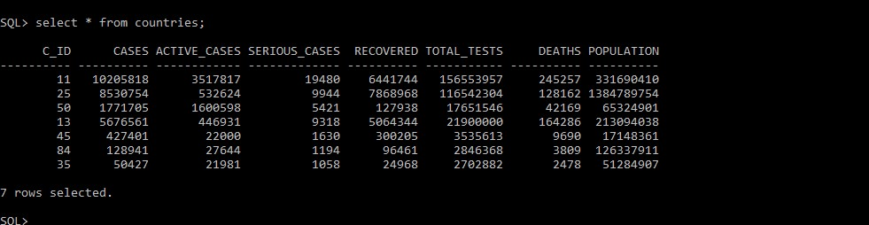

EG.2)In sid_brazil table all the attributes are singlevalued and have atomic values

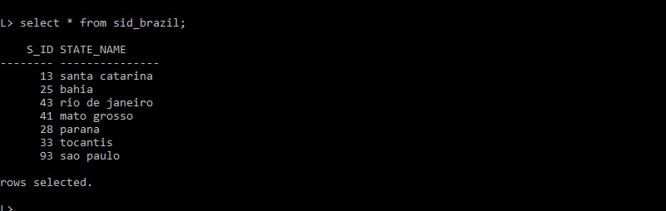

EG.3)In vaccine_creation_info table all the attributes are single-valued and have atomic values



Similarly, all the tables in our database are single-valued and have atomic values.

**SECOND NORMAL FORM (2NF) :**

For a relation to be in second normal form, a relation must be in first normal form and relation must not contain any partial dependency, i.e all the non-prime attributes must be dependent on prime attributes (primary key).

* **Prime attribute** − An attribute, which is a part of the prime-key, is known as a prime attribute.
* **Non-prime attribute** − An attribute, which is not a part of the prime-key, is said to be a non-prime attribute.

RULES FOR SECOND NF:

* In the 2NF, relational must be in 1NF.
* In the second normal form, all non-key attributes are fully functional dependent on the primary key ➢ Partial dependency should not exist.

EG.1) According to second NF, all the non-prime attributes must be dependent on prime-key attributes.

In the following table non-prime attributes like cases, active_cases, serious_cases, recovered, total_tests, deaths , population are dependent prime-key attribute i.e s_id.

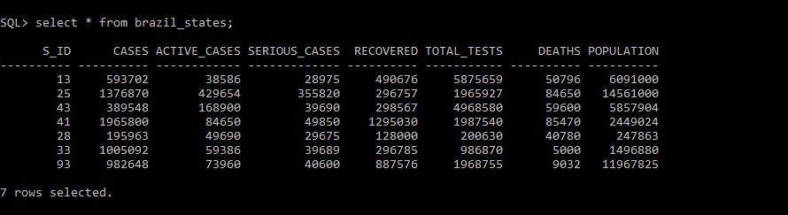

✓ But in case of weak entity non-prime attributes are dependent on foreign key

EG.2) All the non-prime attributes like vacc_name,laboratory_name, manufacturer, testing_date, status, testing_subject are dependent on primary key i.e vacc_id

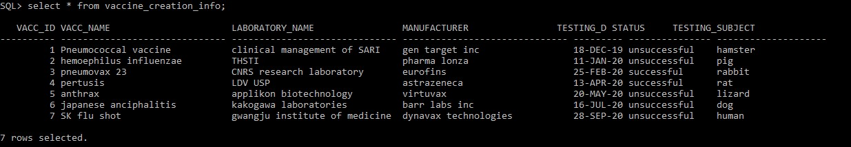

Similarly, all the tables in the database are in second NF without any partial dependency.

**THIRD NORMAL FORM (3NF) :**

A relation is in third normal form, if there is **no transitive dependency** for non-prime attributes as well as it is in second normal form. 3NF is used to reduce the data duplication. It is also used to achieve the data integrity.

RULES FOR THIRD NF:

* A relation will be in 3NF if it is in 2NF.
* It should not contain any transitive dependency.

EG.1) The following table is in second NF as well as there is no transitive dependency. i.e the table is in 3NF.

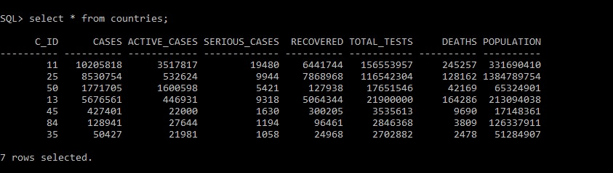

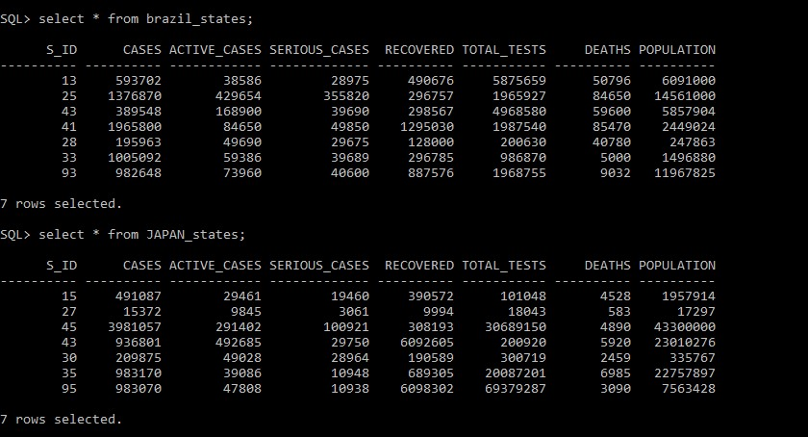

MANY-TO-MANY RELATIONSHIP :

This is a very common situation , it occurs when the table has only foreign-keys. If we add further columns in future there will be no problem due to the existing columns all being foreign keys.

EG.) The following table consist of only foreign-keys. Therefore, there exist a many-to-many relationship.

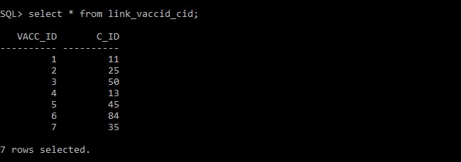



What is an Entity Relationship Diagram (ERD)?

**ER Diagram** stands for Entity Relationship Diagram, also known as ERD is a diagram that displays the relationship of entity sets stored in a database. In other words, ER diagrams help to explain the logical structure of databases.

**ER diagrams are created based on three basic concepts: entities, attributes and relationships.**

ER diagrams are used to sketch out the design of a database.

Why use ER Diagrams?

* Helps you to define terms related to entity relationship modeling
* Provide a preview of how all your tables should connect, what fields are going to be on each table
* Helps to describe entities, attributes, relationships
* ER diagrams are translatable into relational tables which allows you to build databases quickly
* ER diagrams can be used by database designers as a blueprint for implementing data in specific software applications
* The database designer gains a better understanding of the information to be contained in the database with the help of ERP diagram
* ERD Diagram allows you to communicate with the logical structure of the database to users.

Following are the main components and its symbols in ER Diagrams:

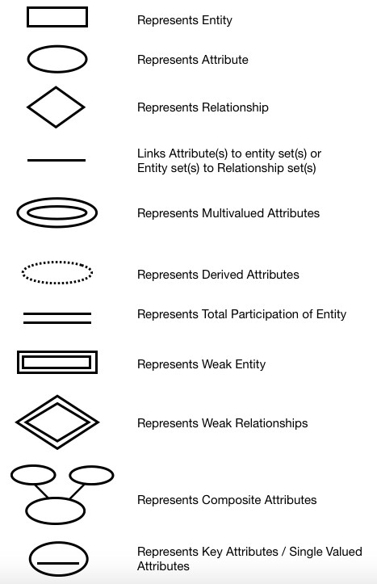

Types of DBMS Entities

The following are the types of entities in DBMS −

# Strong Entity

The strong entity has a primary key. Weak entities are dependent on strong entity. Its existence is not dependent on any other entity.Strong Entity is represented by a single rectangle.

# Weak Entity

The weak entity in DBMS do not have a primary key and are dependent on the parent entity. It mainly depends on other entities. Weak Entity is represented by double rectangle.

Mapping Constraints

A mapping constraint is a data constraint that expresses the number of entities to which another entity can be related via a relationship set.

It is most useful in describing the relationship sets that involve more than two entity sets.

For binary relationship, there are four possible mapping cardinalities. These are as follows:

1. One to one (1:1)
2. One to many (1:M)
3. Many to one (M:1)
4. Many to many (M:M)



ERD of World table :

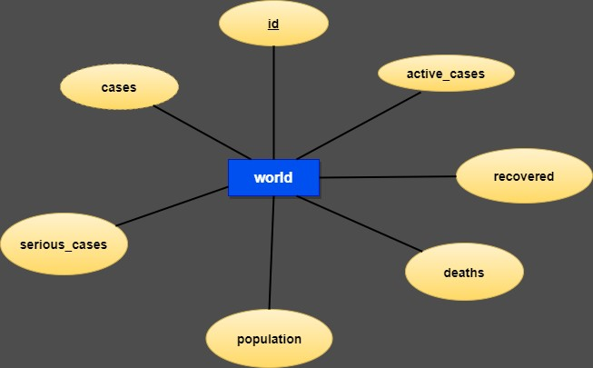

This is a strong entity table because it has a primary key which is the id attribute. There are 7 attributes in this world table(entity). This erd has no relationship in it. It has only one row in it , which shows the record of the whole world in a single row.

ERD of country_id, countries & vaccine_creation_info tables :

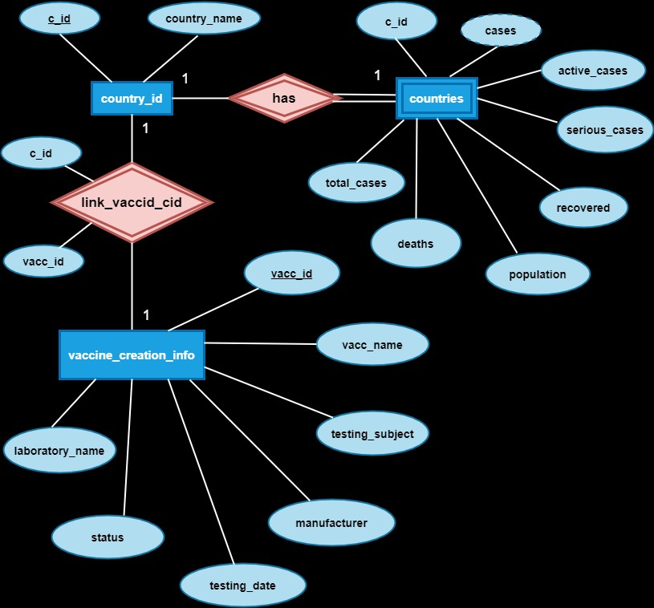

**There are 3 entities in this erd .**

1. **country_id :**

This is a strong entity with 2 attributes , c_id is the primary key over here.

1. **countries :**

This is a weak entity with 8 attributes, c_id is the foreign key here and cases is the derived attribute which is calculated using remaining attributes except population and c_id.

1. **vaccine_creation_info :**

This is a strong entity with 7 attributes , vacc_id is the primary key over here.

**This erd has 2 relatiosnhips :**

1. A relationship (has) is a relationship between the country_id entity and countries entity with a common attribute as c_id .

Here one entity is a strong entity which is country_id , because it has its own primary key but the another entity which is countries is a weak entity because it does not has any primary key but it has a foreign to link with the strong entity i.e country_id. So the here the relationship ( has ) is a identifying relationship.

It is a one to one relationship because one record of country_id table is associated with only 1 record of countries table and vice versa

1. A relationship (link_vaccid_cid) is a relationship between the country_id entity and vaccine_creation_info entity .

This link_vaccid_cid relationship has two attributes , 1 each from both the entities.The attributes of these relationship are foreign key in this relationship and primary key of their respective tables. Because it does not have any primary key, the relationship becomes a weak relationship , but with a 2 strong entities.

It is a one to one relationship because one record of country_id table is associated with only 1 record of vaccine_creation_info table and vice versa.

But this can be a many to many relationship if we add more records in it , because

1 vaccine can be supplied to many countries and 1 country can even take more than 1 vaccine.

ERD of particular countries with their respective state records.

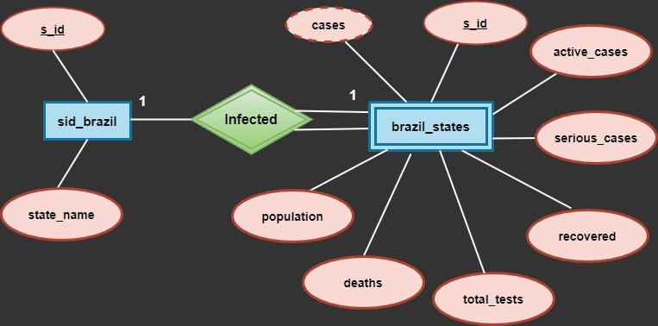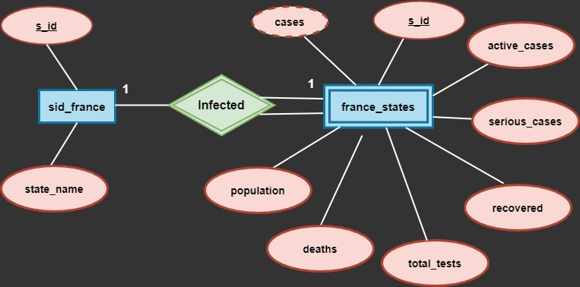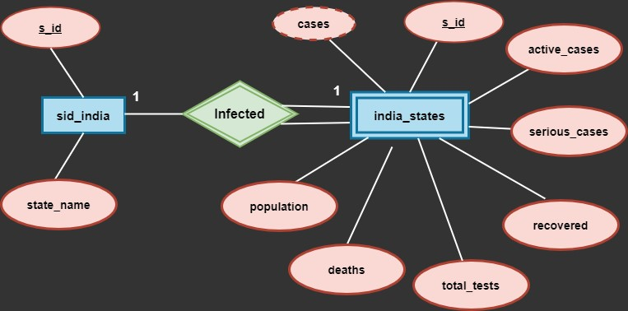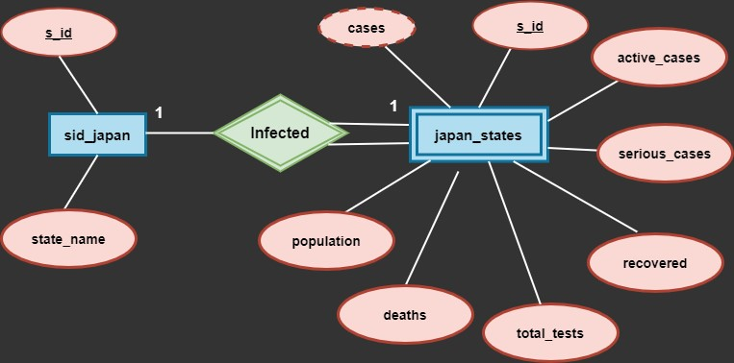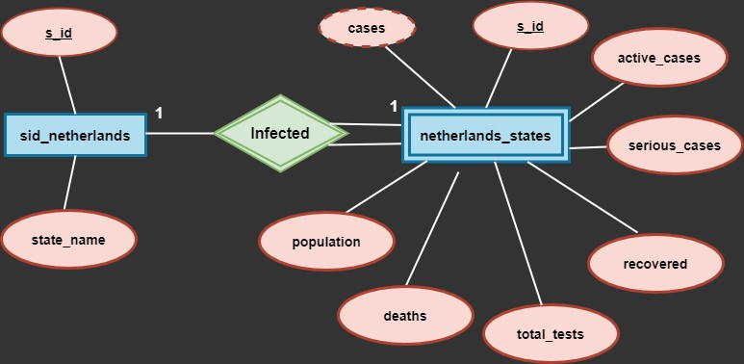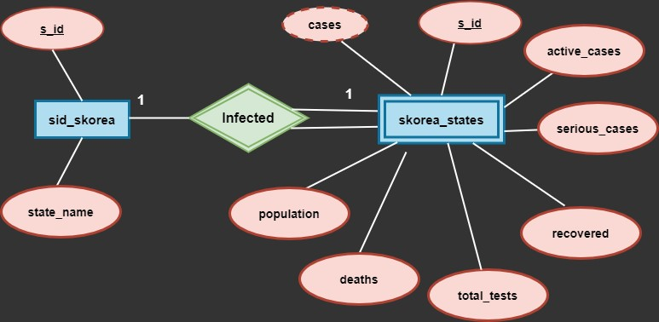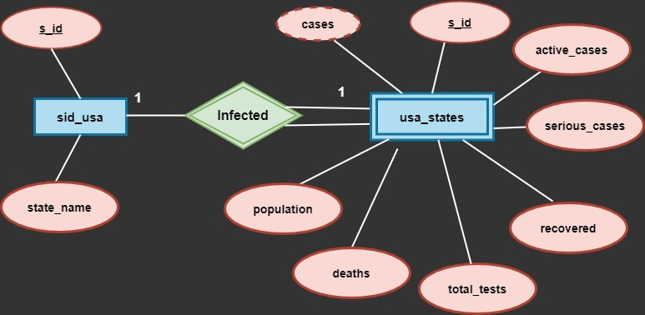

These ERD shows the records of a particular country along with their infected states.

All these ERD has 2 entites , one is strong entity which contains 2 attributes with 1 primary in them and the other entity is a weak entity , because it does not have any own primary but has a foreign key which is dependent on the strong entity The relationship (infected) between these entities is a identifying relationship.

It is a one to one relationship because, one record of a table is associated with only 1 record of another table and vice versa.

**CREATING A NEW USER**

* A new user named as dbms_mp is created in sql command window using the command ‘create user’ .
* This new user is identified by password as ‘dobby’. since security of database is essential.
* The whole database containing the information will be created inside this new user.
* We have granted all the privileges to this new user.

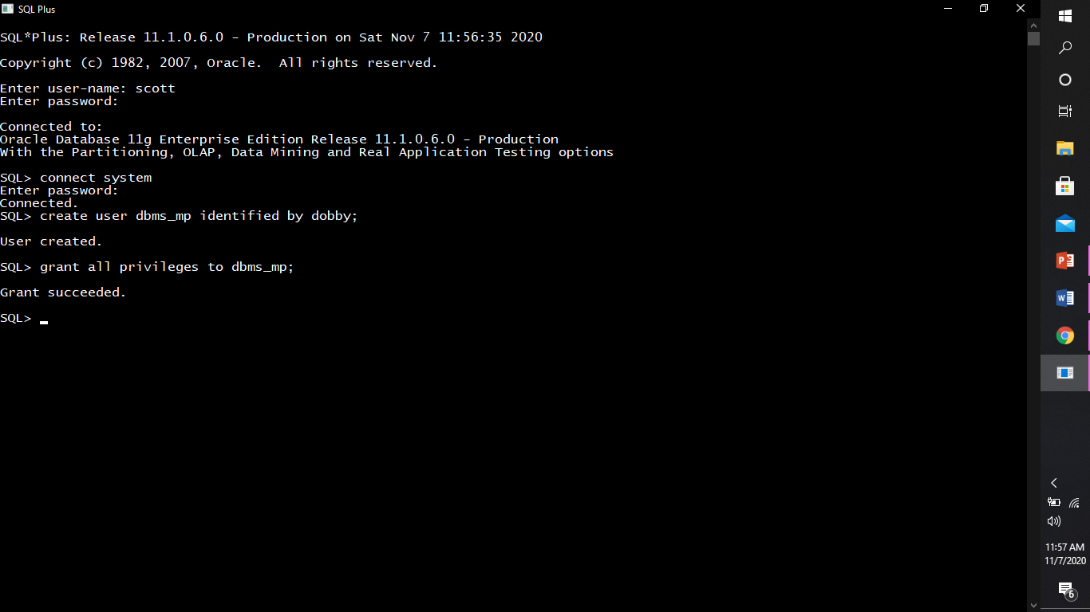

* This is how we can connect to the user ‘dbms_mp’.

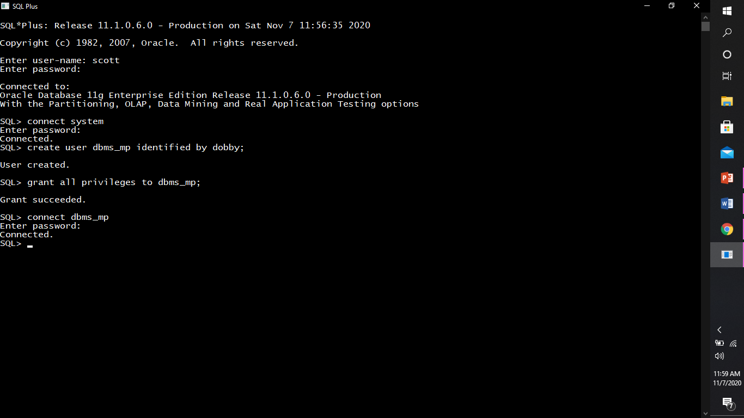

**We have the following tables in our database.**

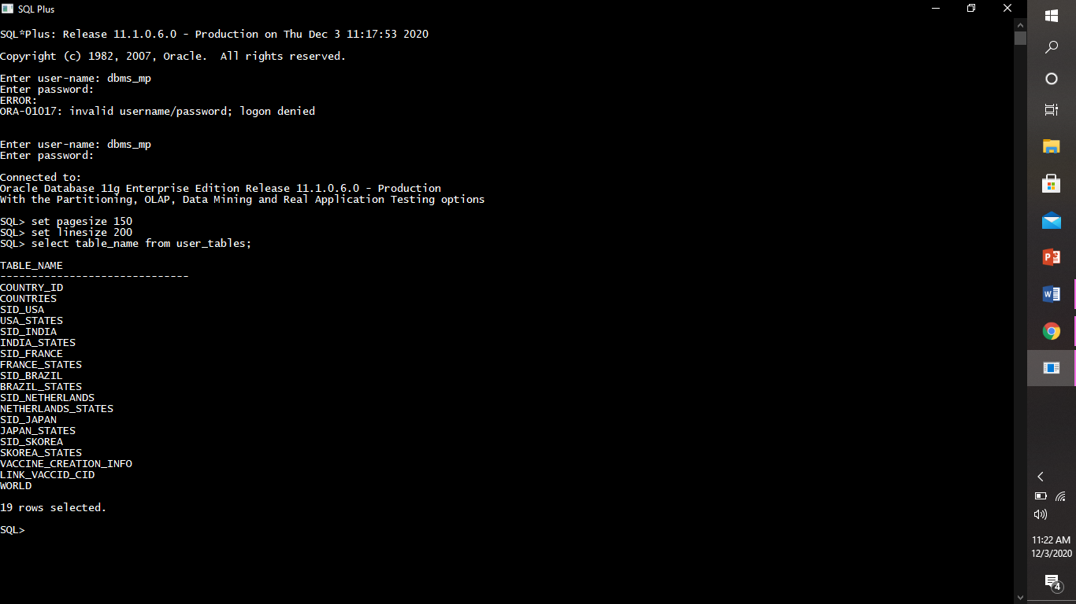

**DATABASE SCHEMA**

A database schema is the skeleton structure that represents the logical view of the entire database. It defines how the data is organized and how the relations among them are associated.

**Our database consists of the following:**

* Describing Structure Of World Table.

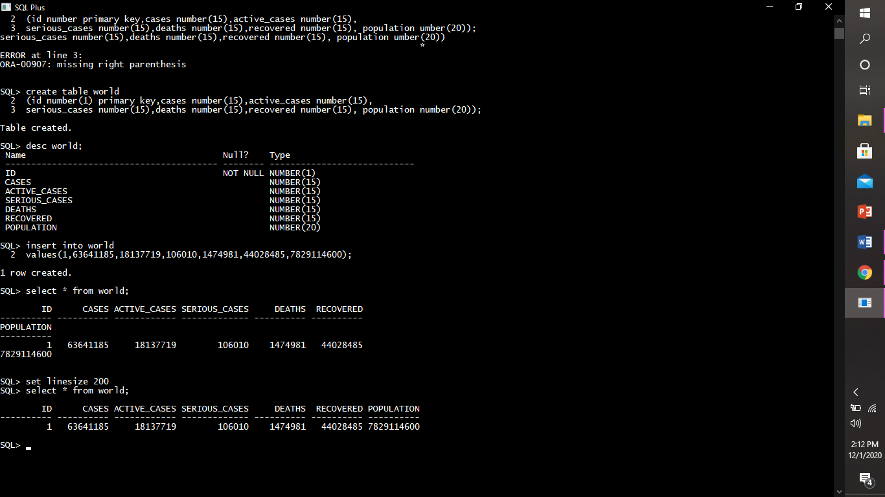



* Describing structure of country_id.

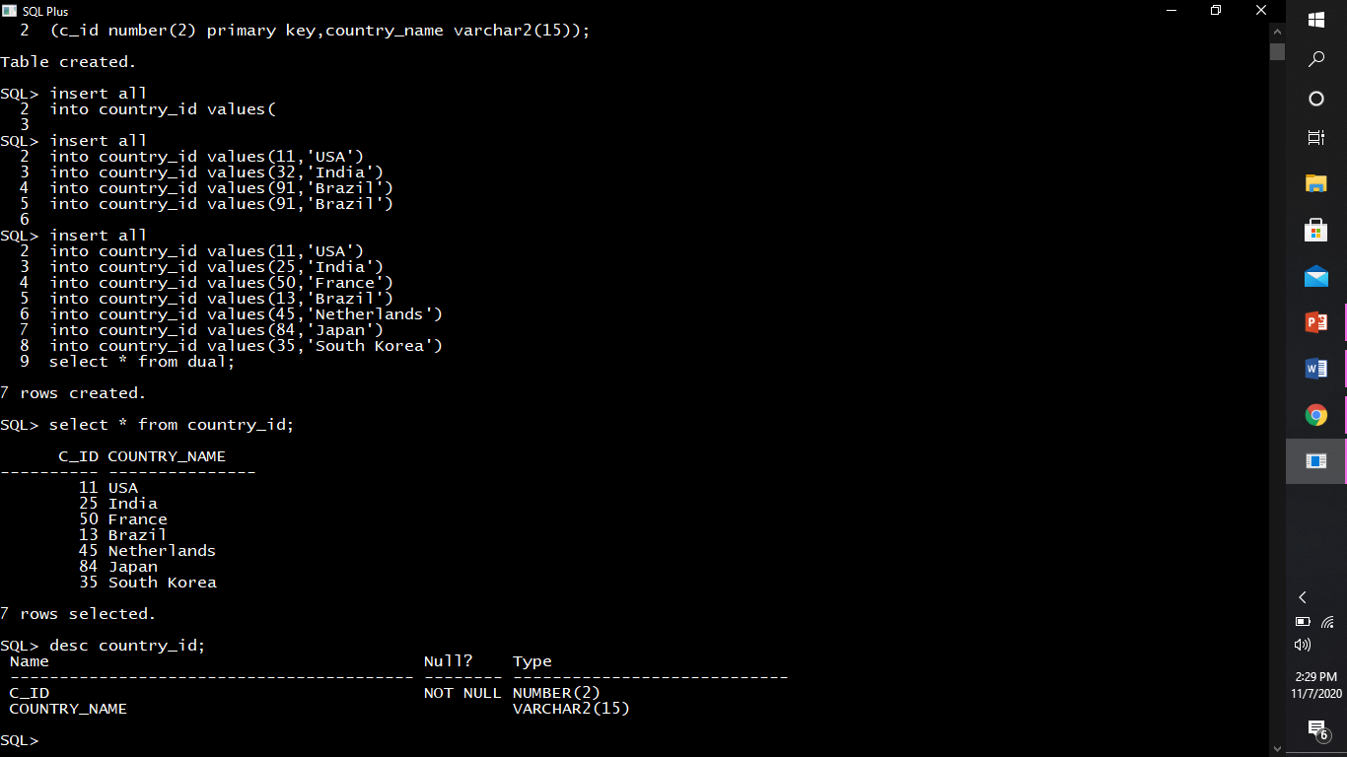

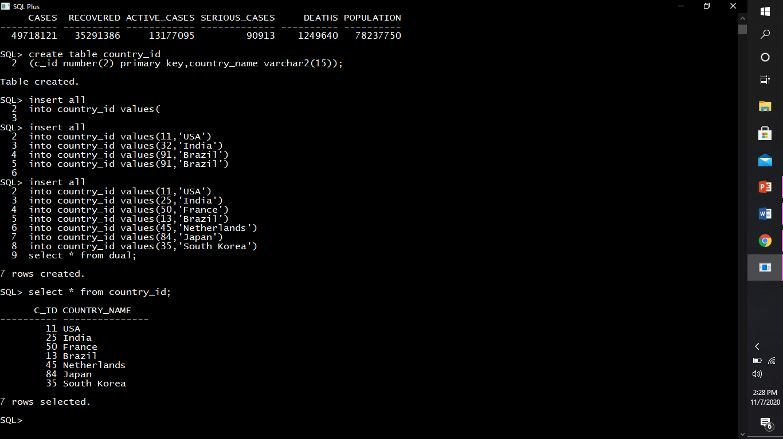

* Describing structure of countries.

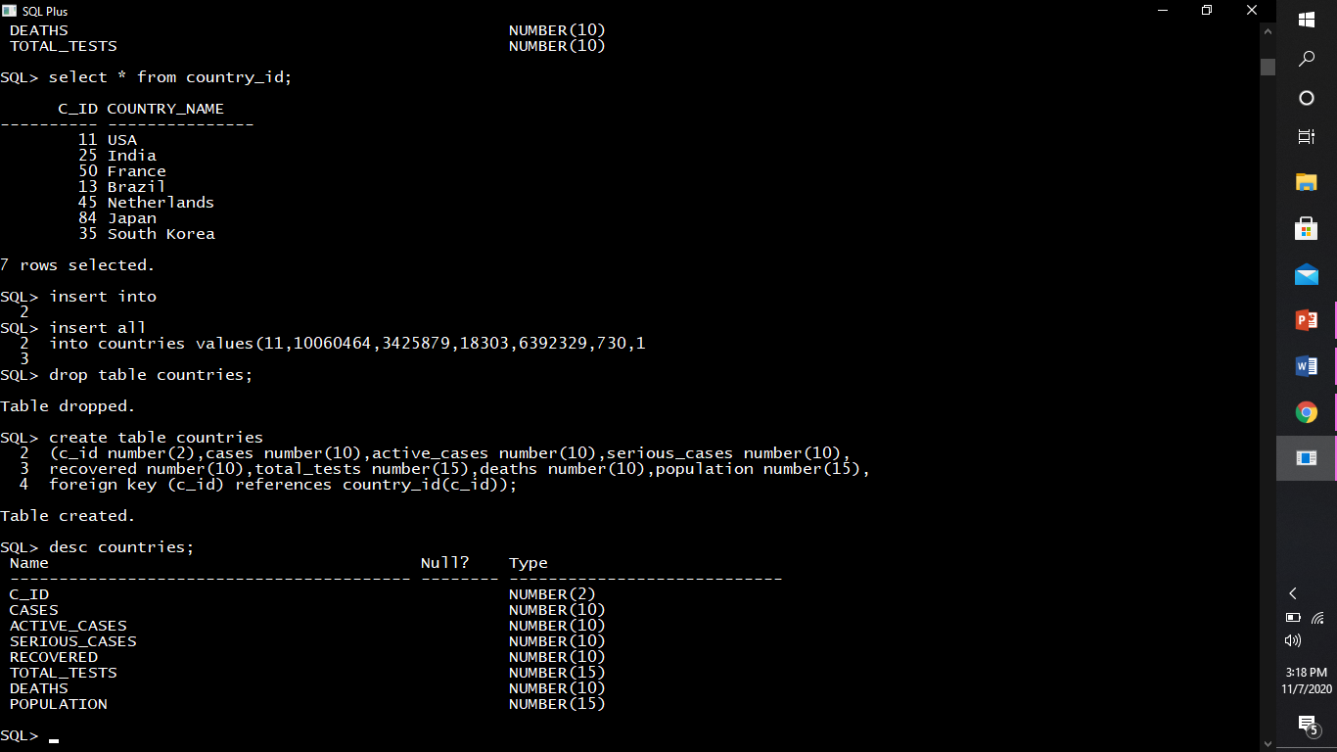

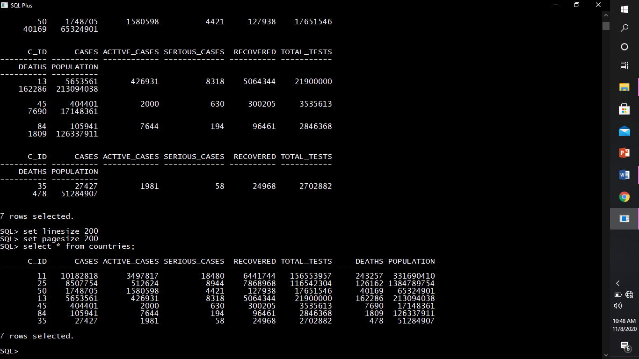

* Describing structure of vaccine_creation_info.

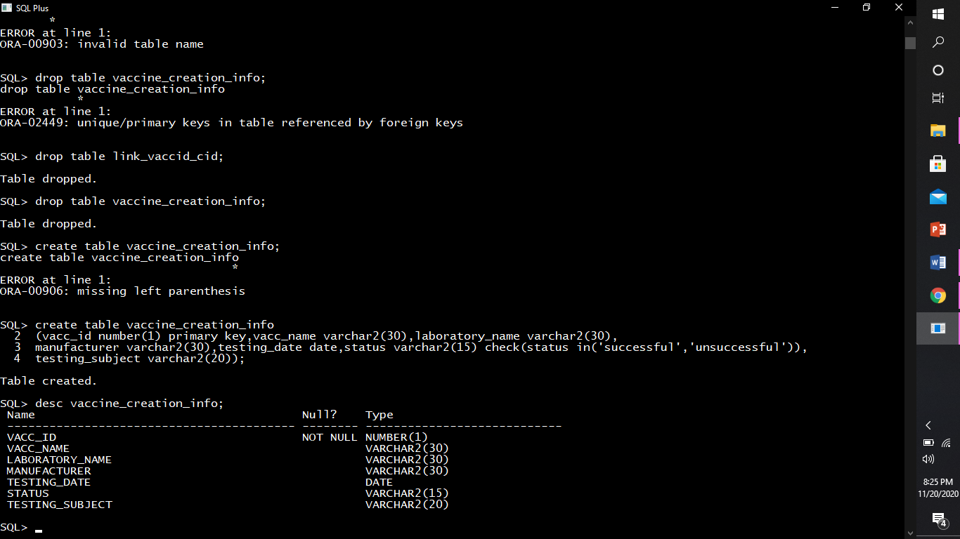

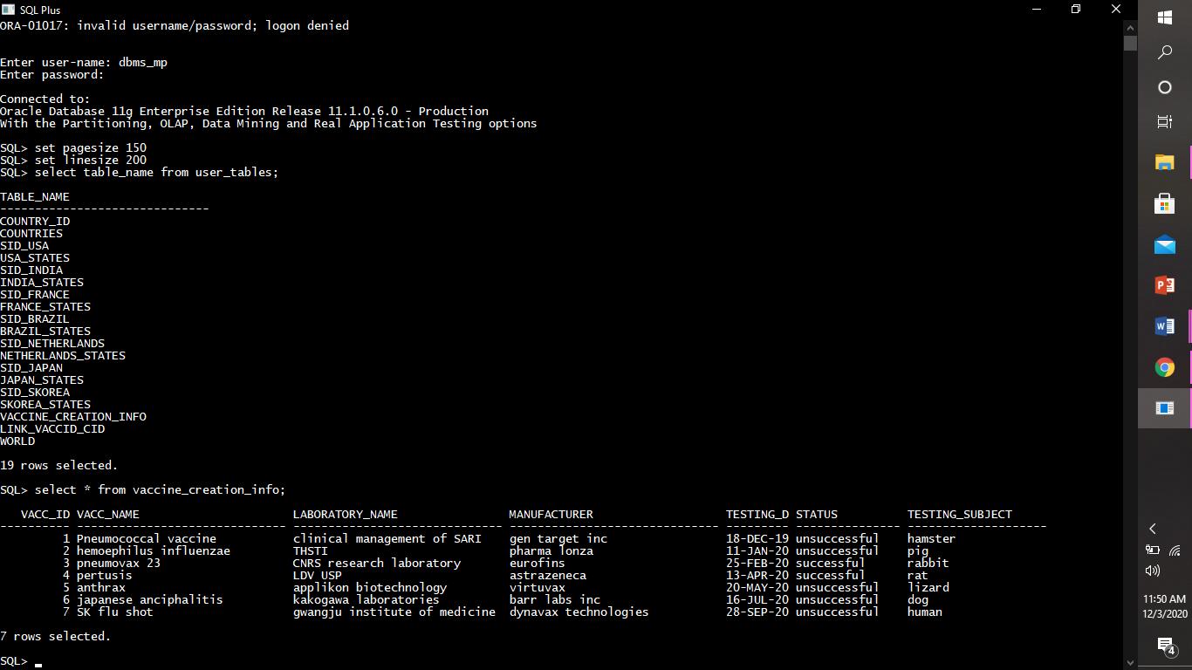

* Describing structure of link_vaccid_cid.

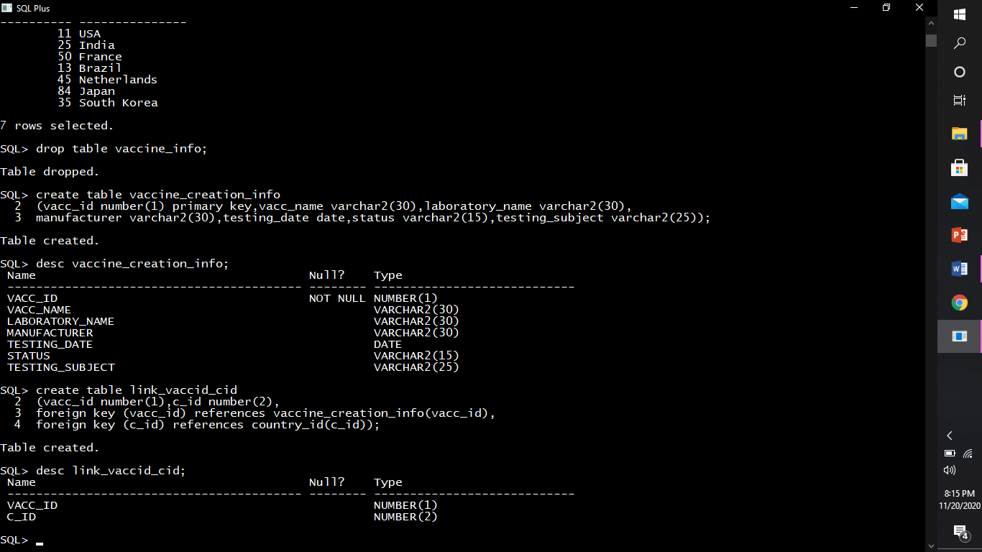

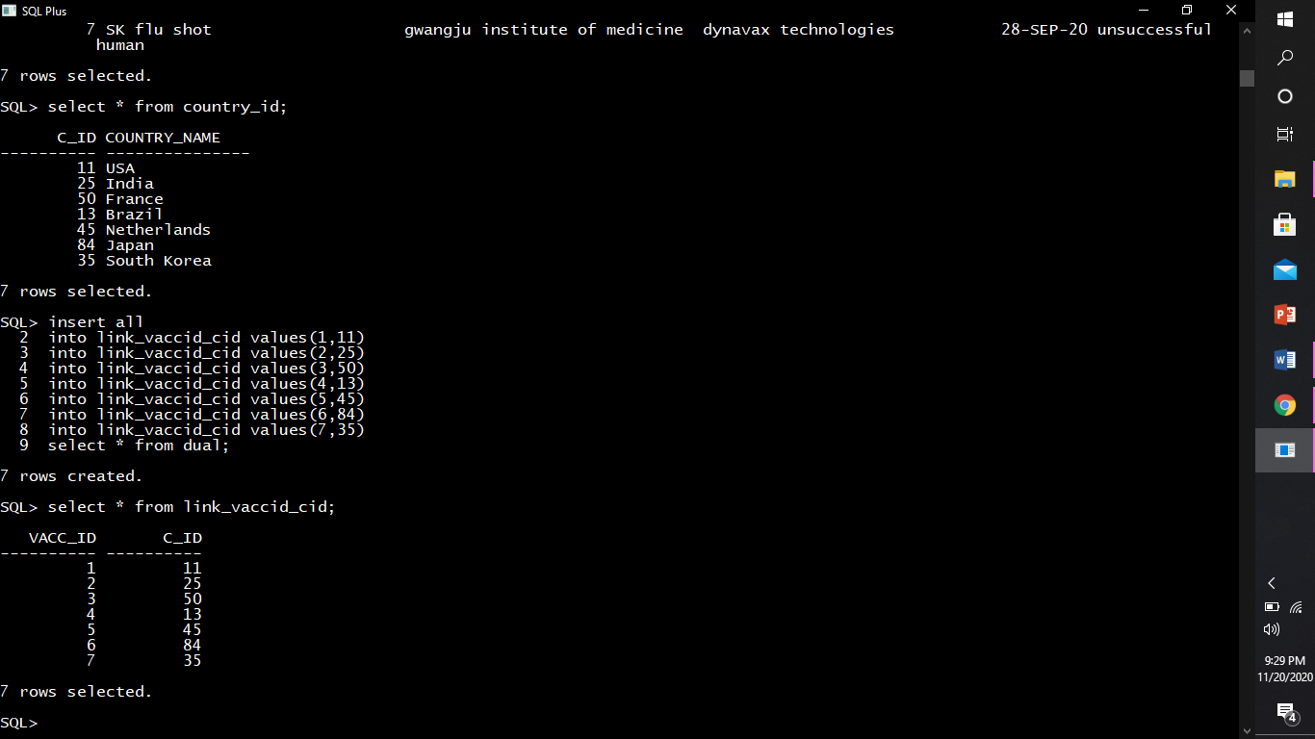

* Describing structure of sid_usa.

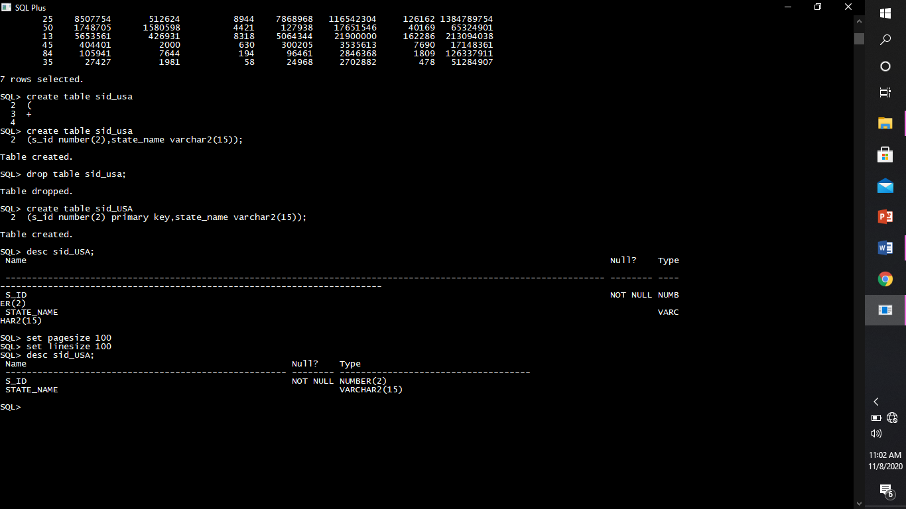

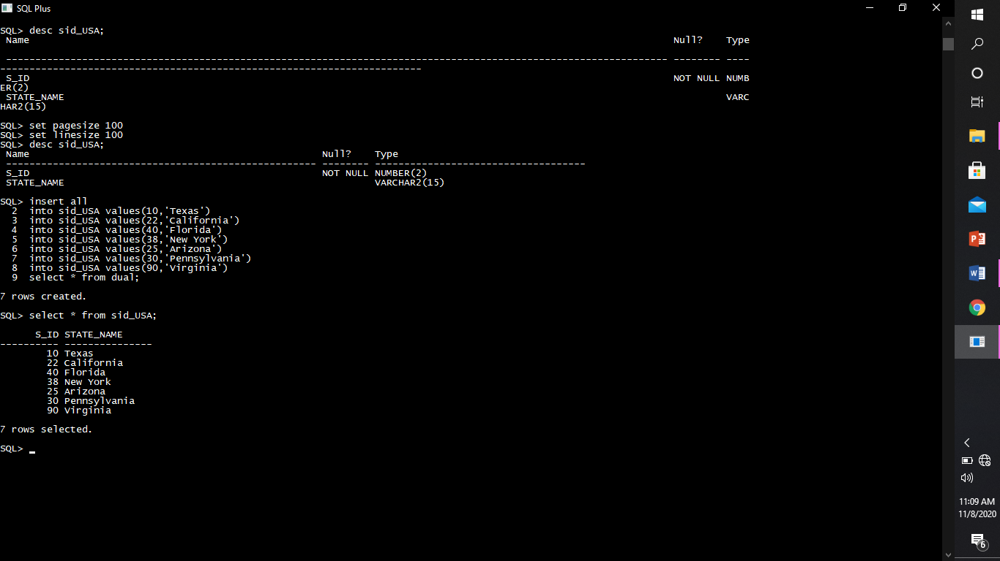

* Describing structure of usa_states.

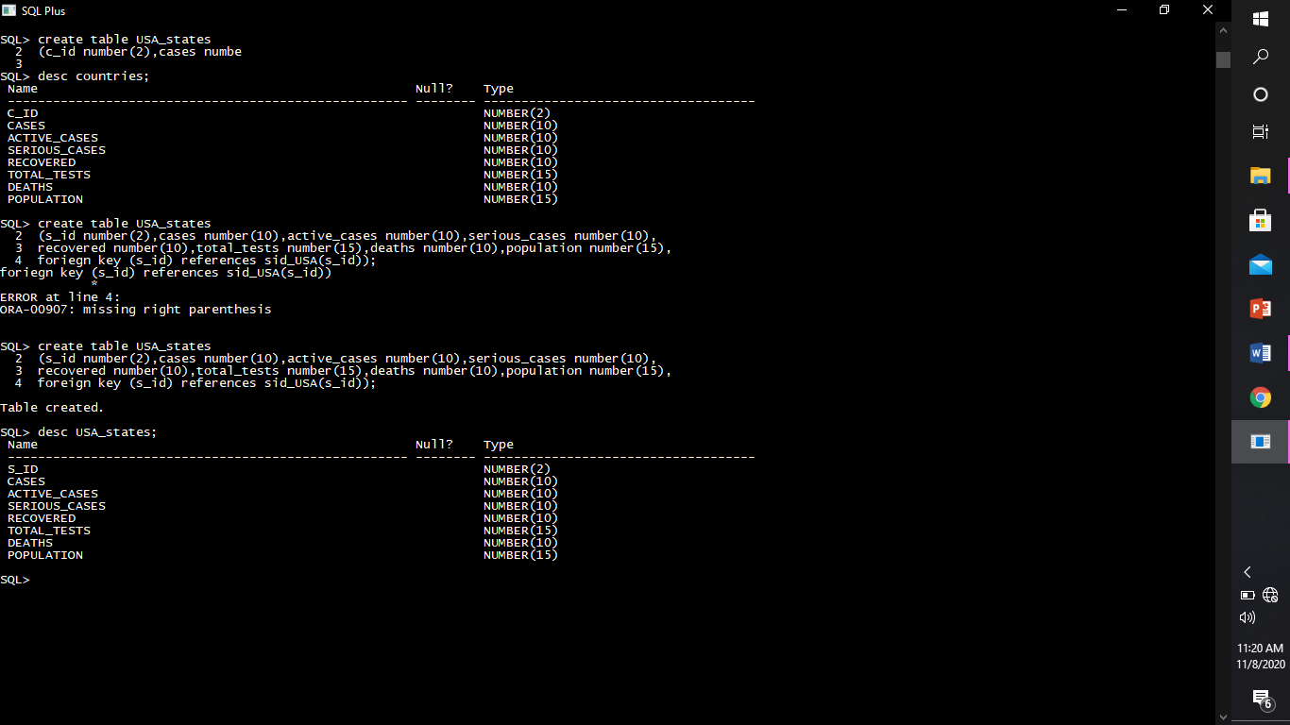

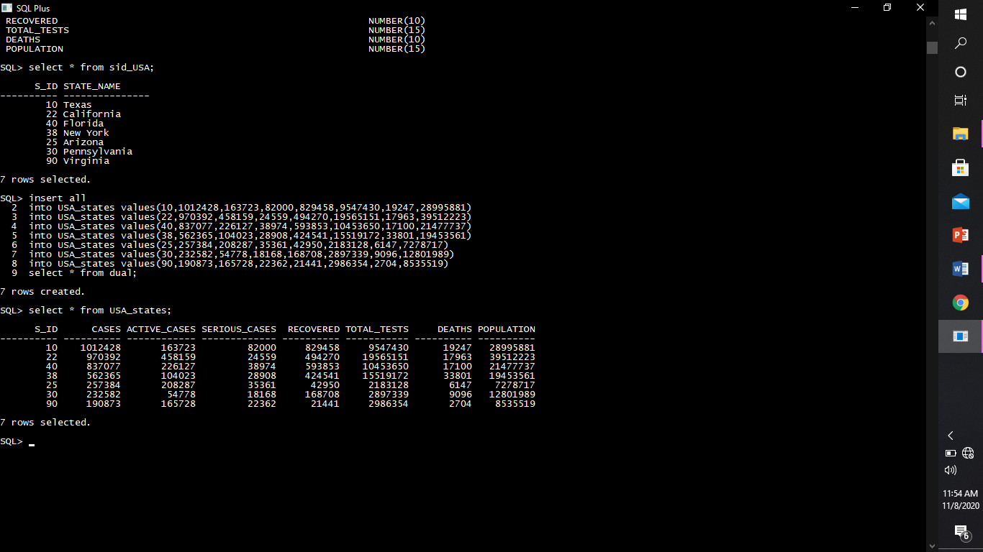

* Describing structure of sid_india.

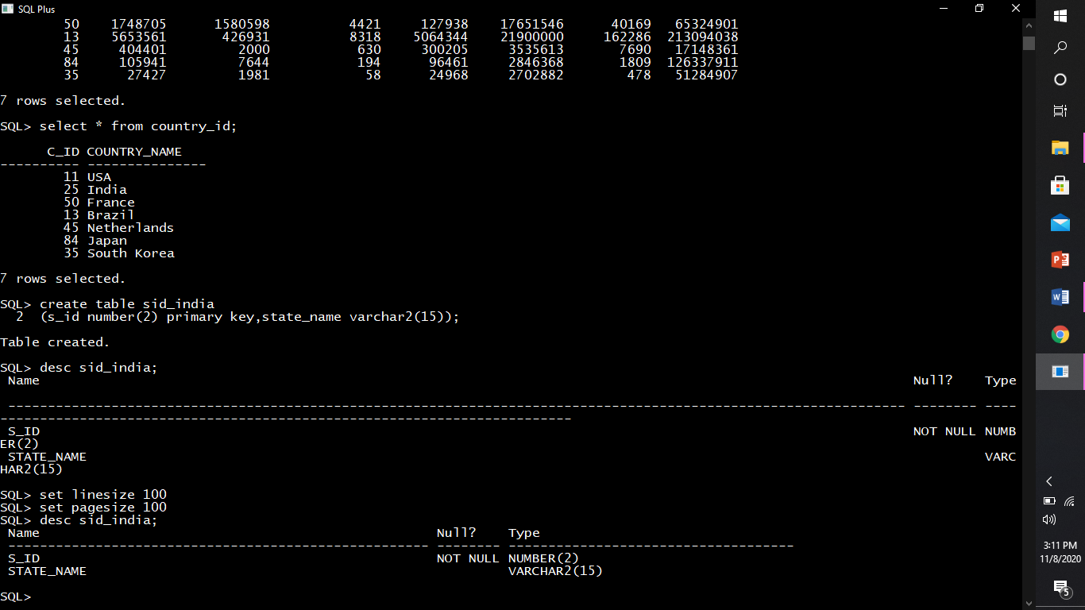

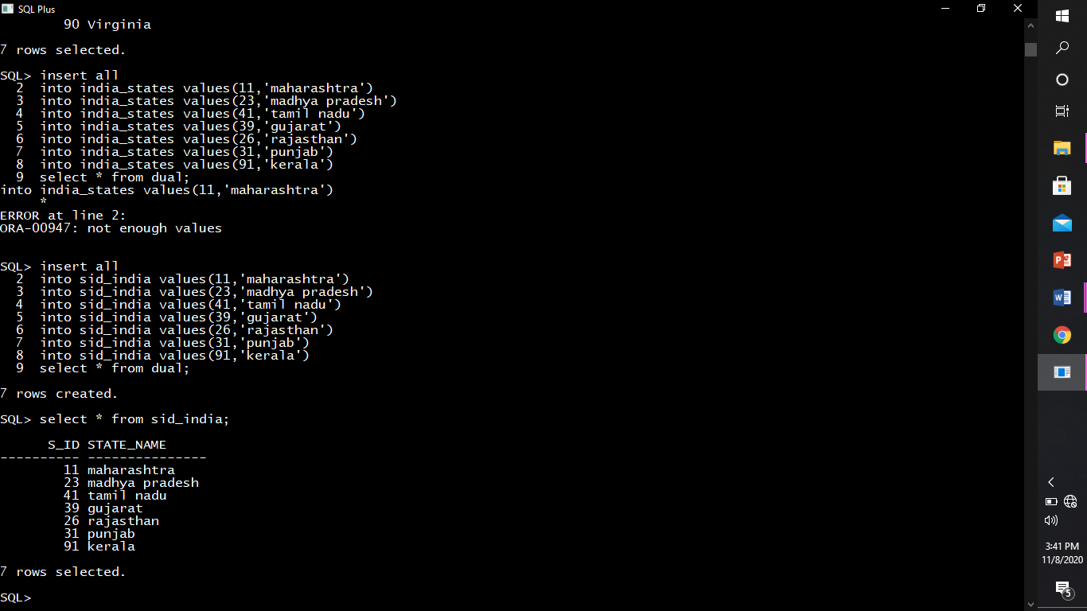

* Describing structure of india_states.

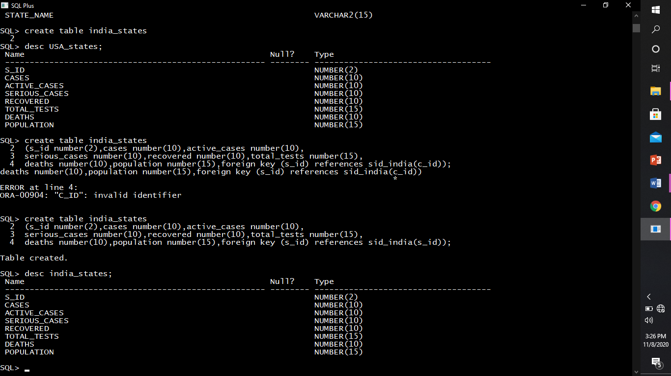

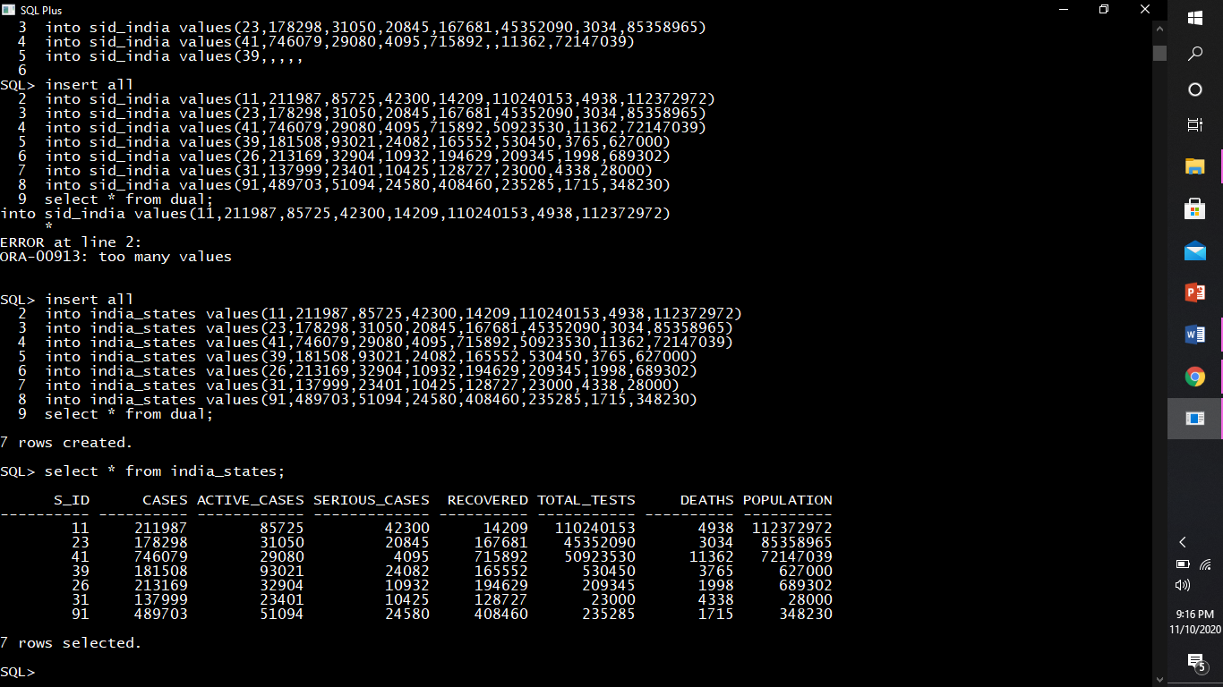

* Describing structure of skorea.

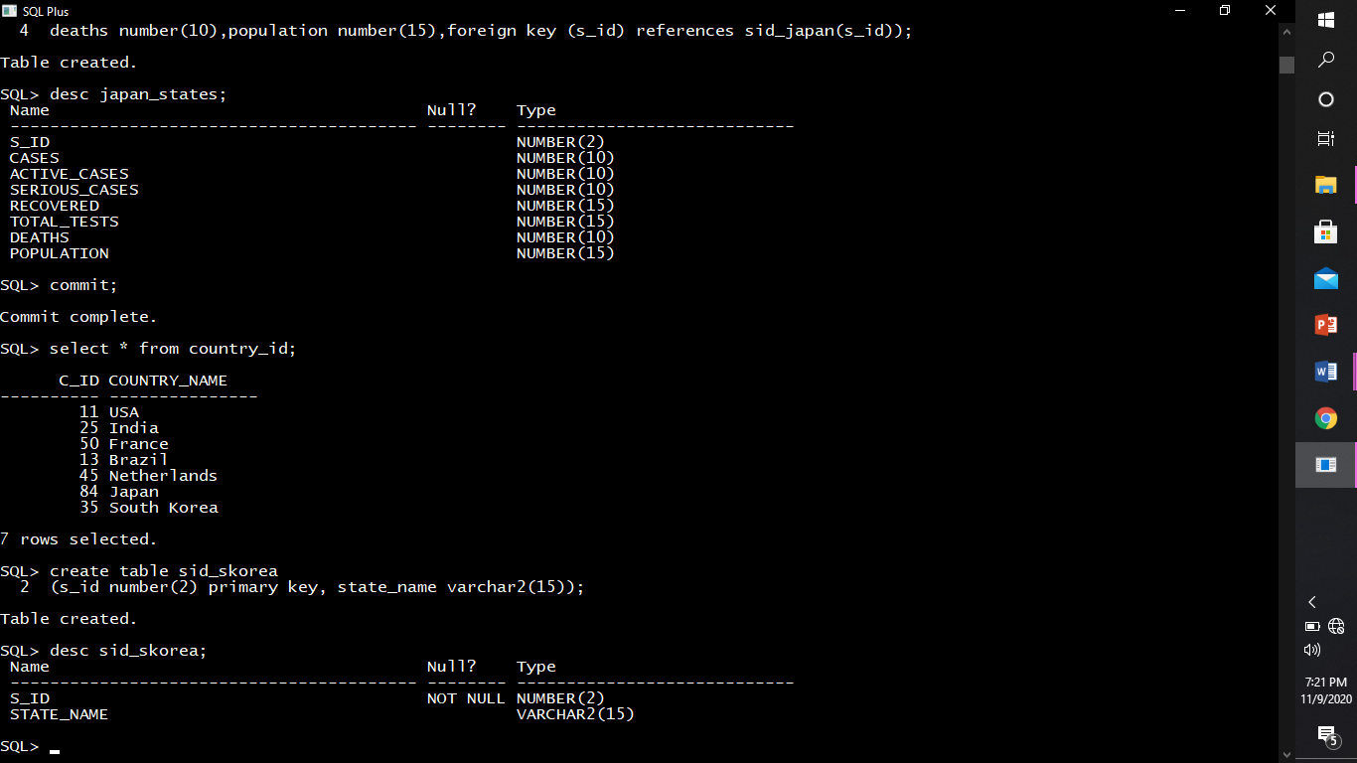

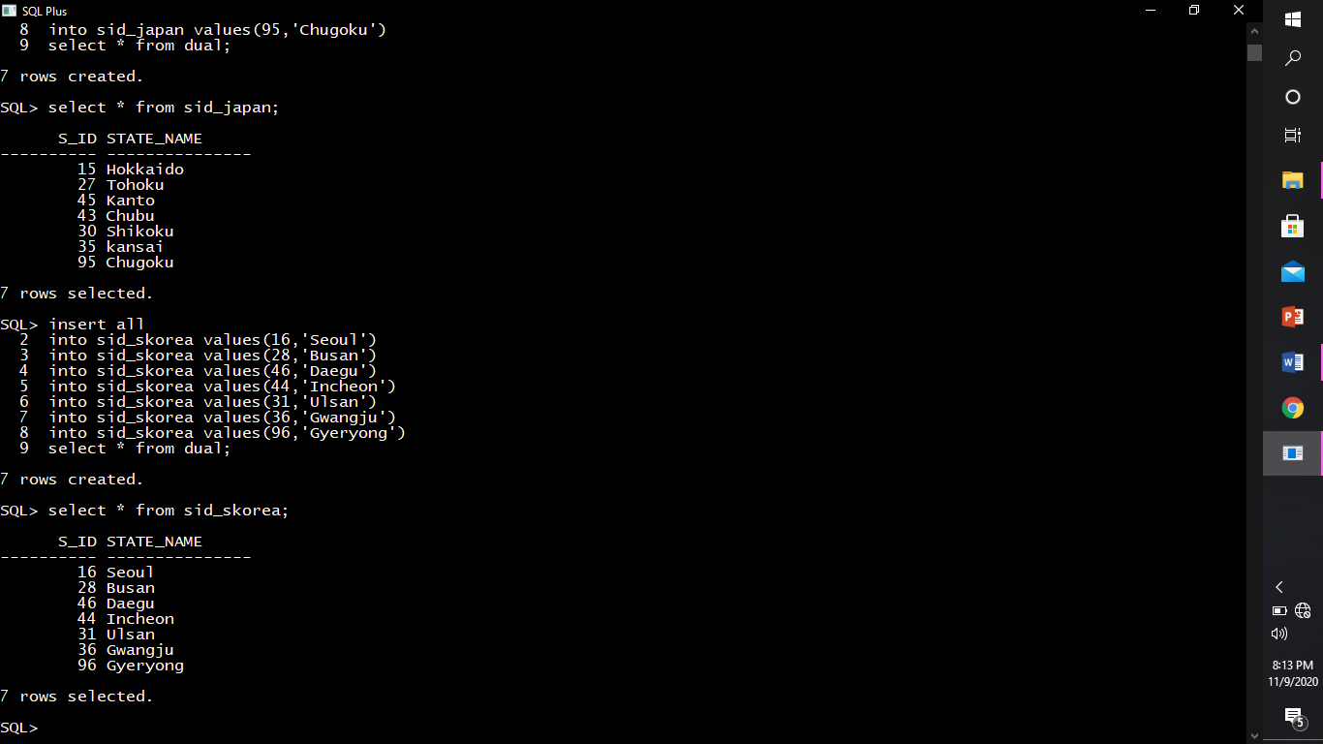

* Describing structure skorea_states

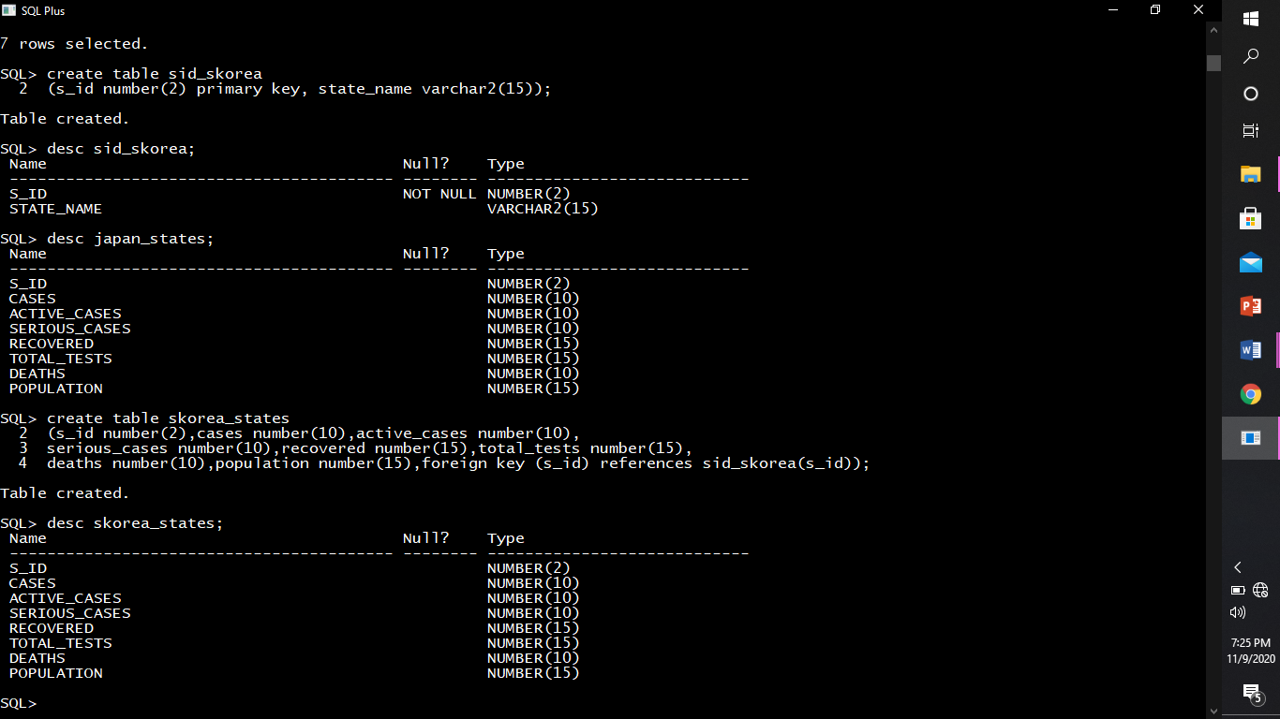

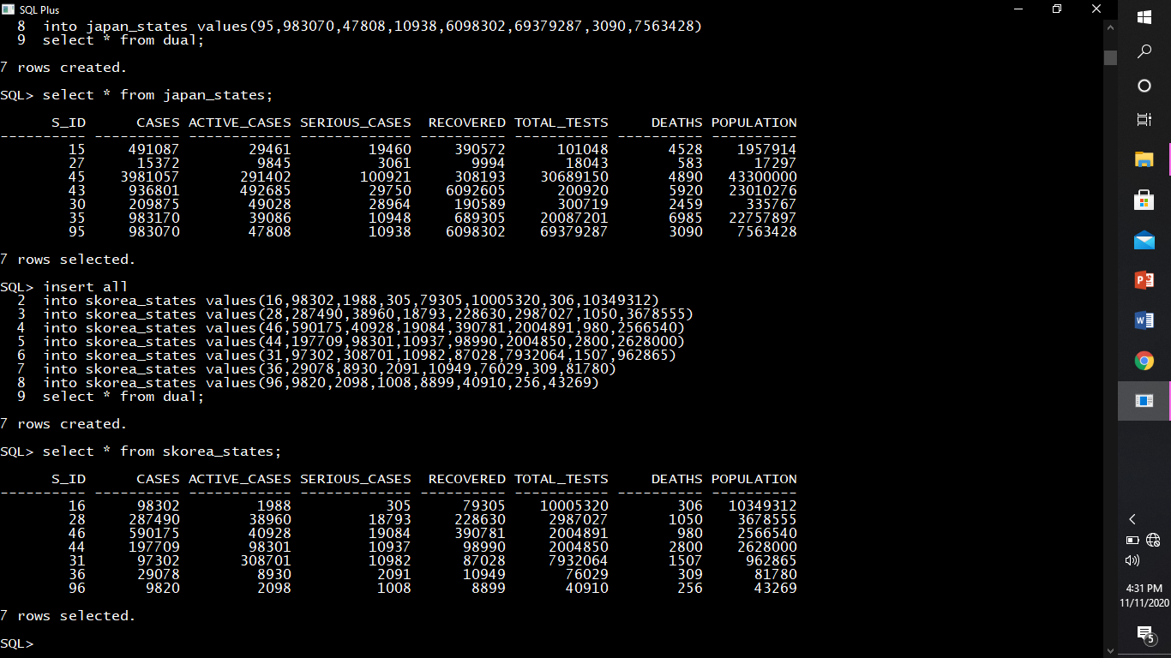

* Describing structure of sid_japan.

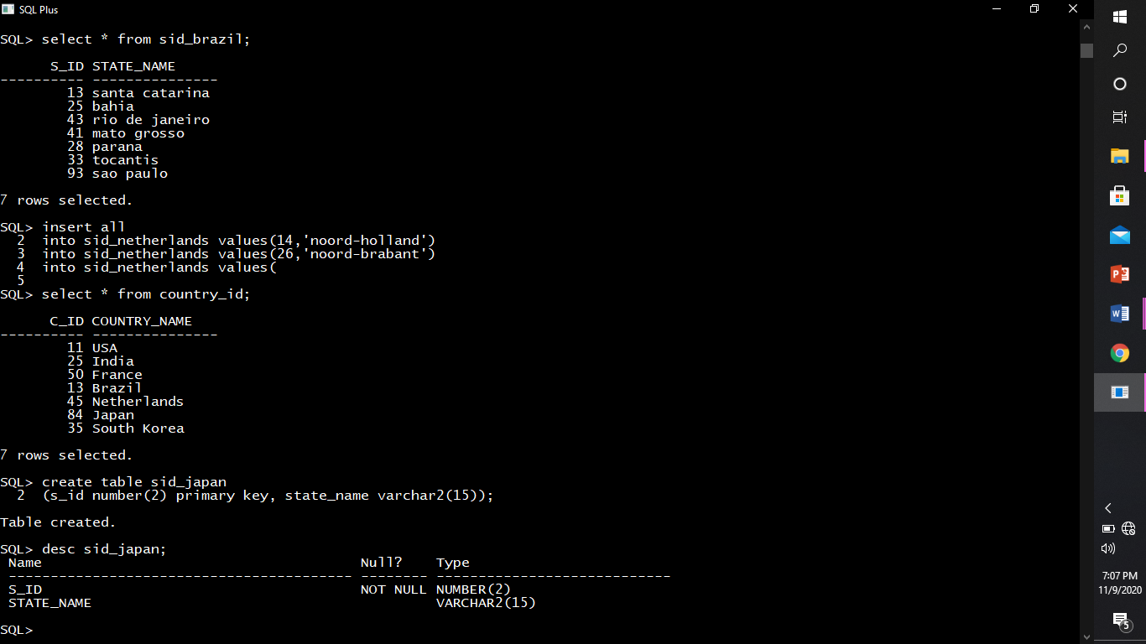

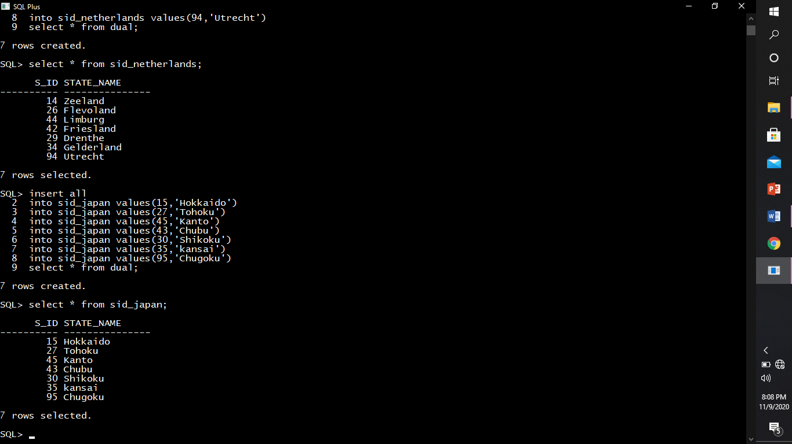

* Describing structure of japan_states.

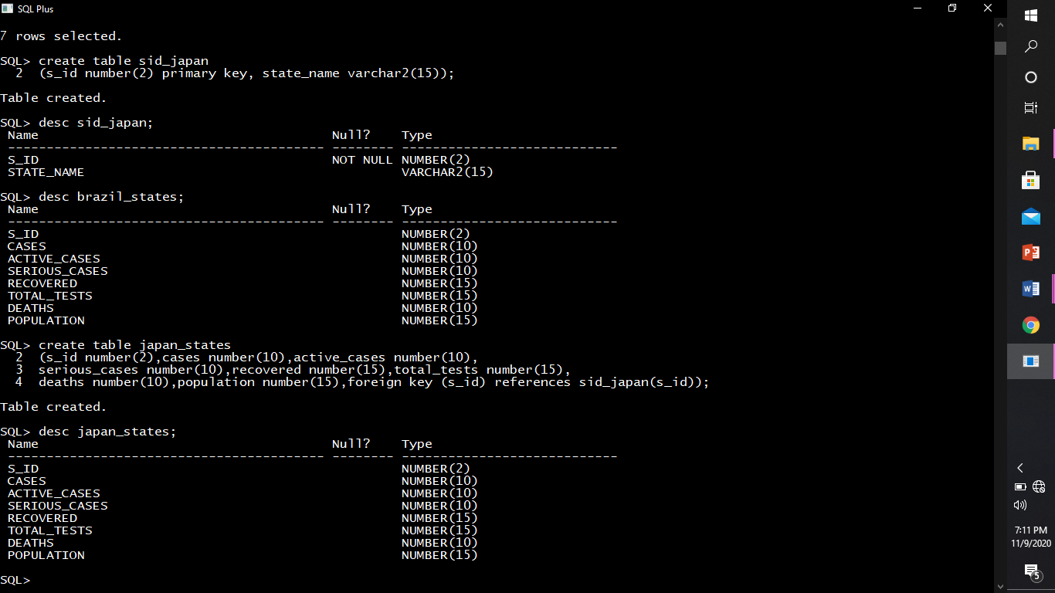

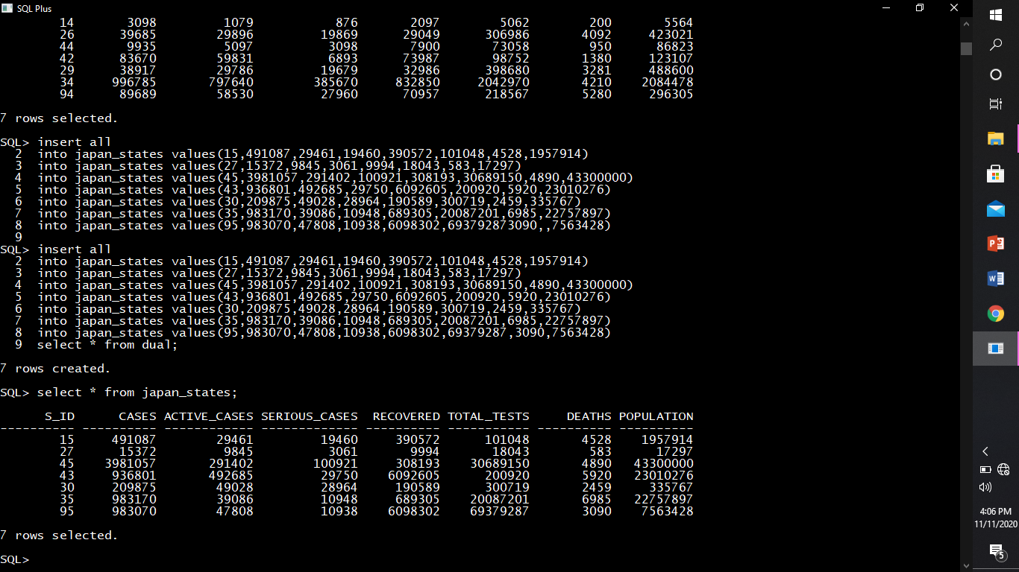

* Describing structure of sid_netherlands.

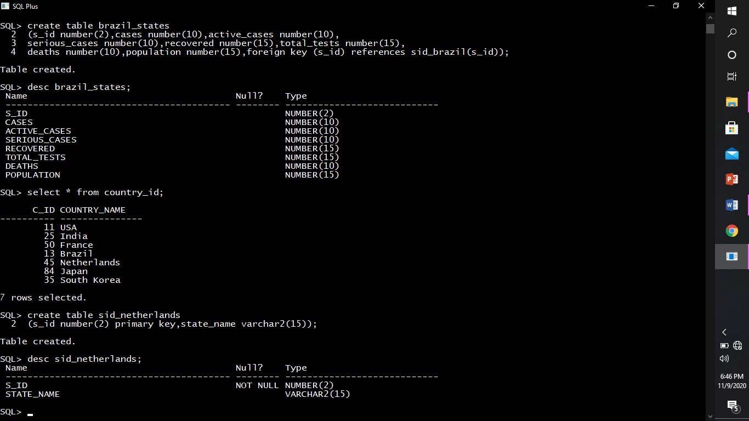

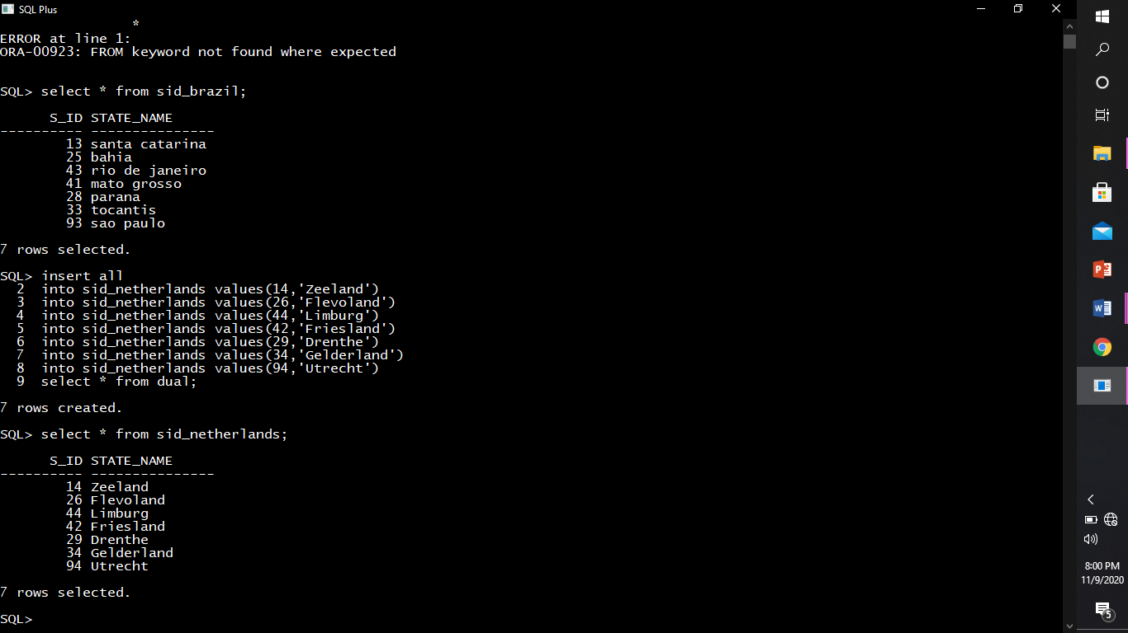

* Describing structure of Netherlands_states.

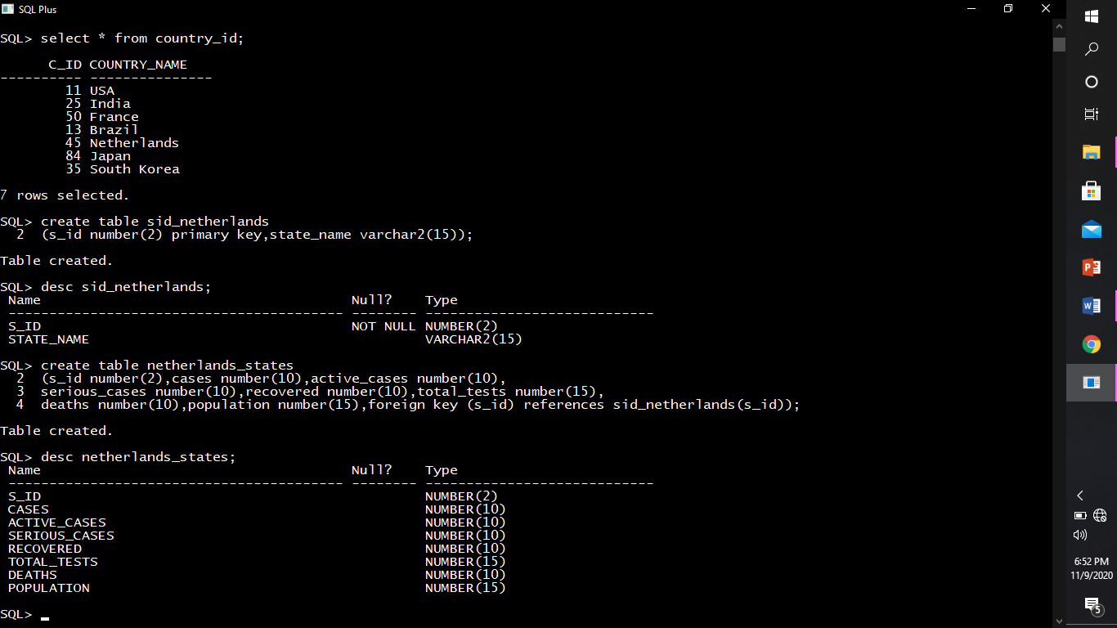

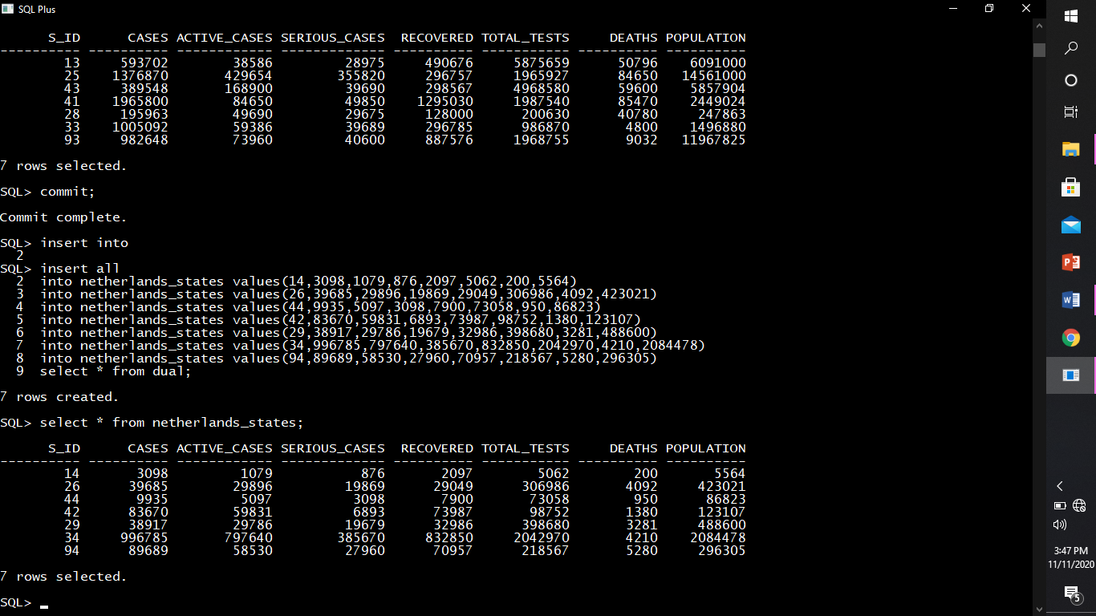

* Describing structure of sid_france.

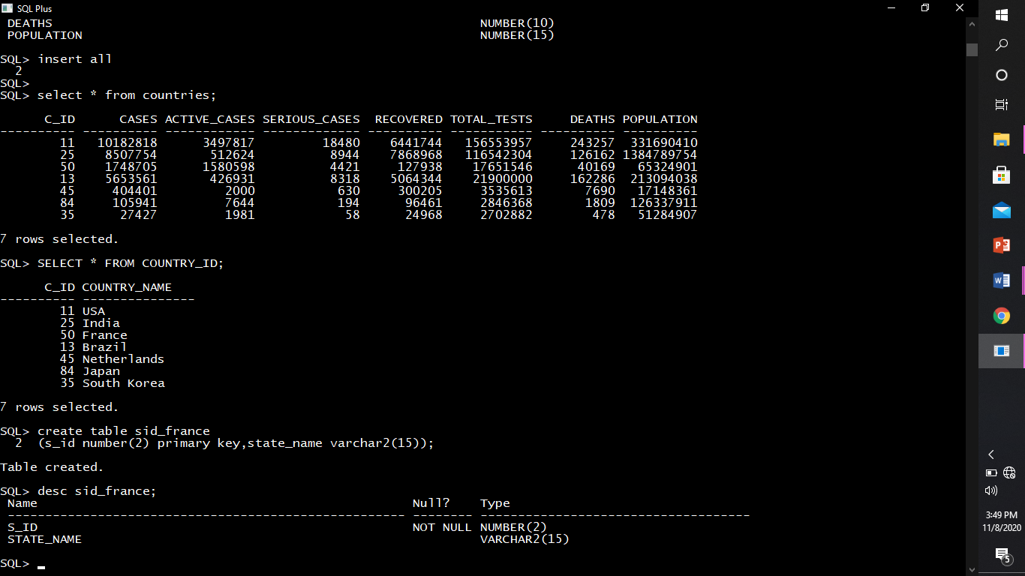

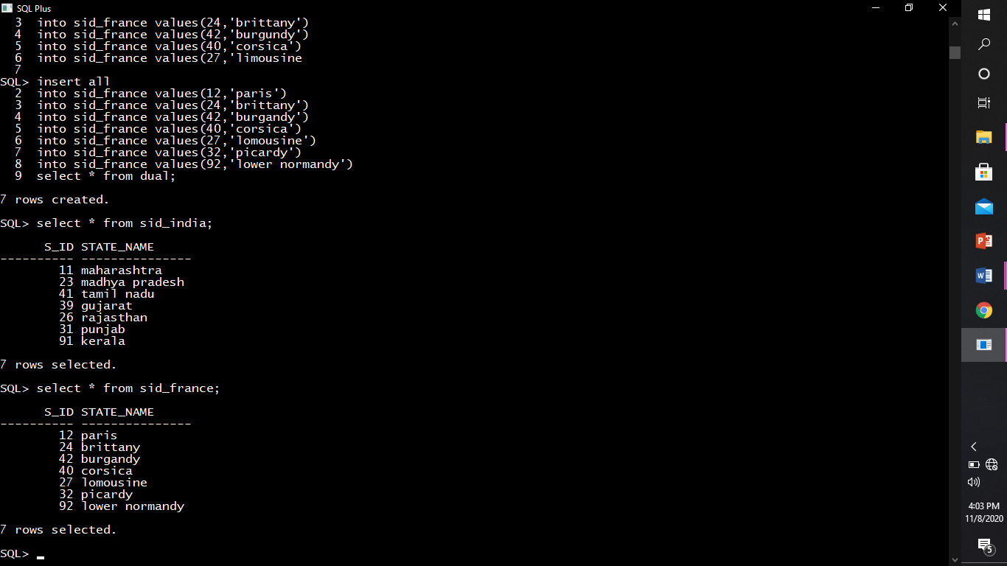

* Describing structure of france_states.

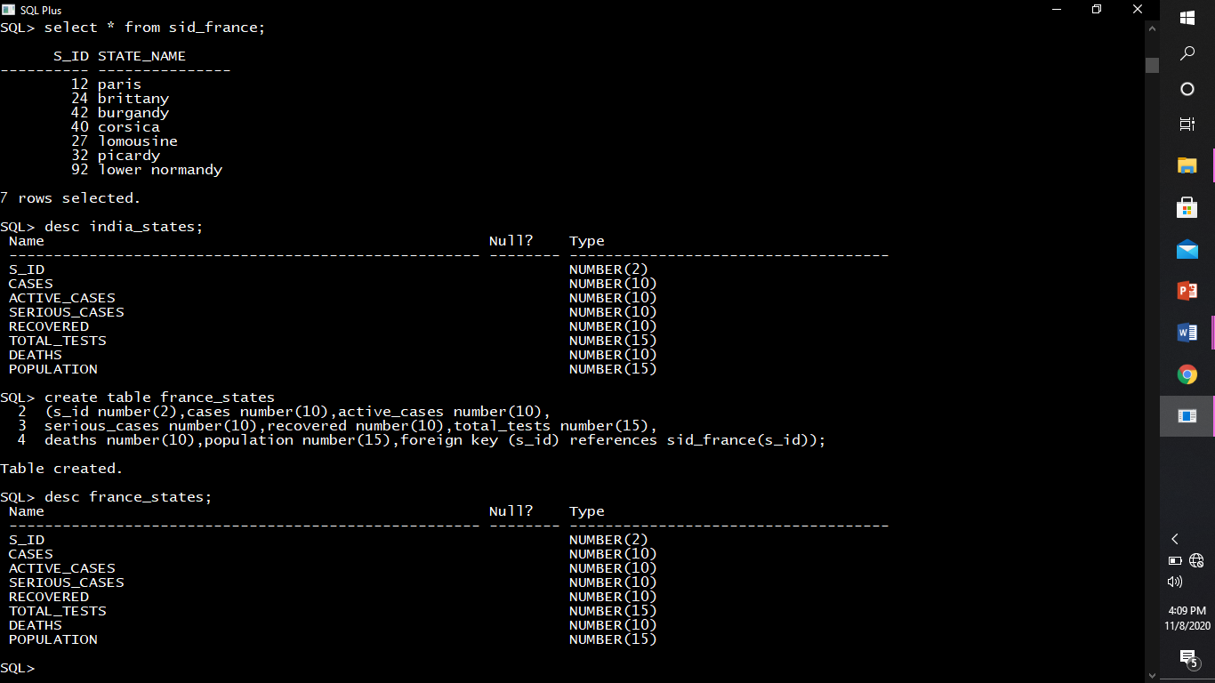

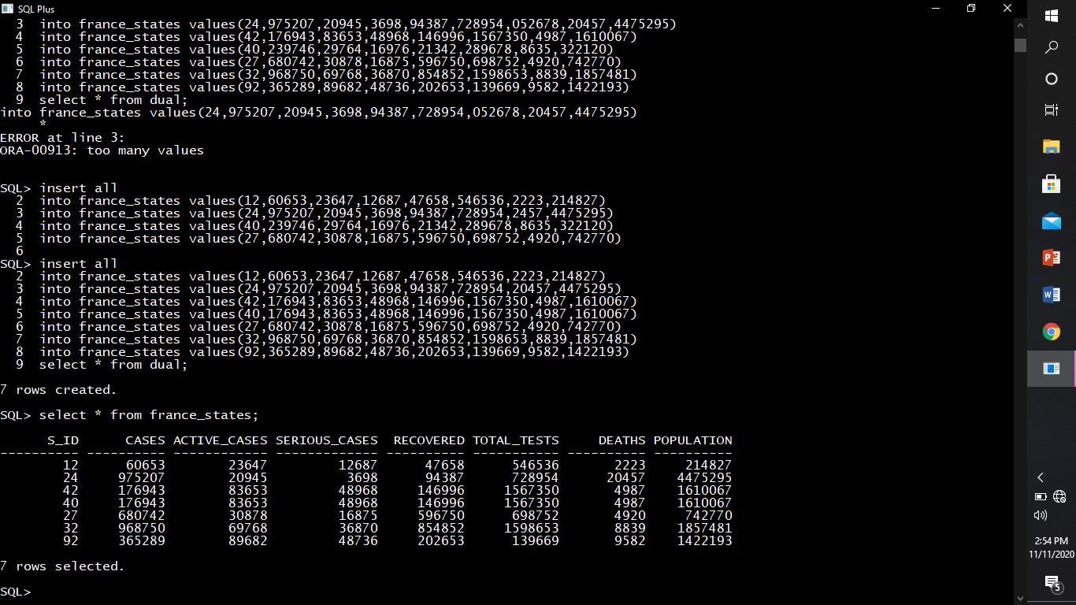

* Describing structure of sid_brazil.

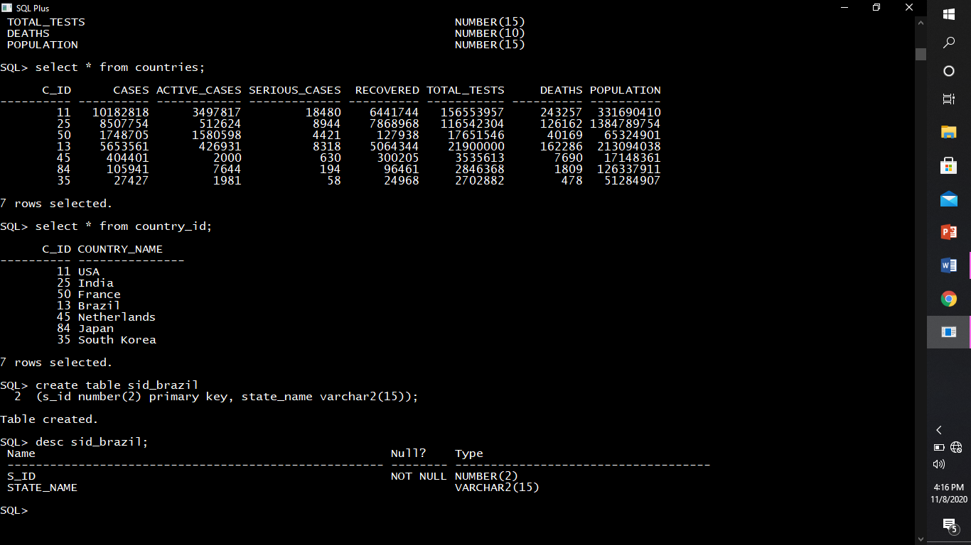

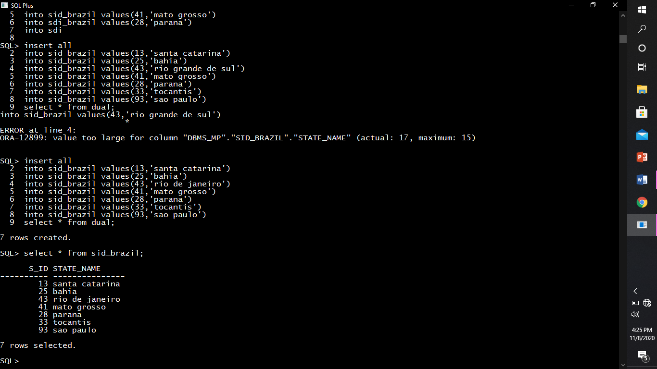

* Describing structure of brazil_states.

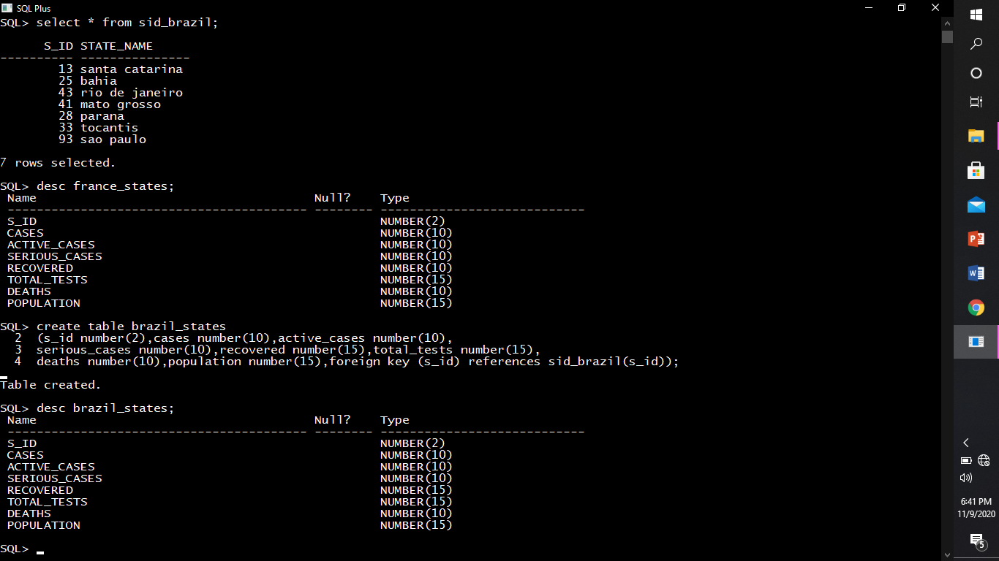

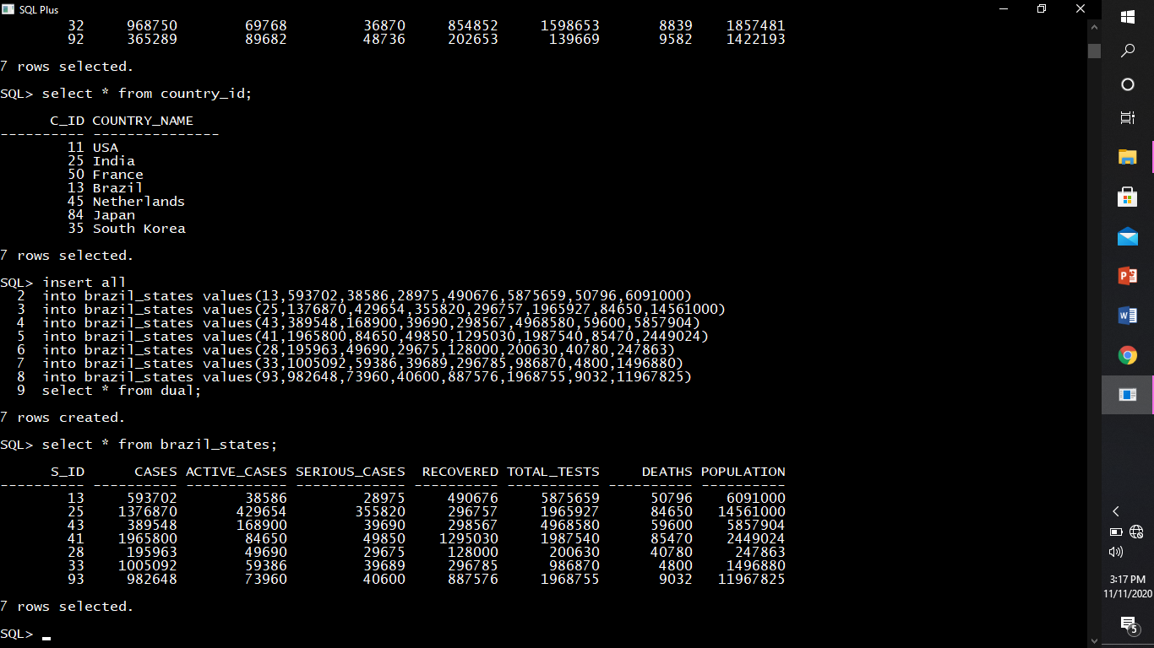

**CONSTRAINTS.**

* PRIMARY KEY Constraint: Each table must normally contain a column or set of columns that uniquely identifies rows of data that are stored in the table. This column or set of columns is referred to as the primary key.

***We have the following primary keys in our database.***

* *Primary Key in sid_USA table is (s_id number).*

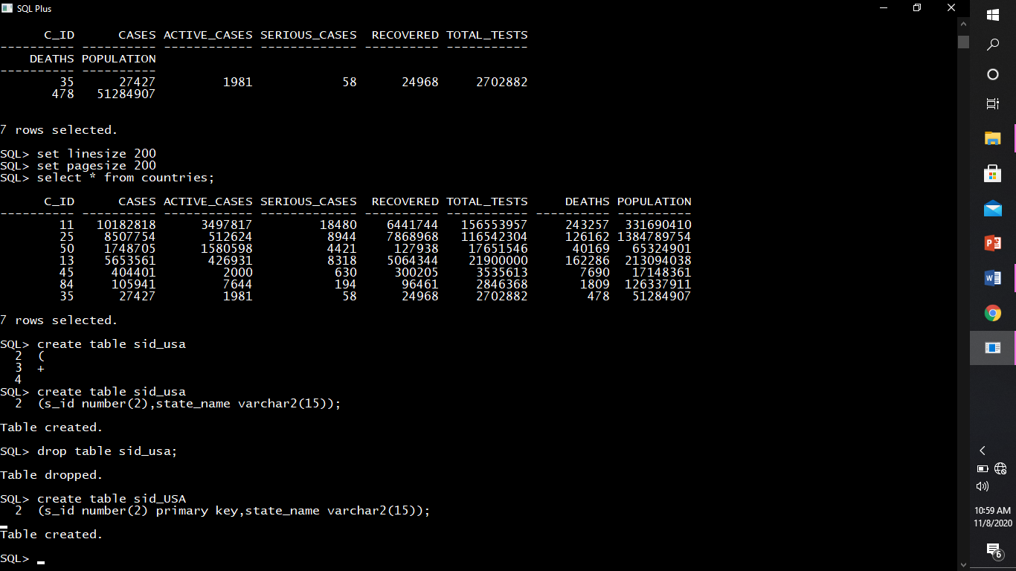

* *Primary Key in sid_korea table is (s_id number).*



* *Primary Key in sid_netherlands table is (s_id number).*



* *Primary Key in sid_japan table is (s_id number).*



* *Primary Key in sid_india table is (s_id number).*



* *Primary Key in sid_france table is (s_id number).*



* *Primary Key in sid_brazil table is (s_id number).*



* *Primary Key in country_id table is (c_id number).*

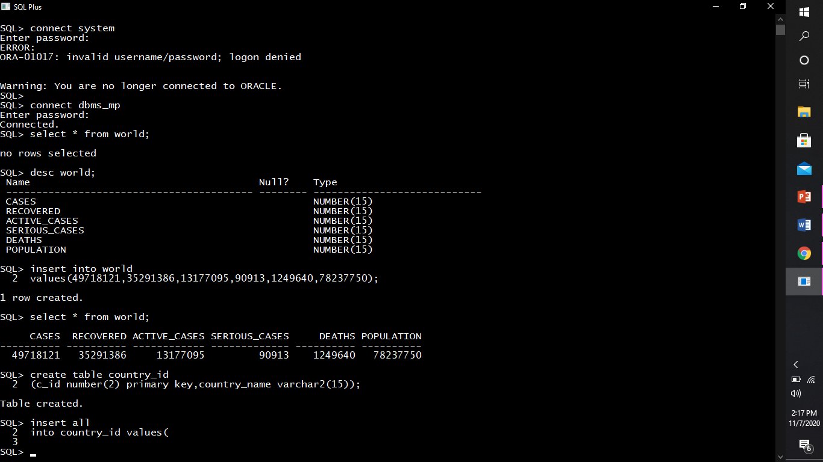

* *Primary Key in vaccine_creation_info table is (vacc_id number).*



* CHECK Constraint: Sometimes the data values stored in a specific column must fall within some acceptable range of values. A CHECK constraint is used to enforce this data limit.

***We have the following check constraints in our database.***



* FOREIGN KEY constraints: A foreign key is a key used to link two tables together. A FOREIGN KEY is a field in one table that refers to the PRIMARY KEY in another table. The table containing the foreign key is called the child table and the table containing the candidate key is called the referenced or parent table.

***We have the following foreign keys in our database.***

* *Foreign Key in USA_states table is (s_id number).*

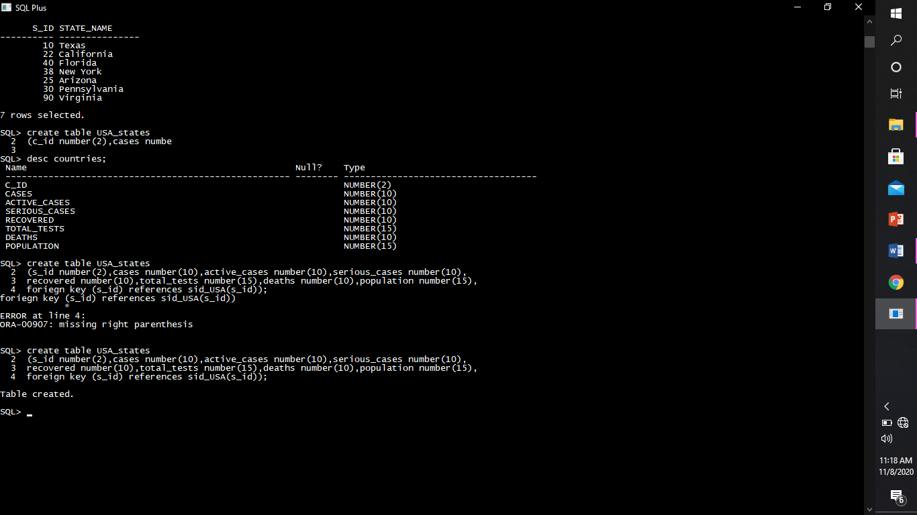

* *Foreign Key in skorea_states table is (s_id number).*



* *Foreign Key in netherland_states table is (s_id number).*



* *Foreign Key in japan_states table is (s_id number).*



* *Foreign Key in india_states table is (s_id number).*



* *Foreign Key in france_states table is (s_id number).*



* *Foreign Key in brazil_states table is (s_id number).*



* *Foreign Key in countries table is (c_id number).*



* *Foreign Key in link_vaccid_id table is (c_id number).*

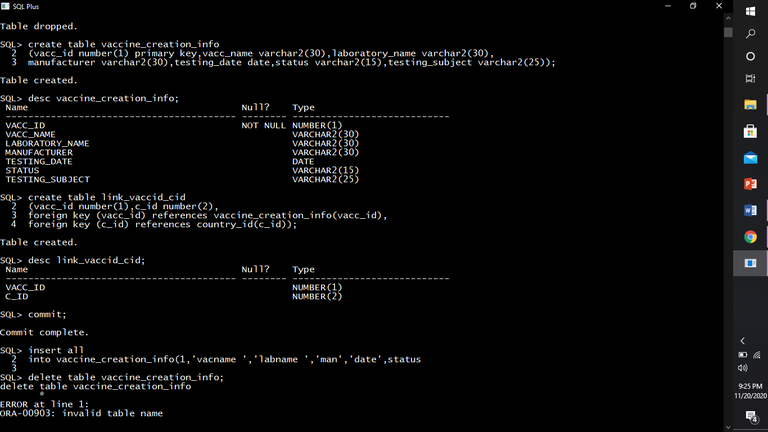

* unique constraints:

A unique key is a set of one or more than one fields/columns of a table that uniquely identify a record in a database table.

You can say that it is little like primary key but it can accept only one null value and it cannot have duplicate values.

We have the following unique keys in our database

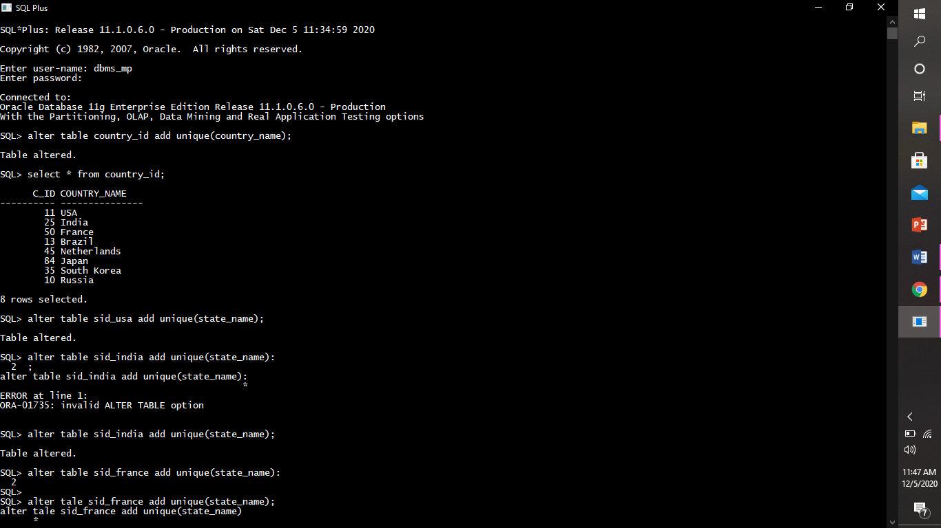

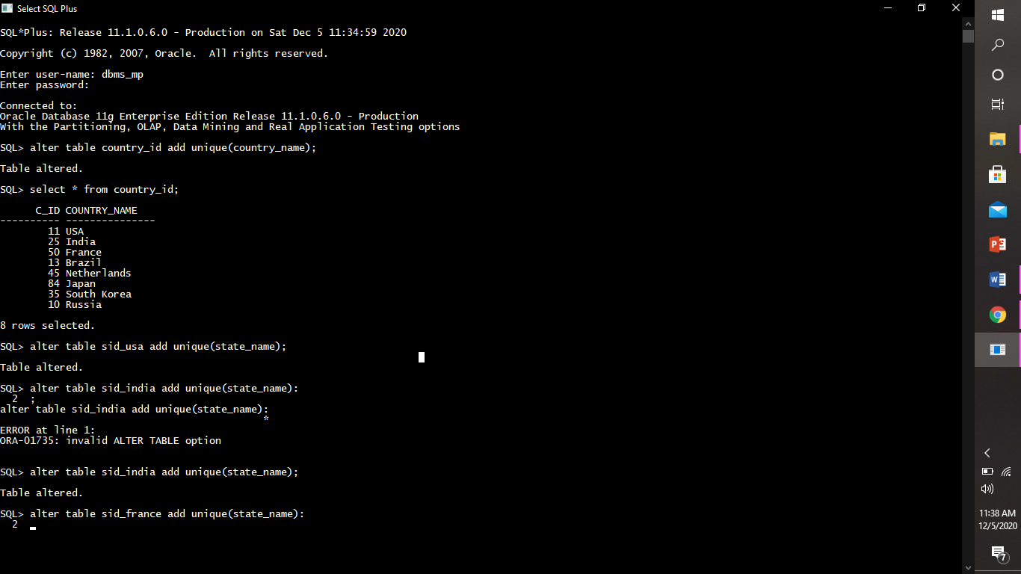



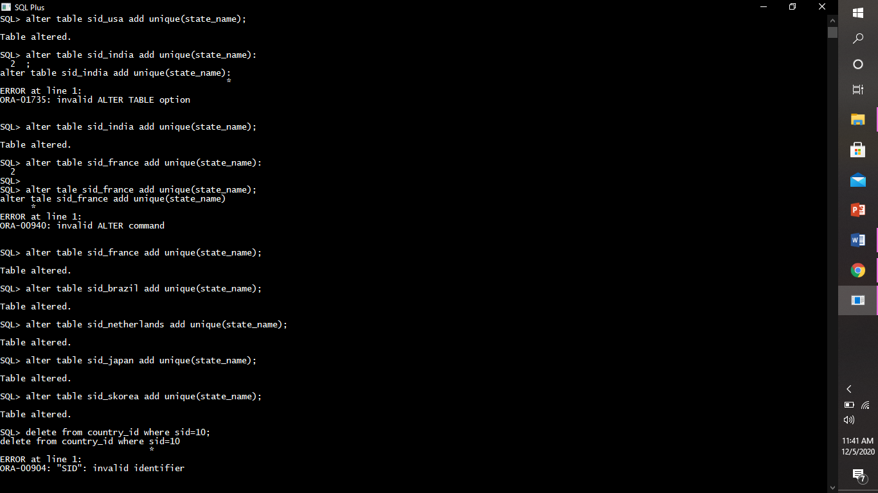









**DDL COMMANDS.**

**DDL(Data Definition Language) :**DDL or Data Definition Language actually consists of the SQL commands that can be used to define the database schema. It simply deals with descriptions of the database schema and is used to create and modify the structure of database objects in the database.

***DDL commands are:***

1)create command: One Of The First Steps In Creating A Database Is To Create The Tables That Will Store Company / Organization’s Data.

* In Order To Create A Table , Four Pieces Of Information Must Be Determined:

1. The Table Name

2. The Column (Field) Names

3. Column Data Types And

4. Column Sizes.

**Examples of create commands are :**

* Creating table world.



* Creating table country_id.



* Creating table countries.



* Creating table vaccine_creation_info



* Create table link_vaccid_cid



* Creating table sid_brazil.



* Creating table brazil_states.



* Create table sid_france.



* Create table france_states.



* Creating sid_india table.



* Creating table india_states.



* Creating table sid_japan



* Creating table japan_states.



* Creating table sid_netherlands.



* Creating table netherlands_states.



* Creating table sid_skorea.



* Creating table skorea_states.



* Creating state id table for usa.



* Creating usa_states table.



2)alter command: This command is used to alter the structure of the database.

***Examples of alter comman are:***

* Alter Command Can Be Used To **Add** New Columns. We use the ADD clause to add columns.

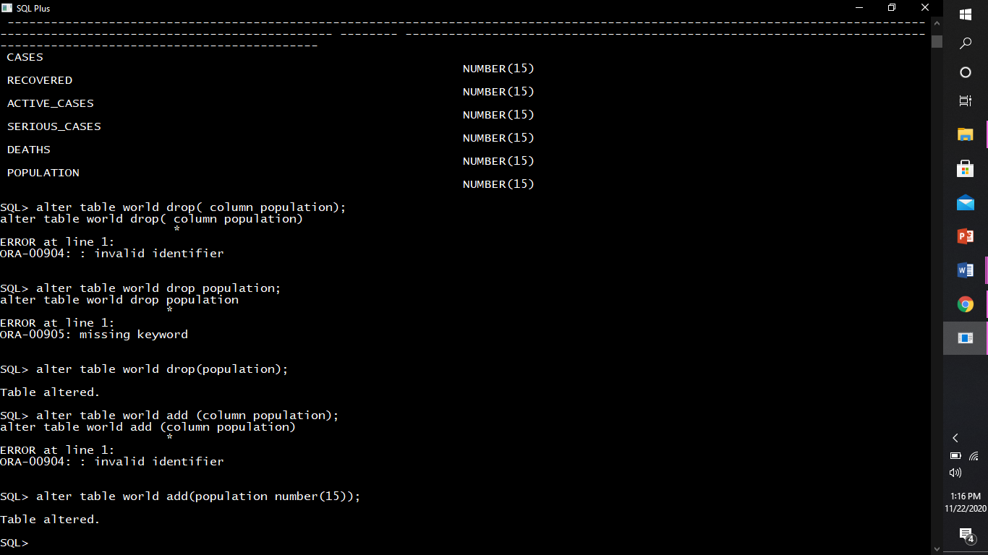

* Alter Command Can Be Used To **Modify** an Existing Columns. We can change a column’s data type, size, and default value.

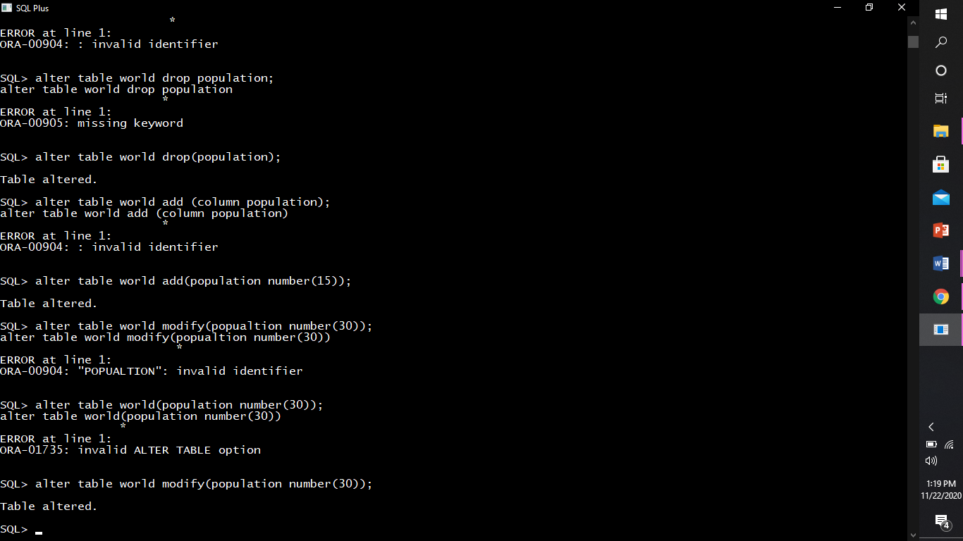

* Alter Command Can Be Used To **Rename** an Existing Columns.This command is used to rename an object existing in the database.

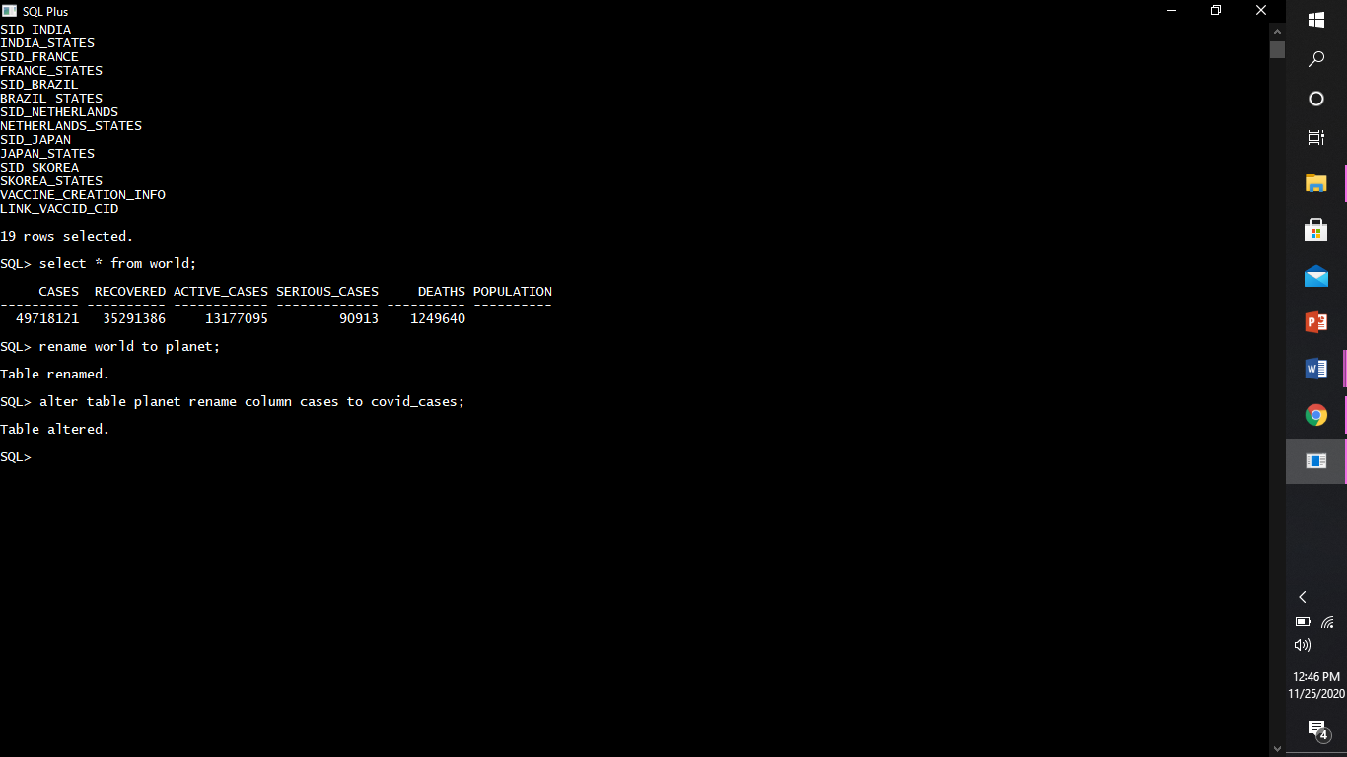

* Alter Command Can Be Used To **DROP** an Existing Columns. This command is used to delete objects from the database.

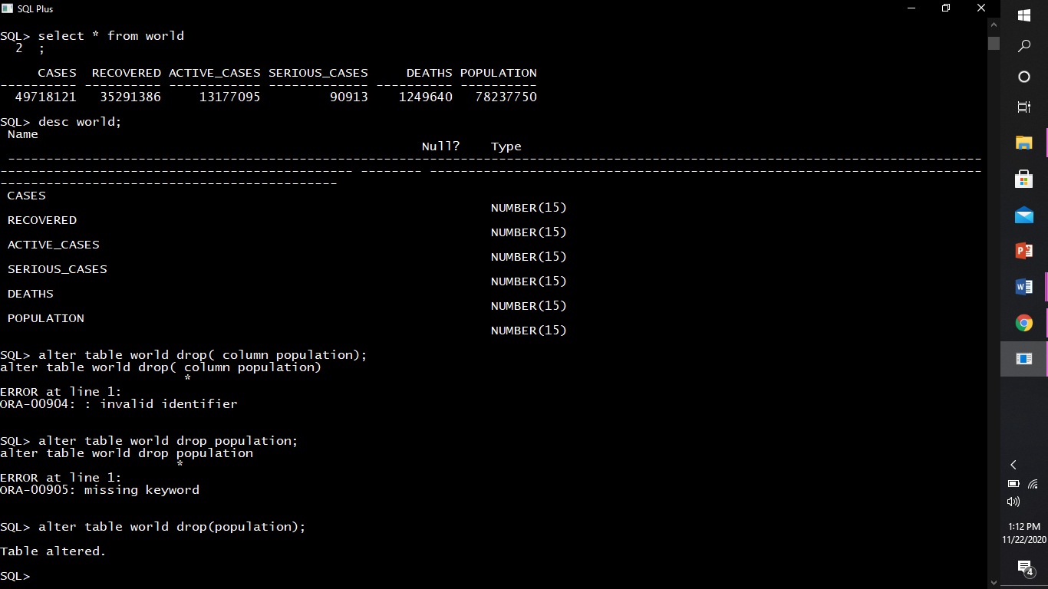

* Alter Command Can Be Used To **add constraint.**

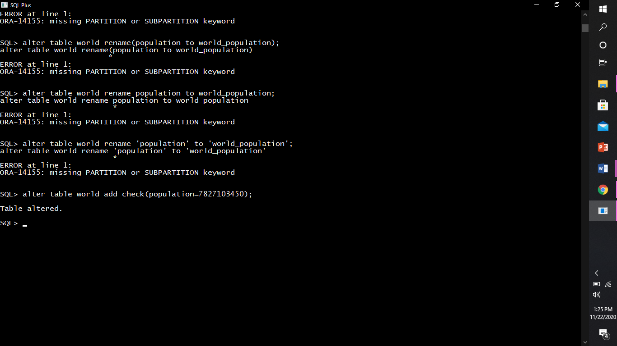

3)drop command : The drop table command removes the data as well as definition(structure) of an oracle table. When we drop a table, the database loses structure with all the data in the table, related constraints and all the indexes associated with it.

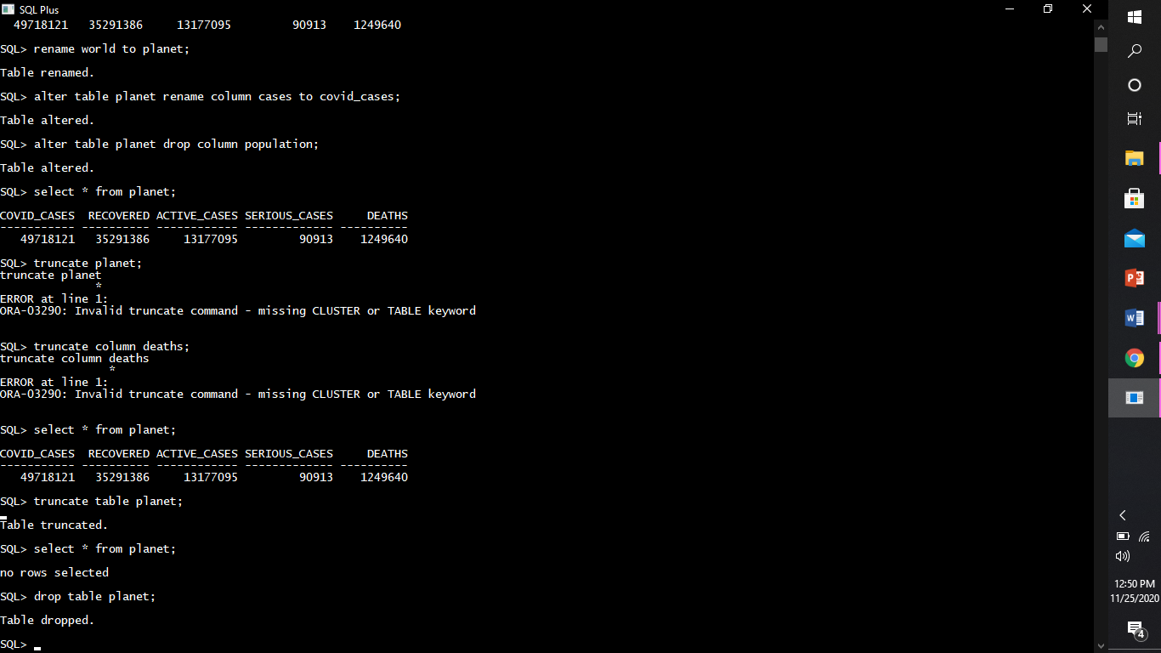

* It can also be used to drop any specific column.



4)truncate command : The truncate table command is used to remove all rows from a table and to release the storage space used by the table but does not delete the table definition(structure) from the database.

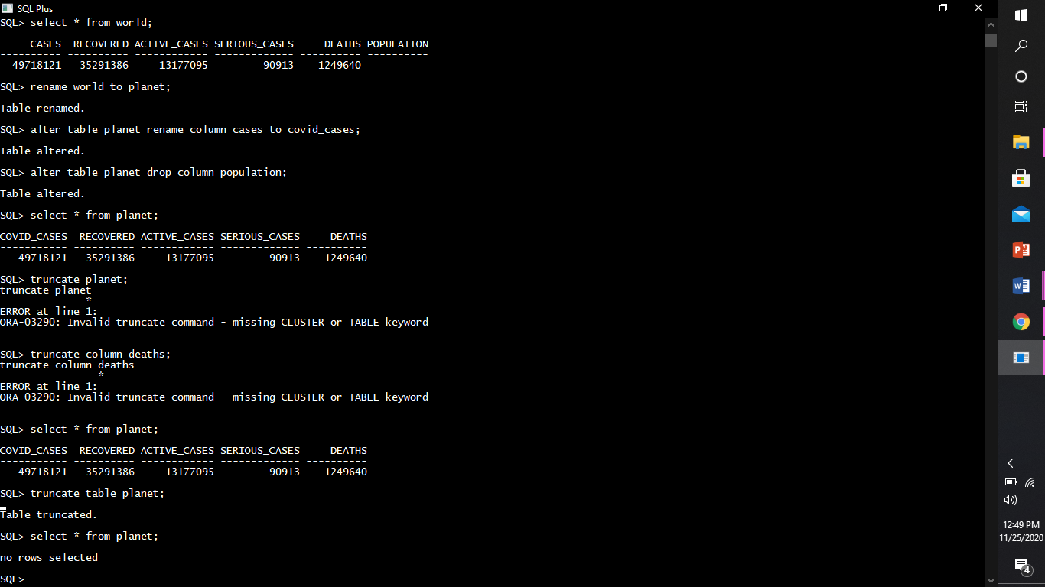

5)desc command : The describe (desc) command can display the column names and data types for any table.

(we have used this command above to describe the structures of tables.)

6)REname command : A table can be renamed with the rename Command. This command does not affect table structure or Data; it simply gives the current table a new Name.

***Examples are :***

1)Renaming the name of the table.

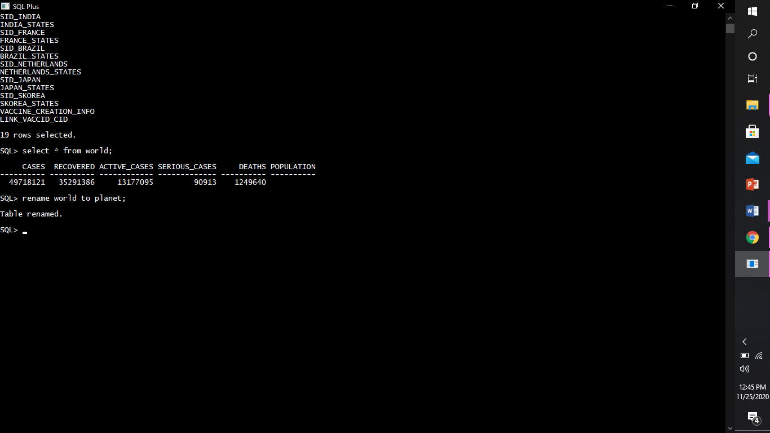

2)Renaming any specific column inside the table.



**DML COMMANDS.**

**DML(Data Manipulation Language) :**The SQL commands that deals with the manipulation of data present in the database belong to DML or Data Manipulation Language and this includes most of the SQL statements.

***DML Commands are :***

1)insert command:  This command is used to insert data into a table.

*Examples of Insert command are :*

* Inserting rows into world table.



* Inserting rows into country_id table.



* Inserting rows into countries table.

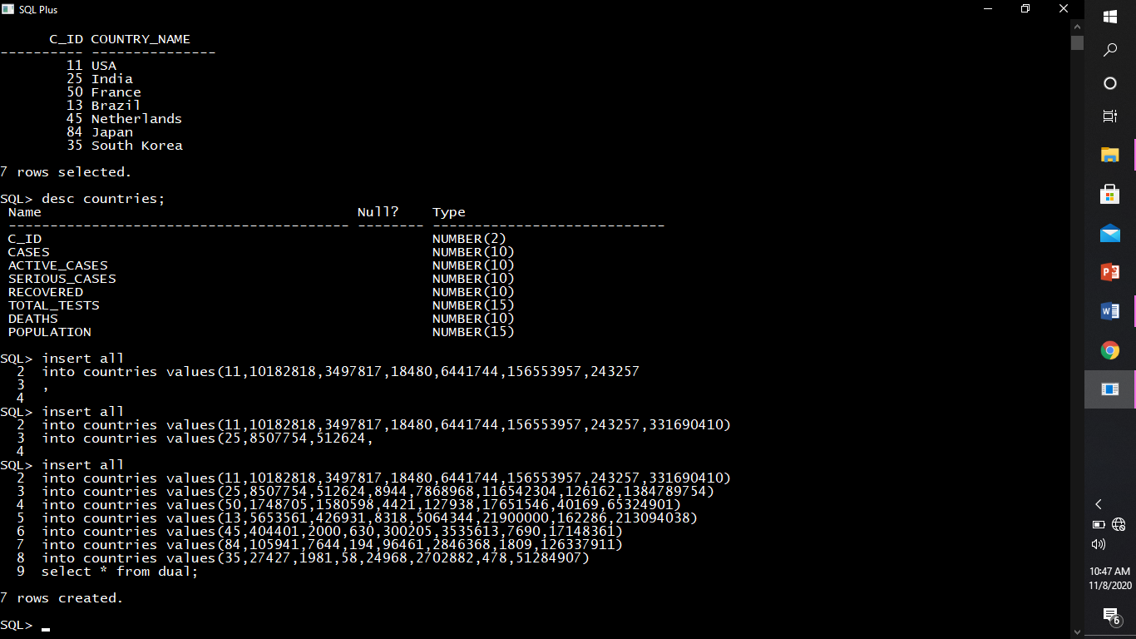

* Inserting rows into vaccine_creation_info

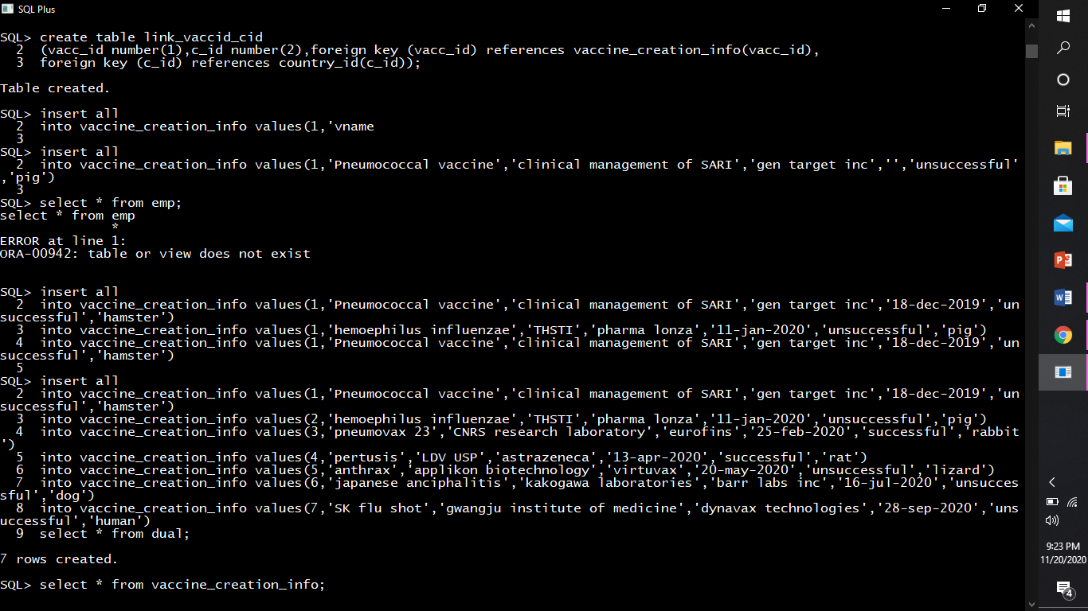

* Inserting rows into link_vaccid_cid



* Inserting rows into sid_usa.



* Inserting rows into usa_states table.



* Inserting rows into sid_india.



* Inserting rows into india_states.



* Inserting rows into sid_skorea.



* Inserting rows into skorea_states.



* Inserting rows into sid_japan



* Inserting rows into japan_states.



* Inserting rows into sid_netherlands.



* Inserting rows into Netherlands_states.



* Inserting rows into sid_france.



* Inserting rows into france_states.



* Inserting rows into sid_brazil.



* Inserting rows into brazil_states.



2)delete command : This command is used to delete records from a database table.

***Examples Of Delete Command Are :***

1)Deleting a particle row satisfying the condition

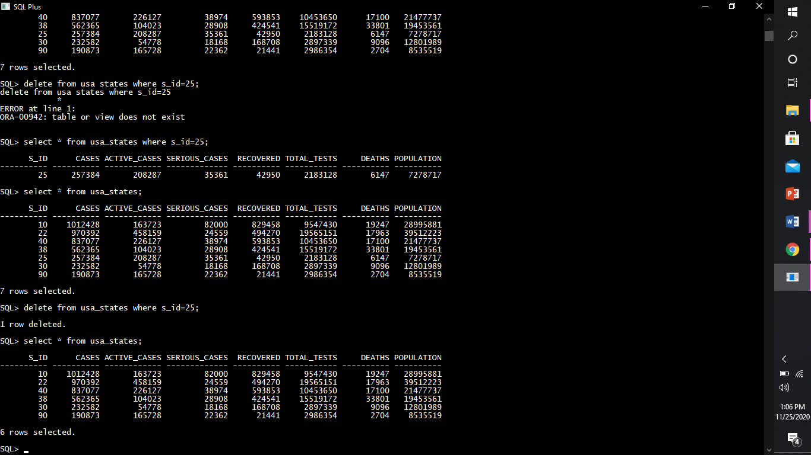

2) Deleting the whole table

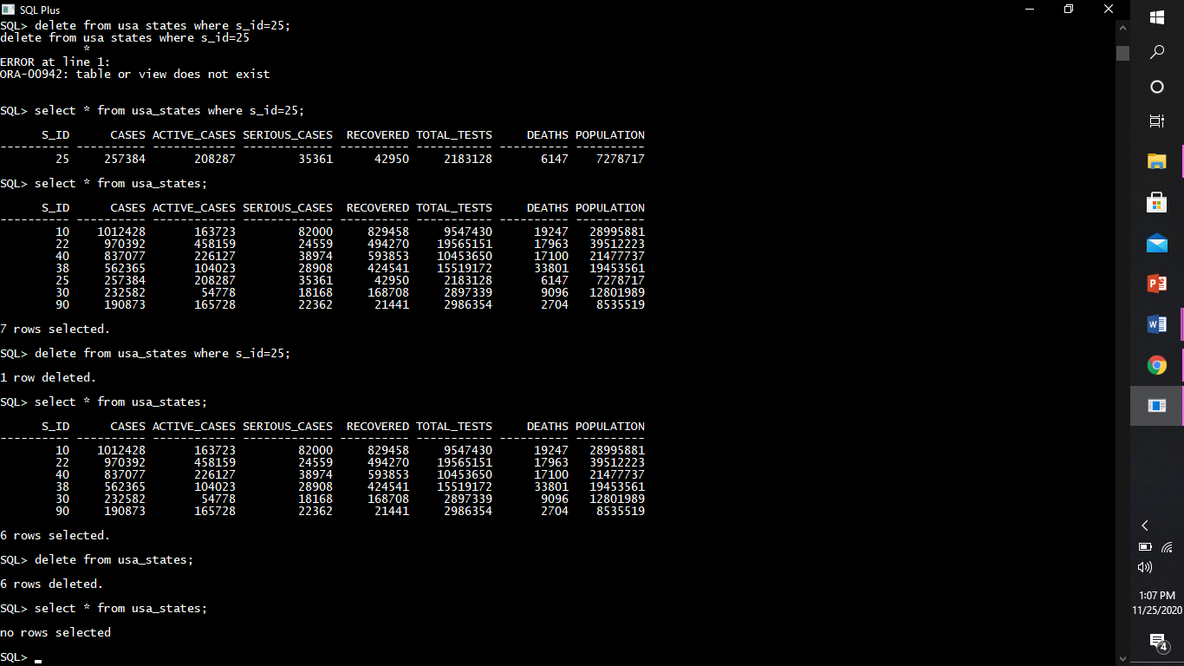

3)update command :This Command  Is Used To Update Existing Data Within A Table.

***Examples of update command are:***

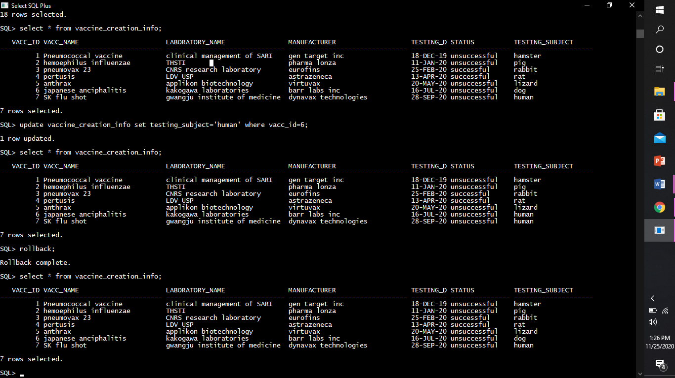



* Using Update Command In Multiple Fields

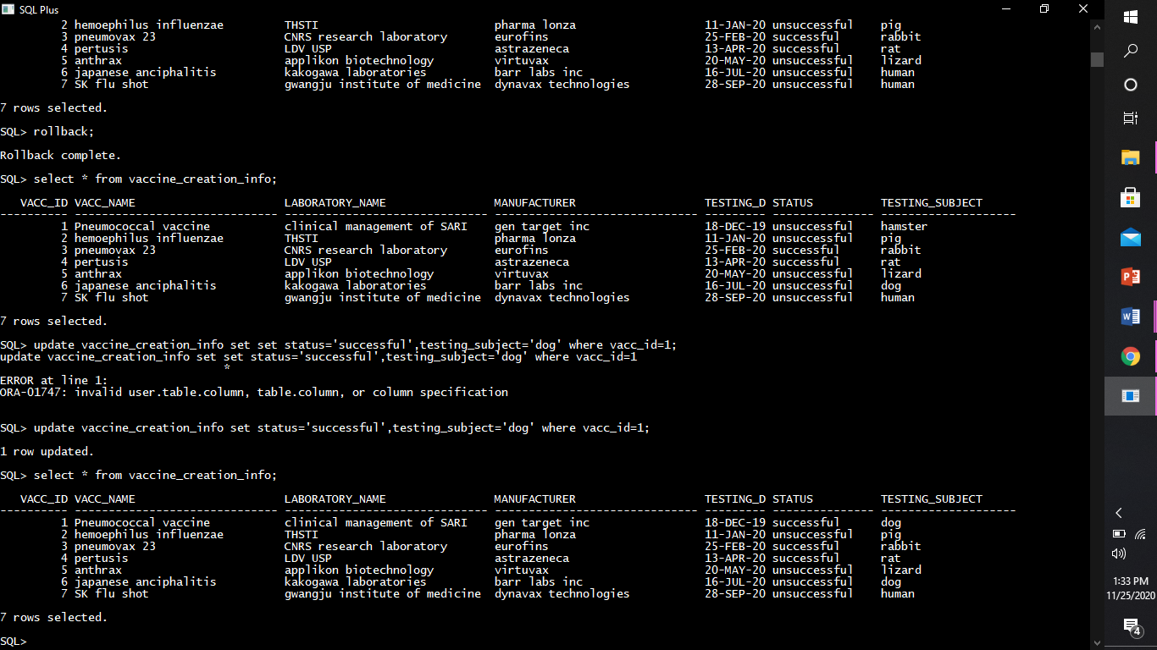



**DQL COMMANDS.**

select clause: This clause is used for Retrieving Certain Records From One Or More Tables.

(select clause is also used with various operators and functions as discussed further.)

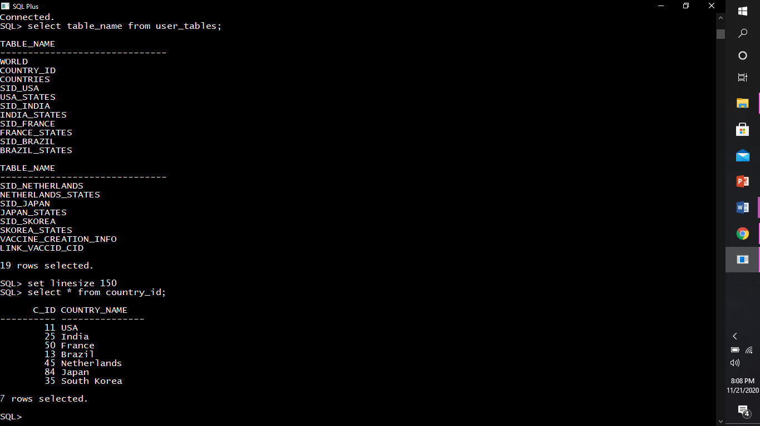

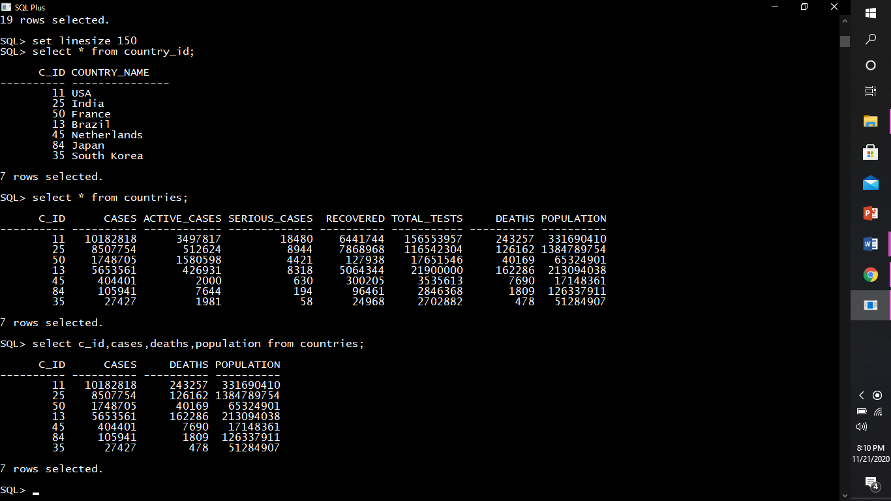

**TCL COMMANDS.**

**TCL(transaction Control Language) :**TCL commands deals with the [transaction within the database](https://www.geeksforgeeks.org/sql-transactions/).

rollback command : Restore Database To Original Since The Last Commit.

***Example1:***

We deleted a particular row from the usa_states table.

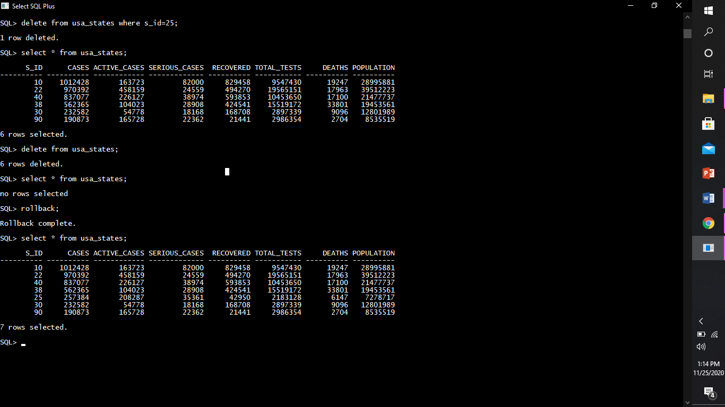

Then we deleted the whole usa_states table



Then we performed the rollback operation



And all the operations performed were rolbacked since it was dml commands .Rollback can’t be done on ddl commands.

***Example2:***

We have a table as vaccine_creation_info



This table is updated using the update command



The updated command can be rollbackd since it’s a dml command

So after performing rollback



The updated row is rollbacked to it’s original value.

commit command: Used to commit the work done so far

(saves work done)

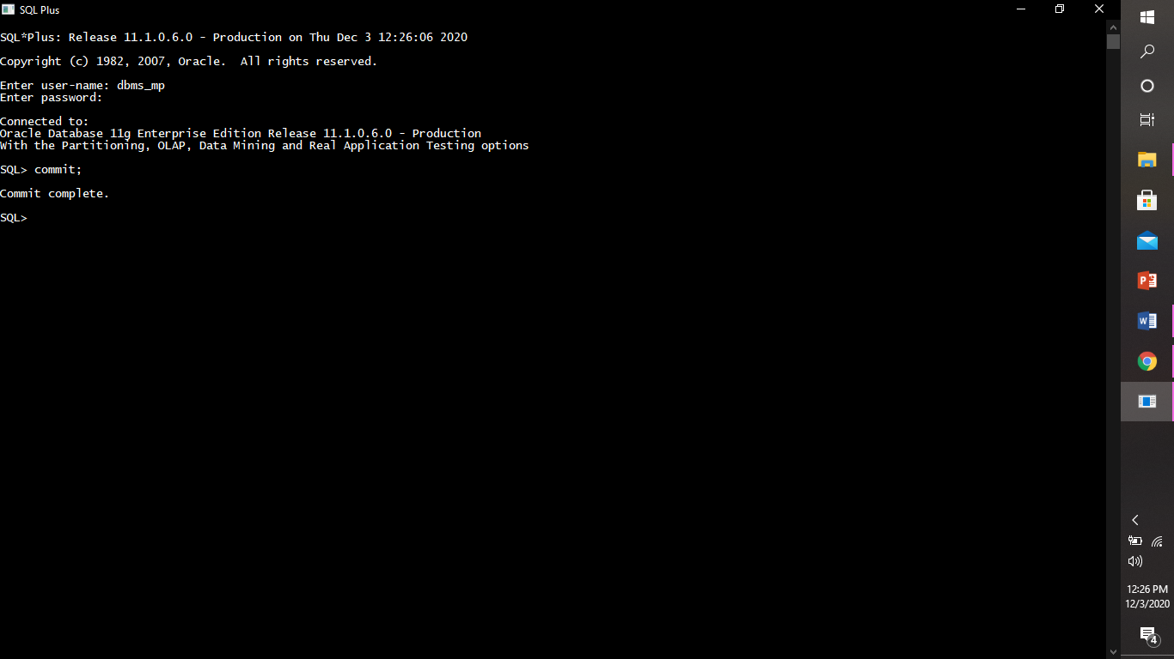

Savepoint Command: Identify A Point In A Transaction To Which You Can Later Roll Back.

**DCL COMMANDS.**

**DCL(Data Control Language) :**DCL includes commands such as GRANT and REVOKE which mainly deals with the rights, permissions and other controls of the database system.DCL commands can only be performed by super users.

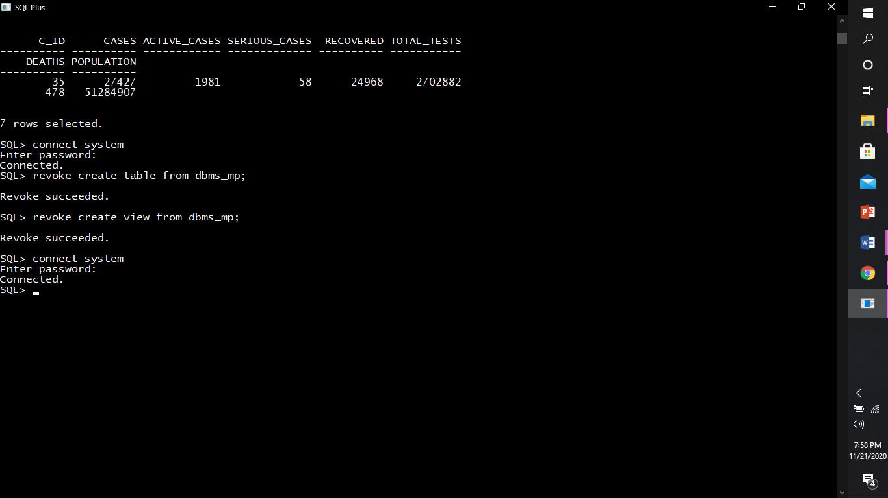

Grant command: This command gives user’s access privileges to database.

Example:

We can grant all the privileges to user at once :

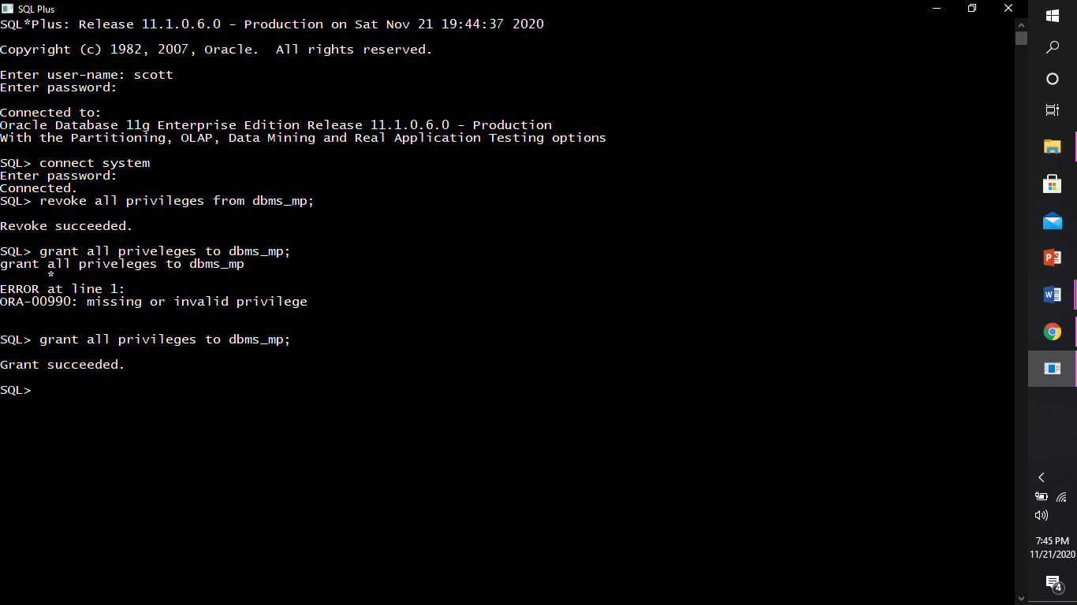

Grant any specific privileges.

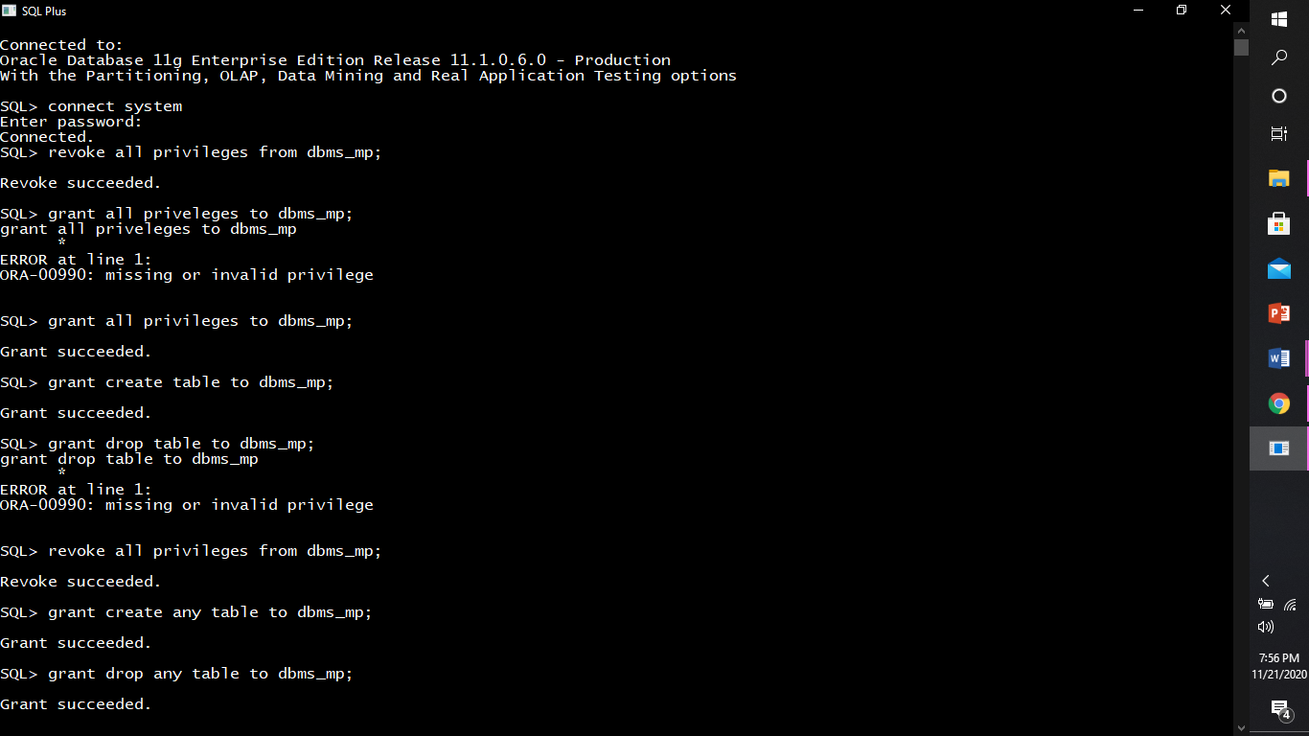

revoke comamnd: This command withdraw user’s access privileges given by using the GRANT command.

Example:

We can revoke all the privileges from user at once:

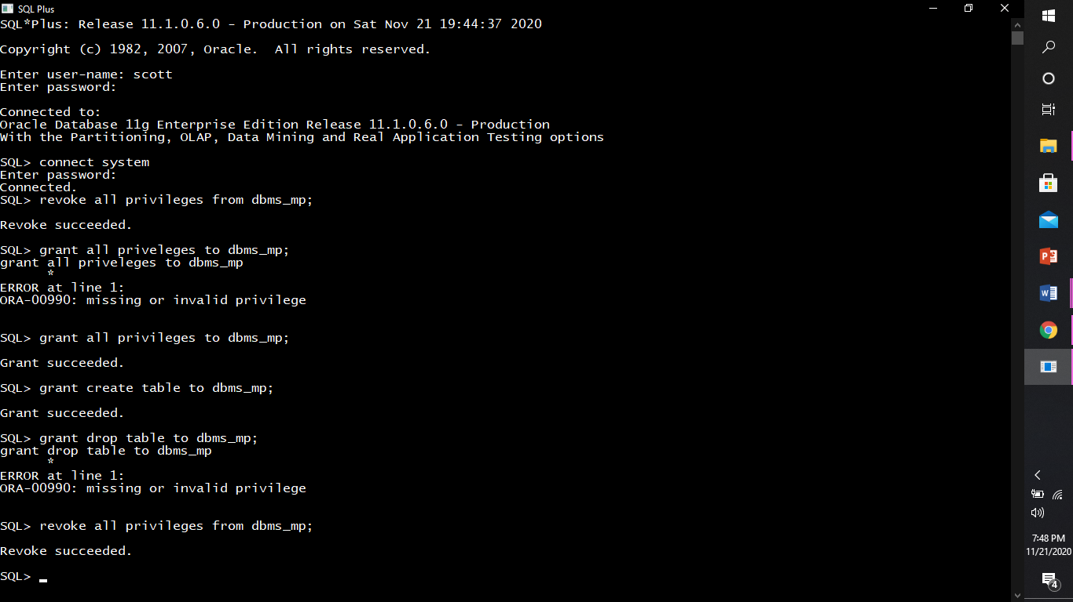

Revoke any specific privelges.

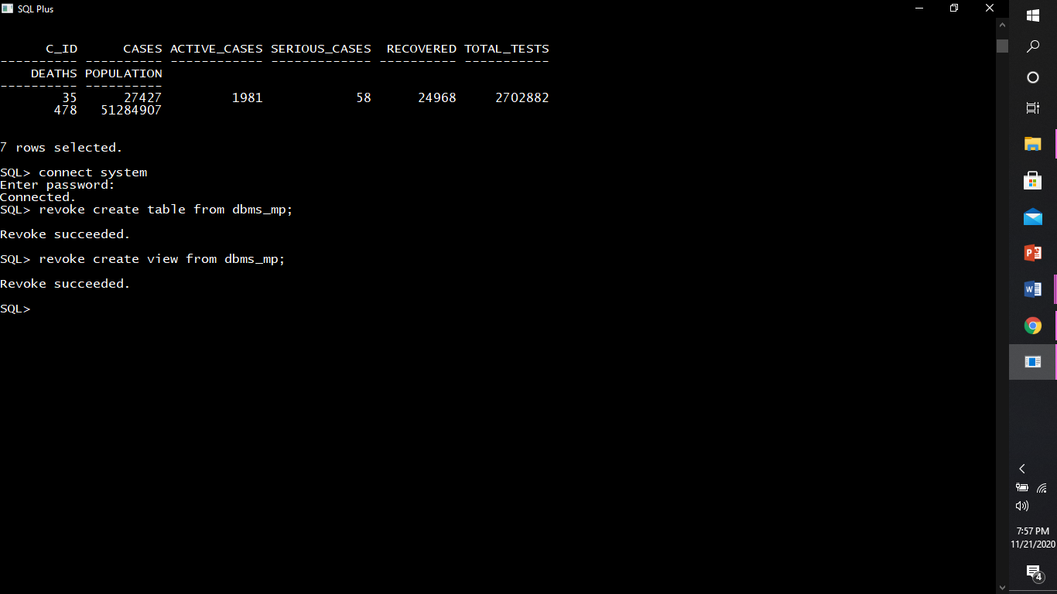

**sql operators.**

arithmetic operators : An arithmetic operator is an operator that denotes a specific mathematical operation.These operators can perform arithmetical operations on numeric operands involved. Arithmetic operators are addition(+), subtraction(-), multiplication(*) and division(/).

1)ADDITION(+): This Operator Is Used To Add Two Or More Expressions Or Numbers.

***Example:***

The below query displays the total cases by adding active_cases, serious_cases, and recovered covid patients.

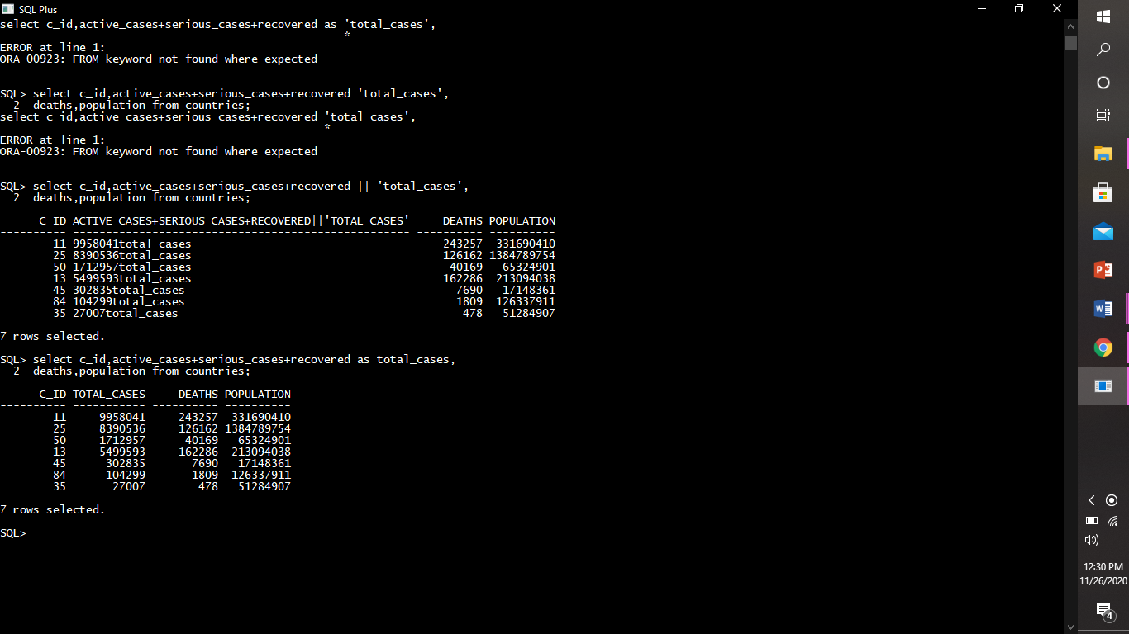

2)SUBTRACTION(-): This Operator Is Used To Subtract One Expression Or Number From Another Expression Or Number.

Example:

This query displays the cured covid patients.

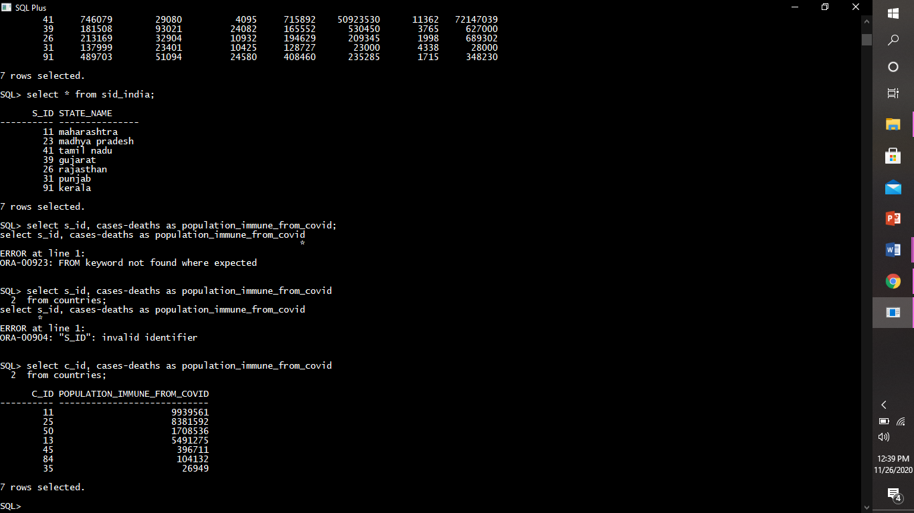

3)Multiplication (*): This Operator Is Used To Multiply Two Or More Expressions Or Numbers.

Example:

4)Division (/):This operator is used to divide one expressions or numbers by another.

Example:

comparison operators**:-** A comparison (or relational) operator is a mathematical symbol which is used to compare two values. Comparison operators are used in conditions that compares one expression with another. The result of a comparison can be true, false, or unknown (an operator that has one or two null expressions returns unknown).

1.] equal (=): The equal to operator is used for equality test within two numbers or expressions.

Example:

This query displays the row from country_id table which has c_id=35.

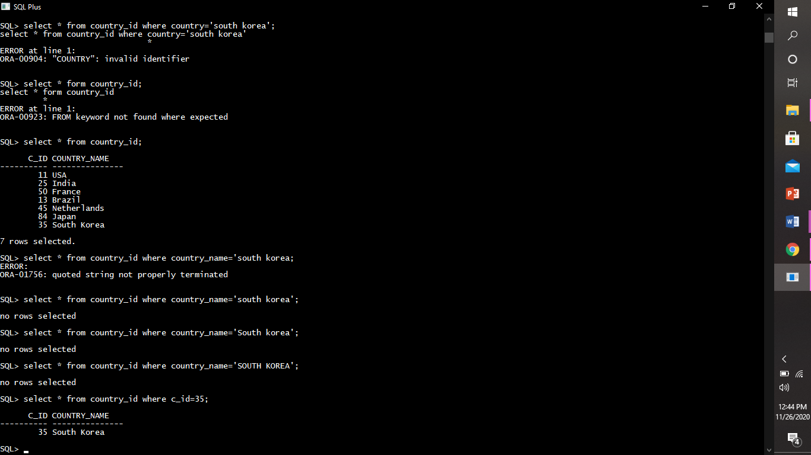

2.]greater than (>):The greater than operator is used to test whether an expression (or number) is greater than another one.

Example:

This query displays the records of states in usa where the covid cases are greater than 900000.

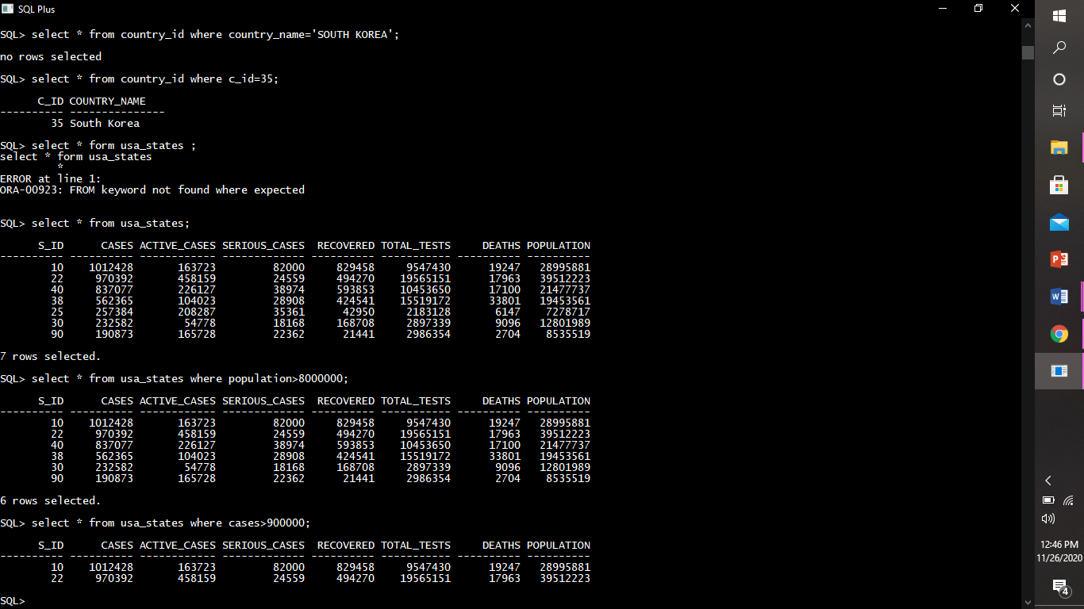

3.] less than (<): The less than operator is used to test whether an expression (or number) is less than another one.

Example:

This query displays the records of states in south korea having population less than 2000000.

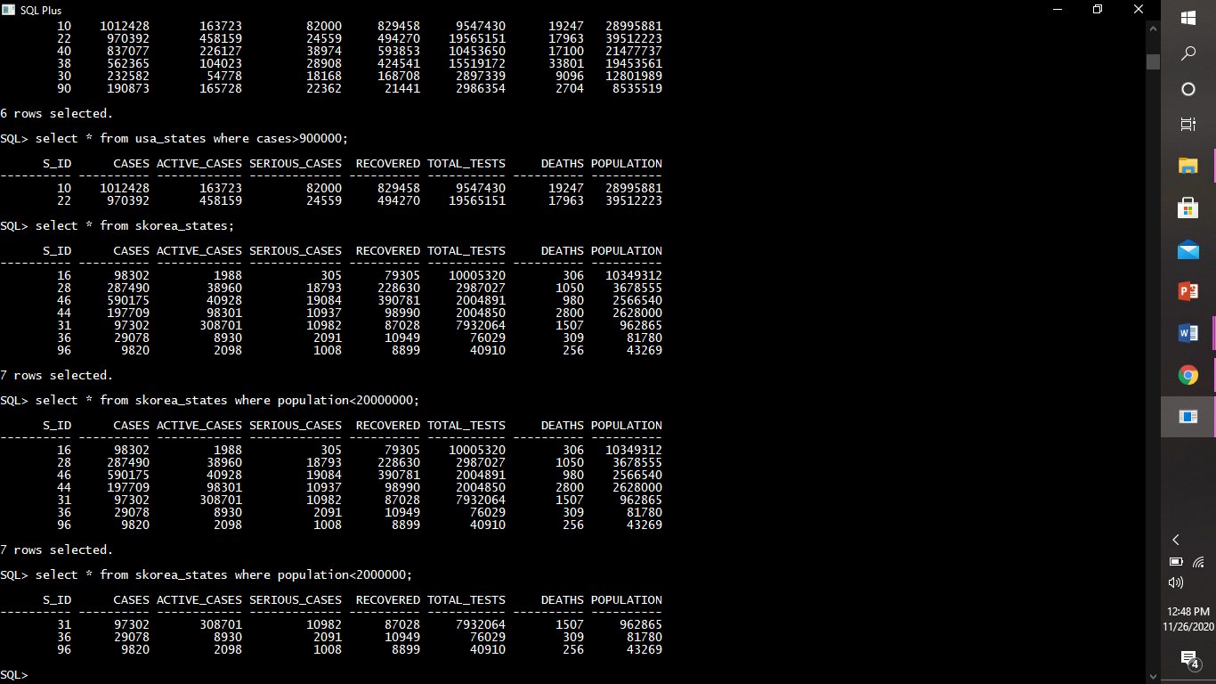

4.] greater than equal to (>=):The greater than equal to operator is used to test whether an expression (or number) is either greater than or equal to another one.

Example:

This query displays the records of states from japan having no. of deaths greater than or equal to 4890.

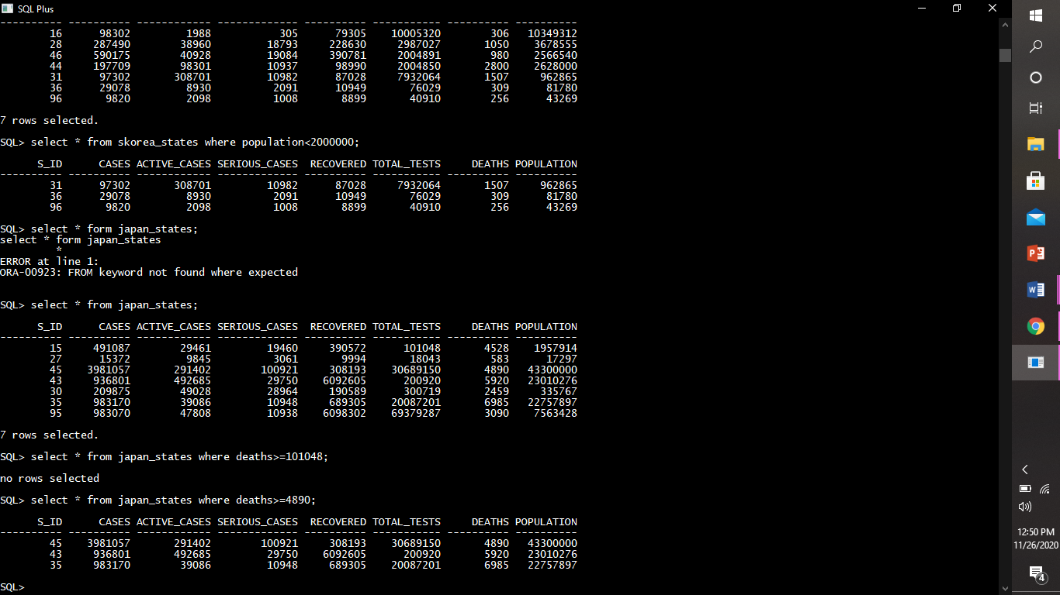

5.] less than equal to (<=):The less than equal to operator is used to test whether an expression (or number) is either less than or equal to another one.

Example:

This query displays the records of states from brazil having total tests less than or equal to 986870.

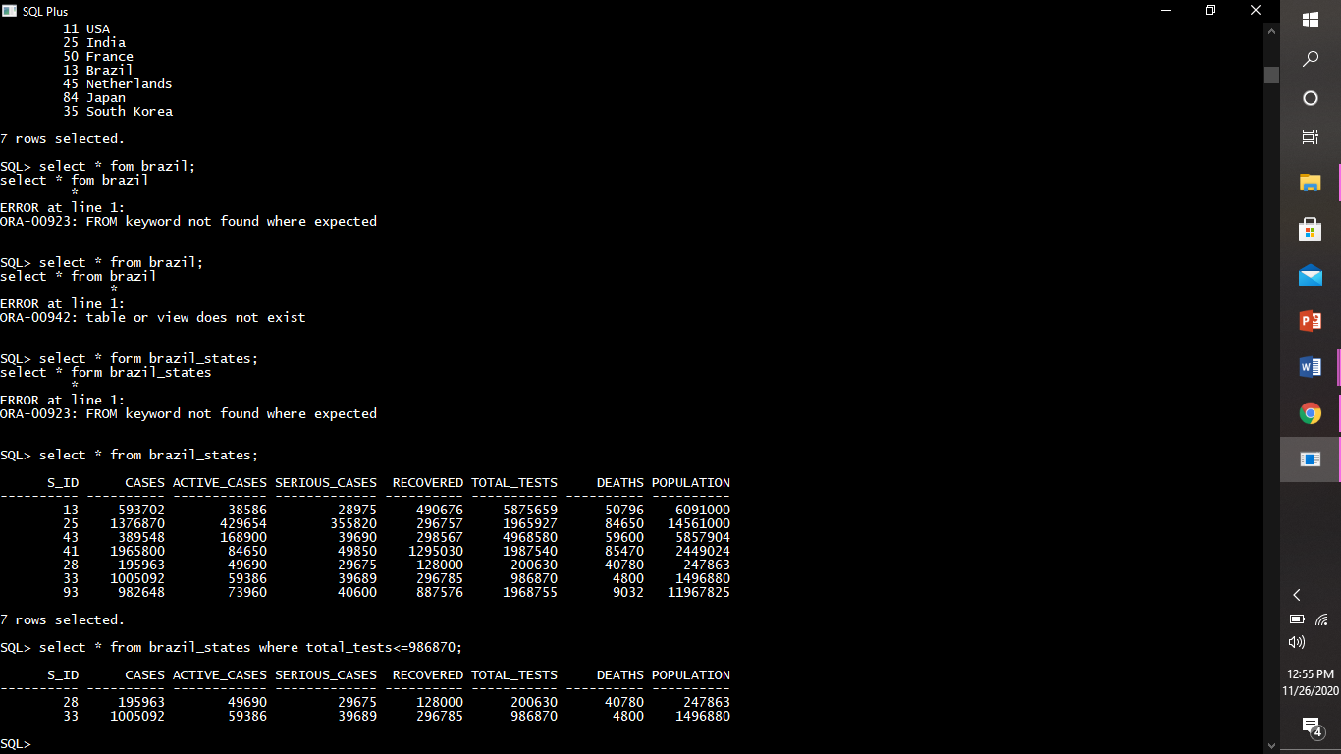

6.] not equal to (<>,!=):The not equal to operator is used for inequality test between two numbers or expression.

Example:

This query displays the row from sid_skorea table whose s_id is not equal to 96.

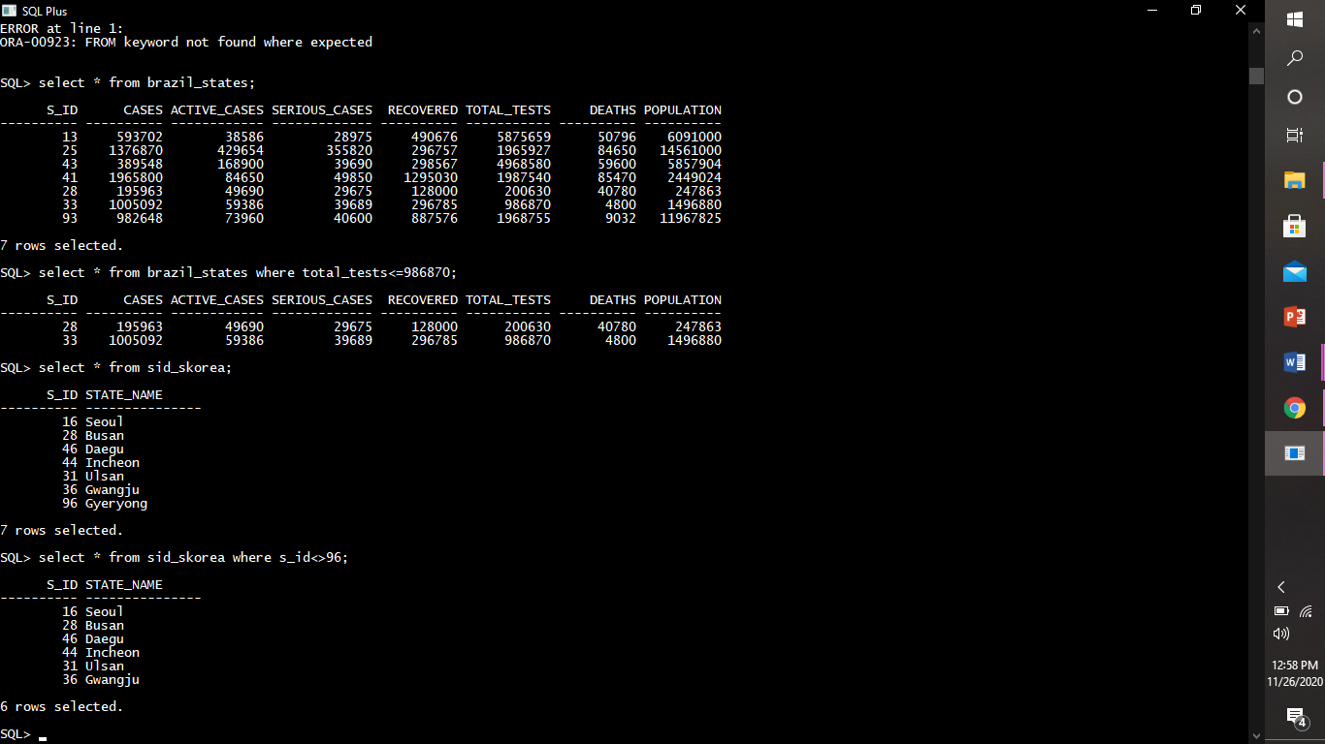

logical operators :- The Logical operators are those that are true or false. They return a true or false values to combine one or more true or false values.

And: Logical AND compares between two Booleans as expression and returns true when both expressions are true.

***Example:***

This query displays the records from vaccine_creation_info table where the status of vaccine is ‘successful’ and testing subject is ’rabbit’.

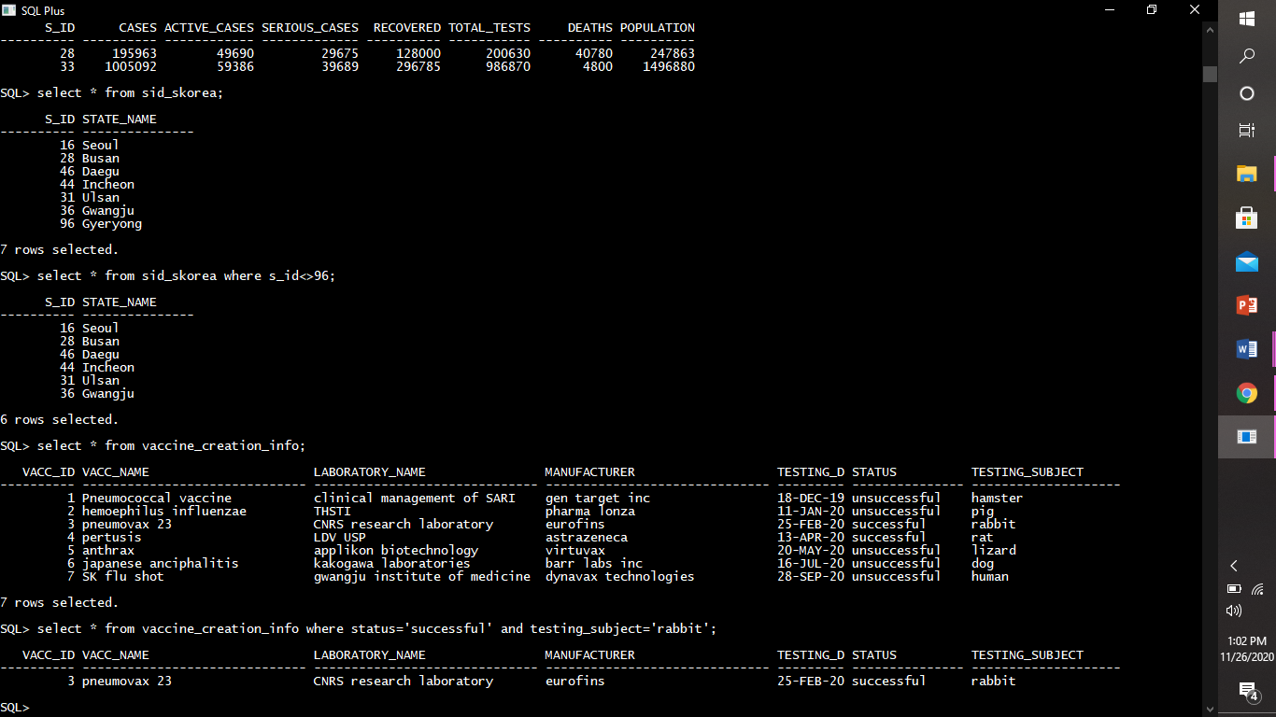

Or: Logical OR compares between two Booleans as expression and returns true when one of the expression is true.

***Example:***

This query displays the records from vaccine_creation_info table where the status of vaccine is ‘successful’ or manufactuer is ’barr labs inc’.

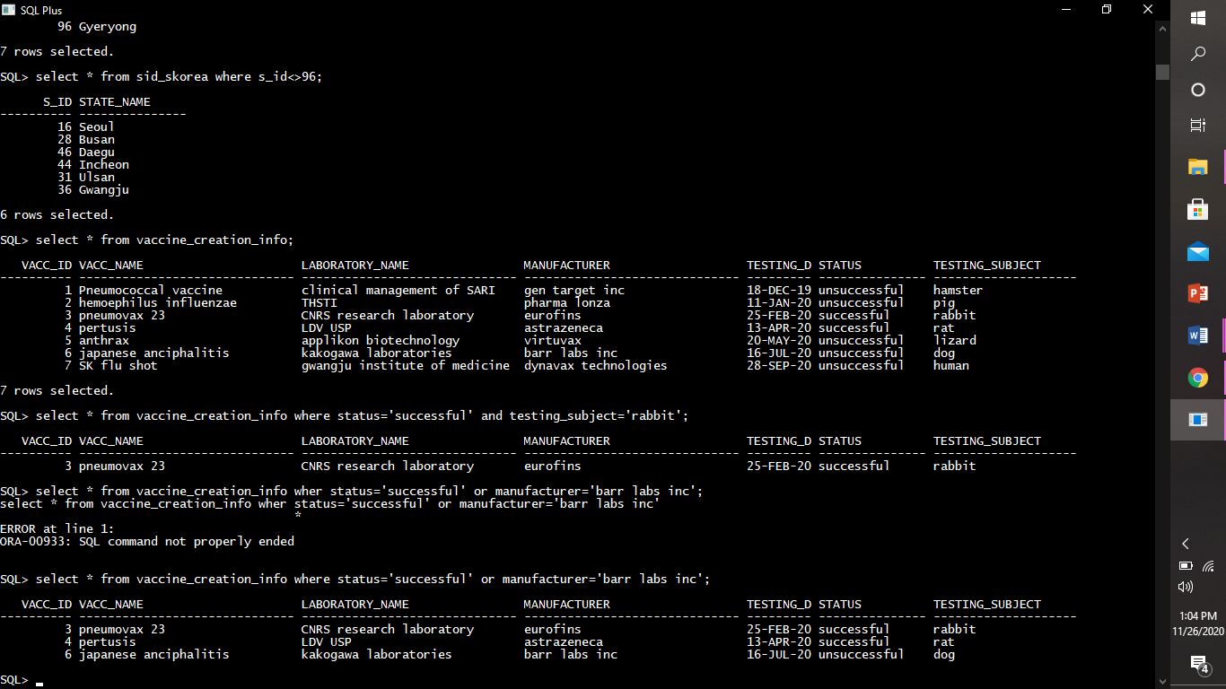

Not: Not takes a single Boolean as an argument and changes its value from false to true or from true to false.

***Example:***

This query displays the records from vaccine_creation_info table where the status of vaccine is ‘unsuccessful’ (i.e not ‘successful’).

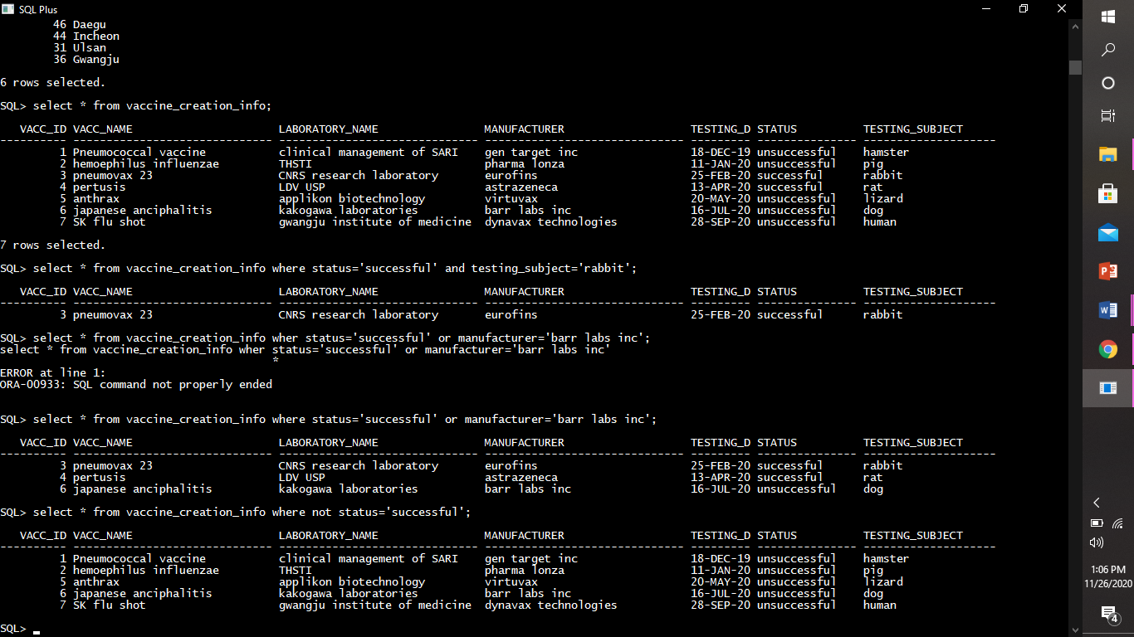

set operators :- Set operators are used to join the results of two (or more) SELECT statements.

UNION : When multiple SELECT queries are joined using UNION operator, Oracle displays the combined result from all the compounded SELECT queries, after removing all duplicates and in sorted order (ascending by default), without ignoring the NULL values.

***Example:***

This query combine two tables i.e india_states and skorea_states and display the records of both the tables.

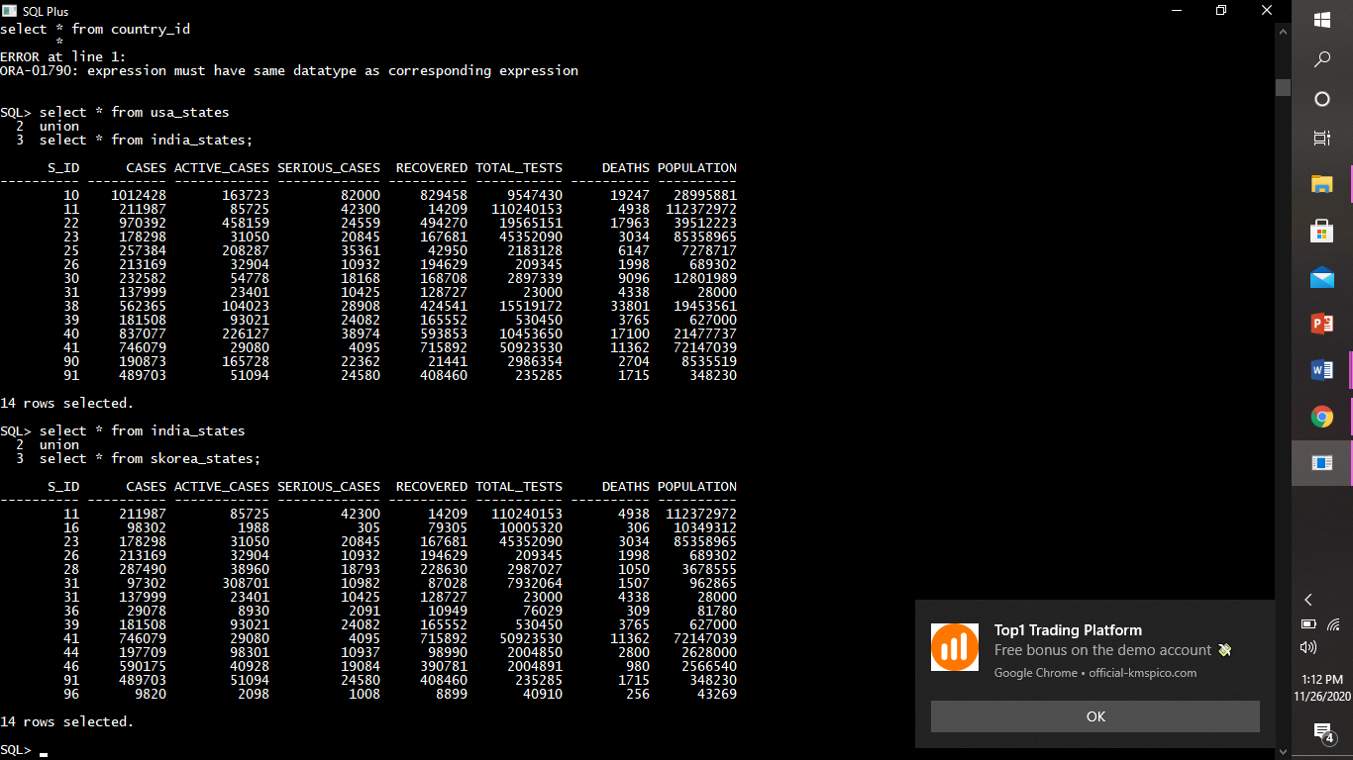

Union All : UNION and UNION ALL are similar in their functioning with a slight difference. But UNION ALL gives the result set without removing duplication and sorting the data. For example,in above query UNION is replaced by UNION ALL to see the effect.

***Example:***

This query combine two tables i.e sid_india and sid_skorea and display the records of both the tables.

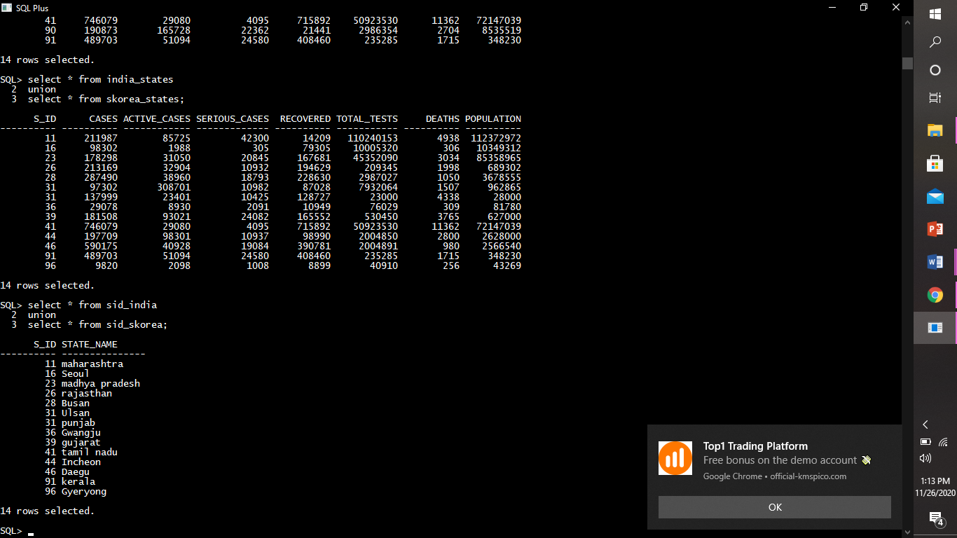

range searching operators (Between, Not Between):- In order to select data that is within a range of values, the BETWEEN operator is used. In order to select the data outside the range of values, the NOT BETWEEN operator is used.

***Example:***

This query displays the records from countries table where the no.of deaths are between 1800 and 4000.

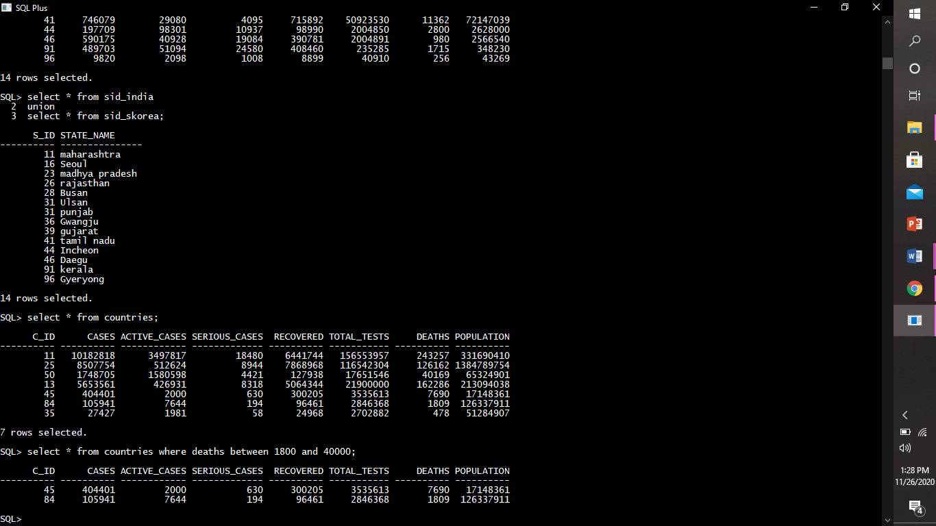

pattern matching operators (Like):-This operator is used to check whether a character string matches a specified pattern or not.

The following example finds the state whose name starts with the letter “G “:

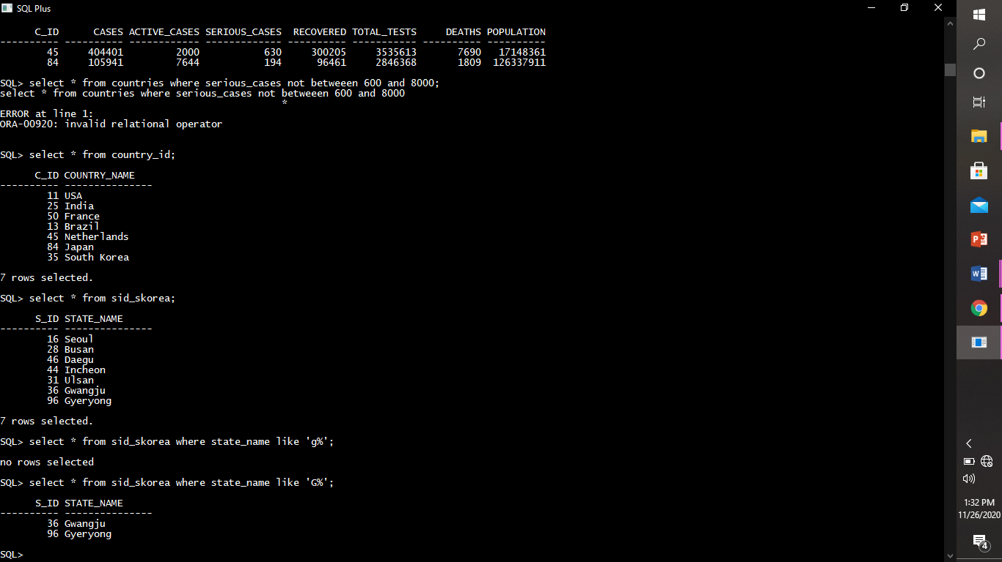

The following example finds the state whose name ends with the string “ce”:

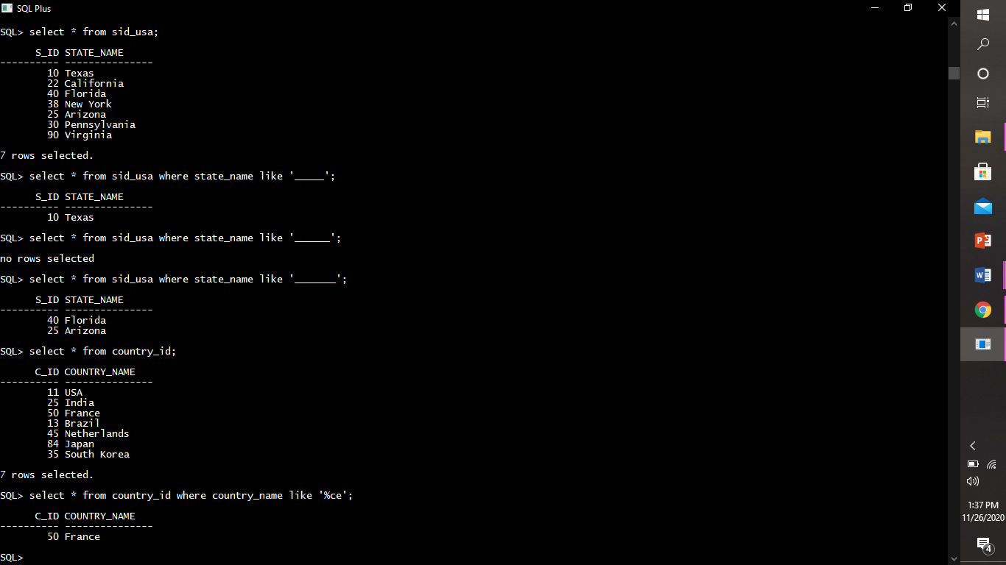

The following example finds the state whose name contains 7 letters only.

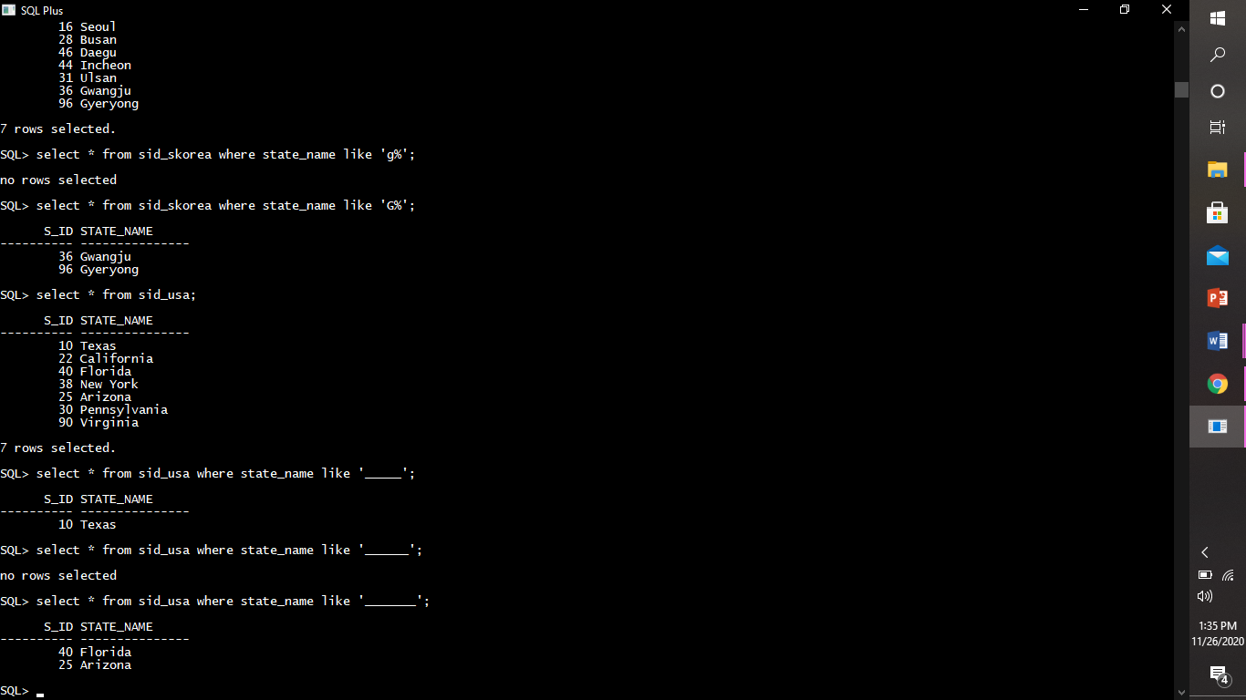

**sql built in functions**

column alias name: Column Aliases Are Used To Make Column Headings in Our Result Set Easier To Read.

***Example:***





table alias name: Table Aliases Are Used To Shorten Sql Query To Make It Easier To Read Or When We Are Performing A Join (i.e: Listing The Same Table More Than Once In The From Clause).

***Example:***

This query will display country id , country name and population from country id table and countries table.

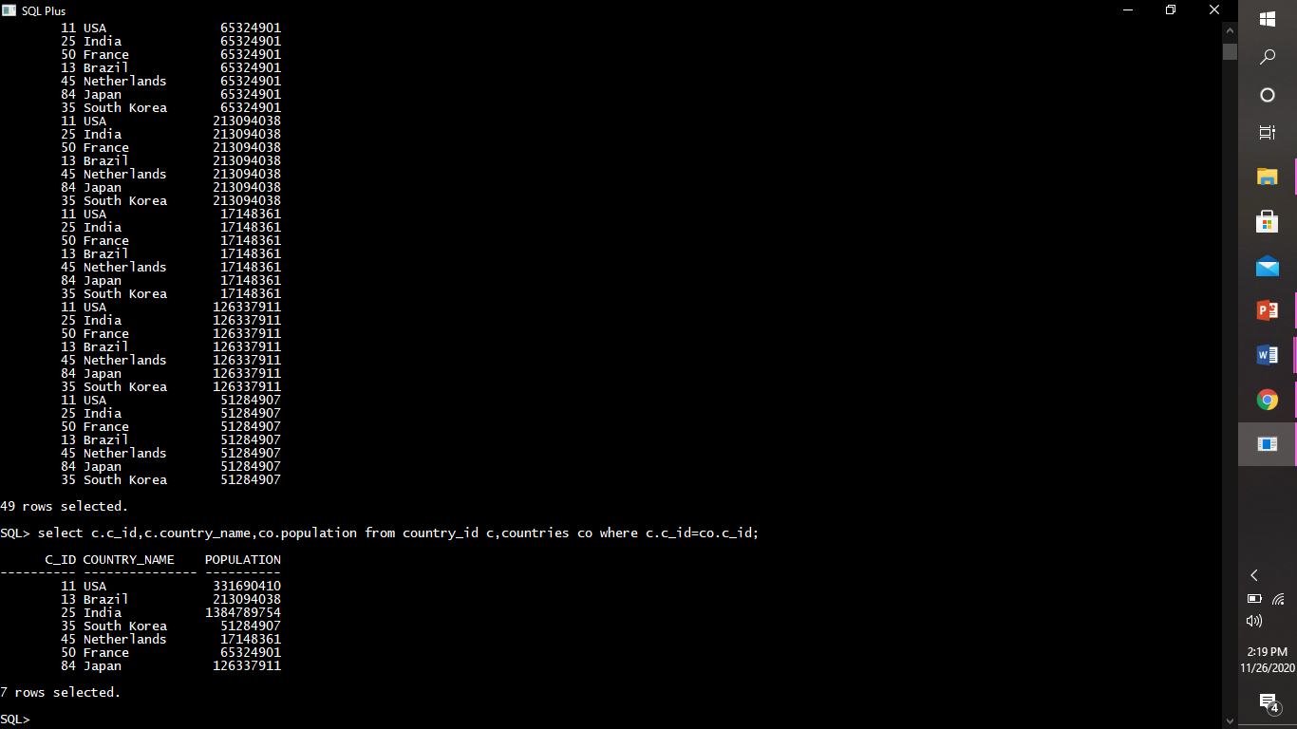

string functions :-

*Case Manipulation Function :*

1. **CONCAT:** Concatenates [joins] the first character value to the second character value; equivalent to concatenation operator (||).

Example:

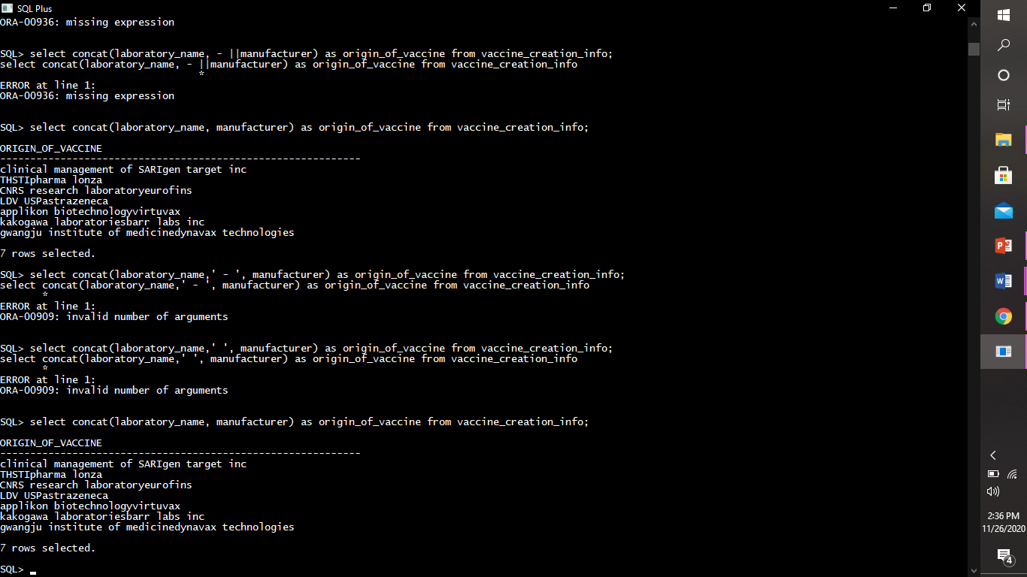

1. **SUBSTR:** Returns specific characters from character value starting at a specific character position and going specified character positions long.

Example:

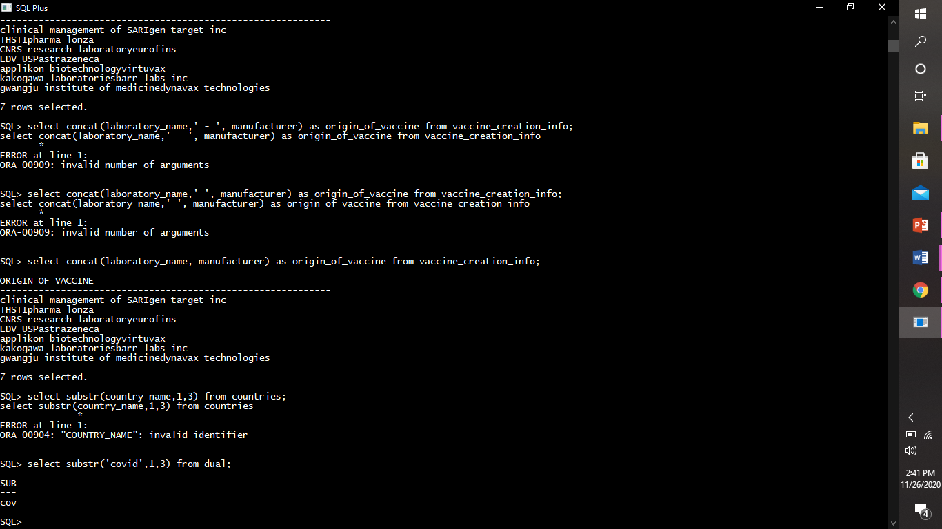

1. **INSTR:** Returns the numeric position of a named string.

Example:

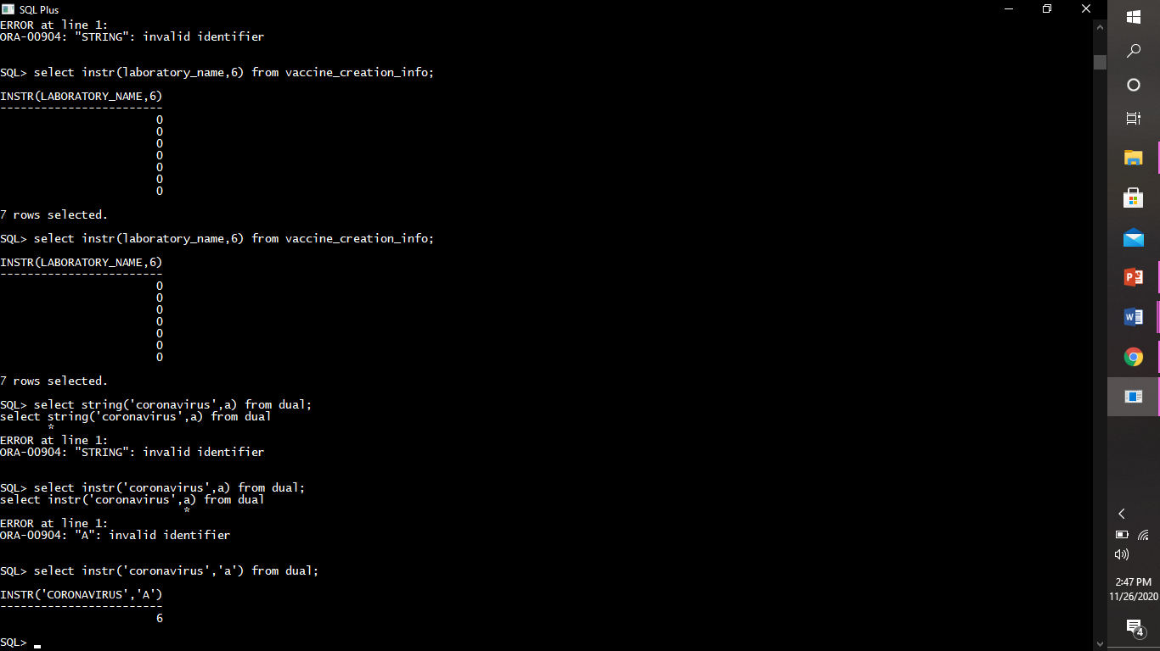

1. **LENGTH:** Returns the number of characters in the expression.

Example:

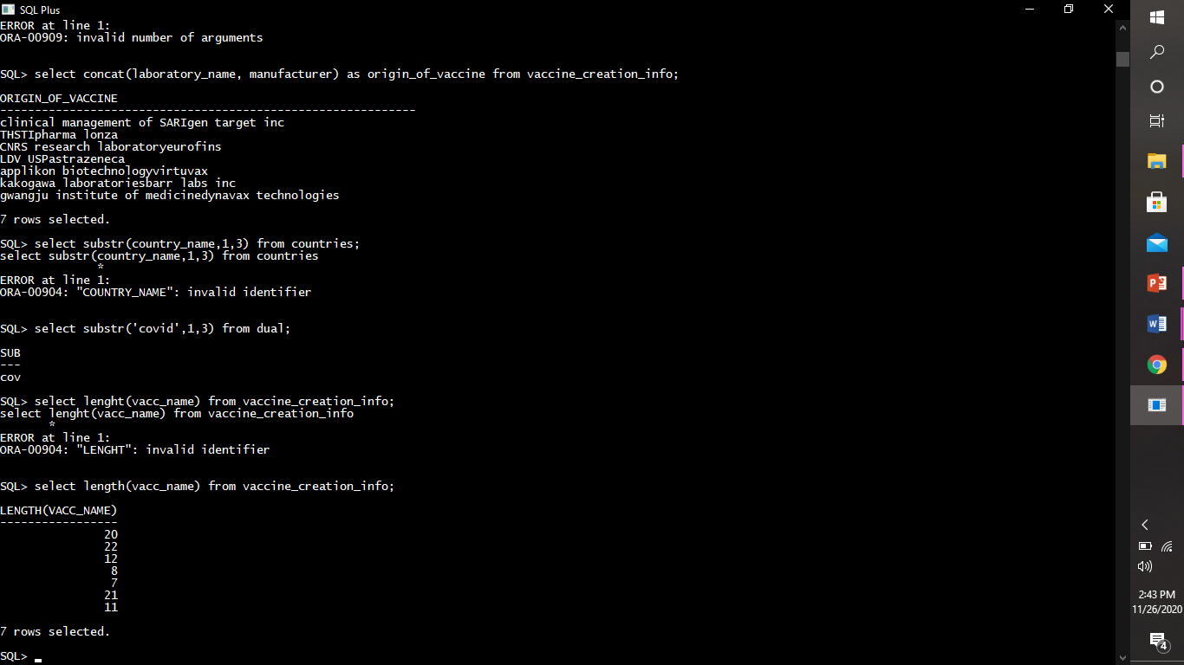

**Character Manipulation Function***:* The case-conversion functions perform letter case conversion on alphabetic characters. In the default locale, only the ASCII characters in the ranges A - Z and a - z can be modified by these functions, which enable you to perform case-insensitive searches in your queries and to specify the format of the output. The case-conversion functions are UPPER, LOWER, and INITCAP.

1)**UPPER :** The **UPPER** function accepts an expression argument and returns a character string in which every lowercase alphabetical character in the expression is replaced by a corresponding uppercase alphabetic character.

Example:

This query will display the names of states in capital letters (upper case) from sid_india table.

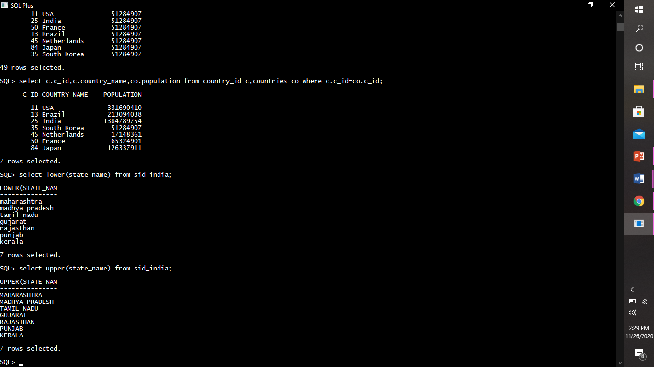

2)**LOWER :** The **LOWER** function accepts an expression argument and returns a character string in which every uppercase alphabetic character in the expression is replaced by a corresponding lowercase alphabetic character.

***Example:***

This query will display the names of states in lower case from sid_india table.

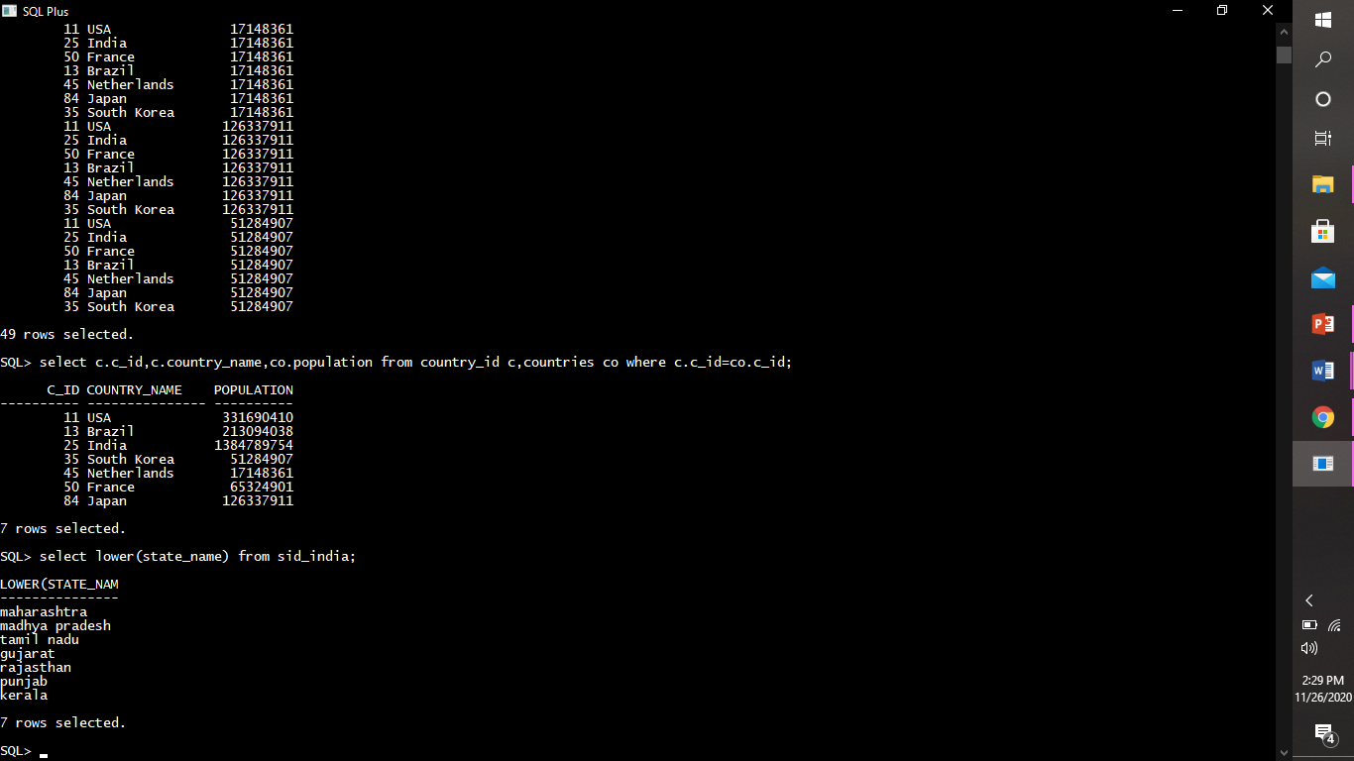

3)**INITCAP :** The **INITCAP** function returns a copy of the expression in which every word in the expression begins with an uppercase letter. With this function, a word begins after any character other than a letter. Thus, in addition to a blank space, symbols such as commas, periods, colons, and so on, introduce a new word.

***Example:***

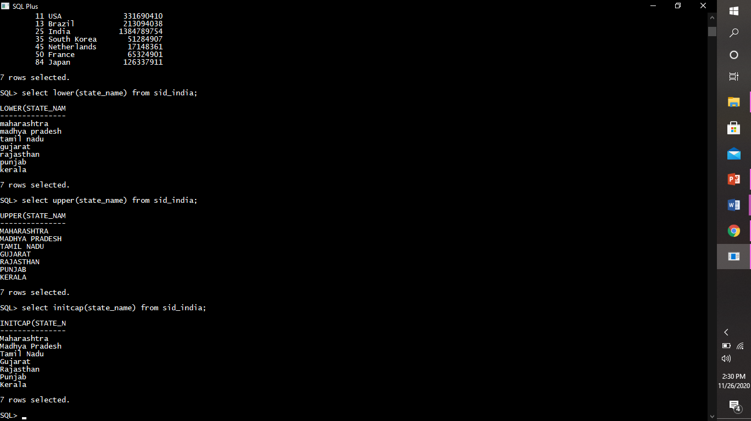

arithematic functions: A mathematical function executes a mathematical operation usually based on input values that are provided as arguments, and return a numeric value as the result of the operation.

count:

Example:

This query will display the total no. of countries in country_id table.

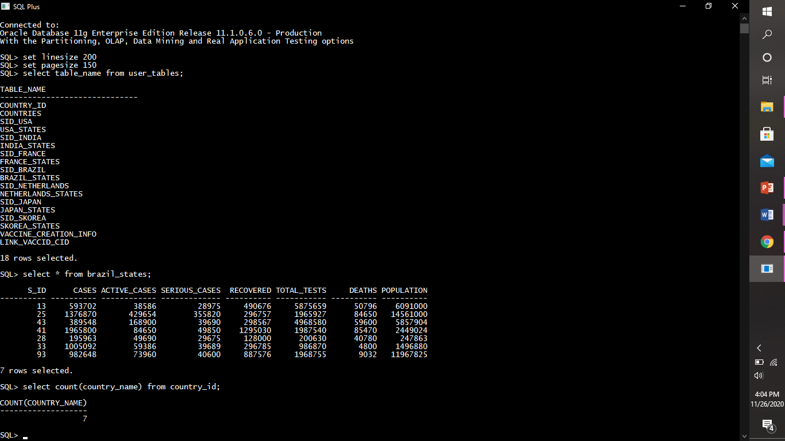

max:

Example:

This query will display the maximum population from countries table.

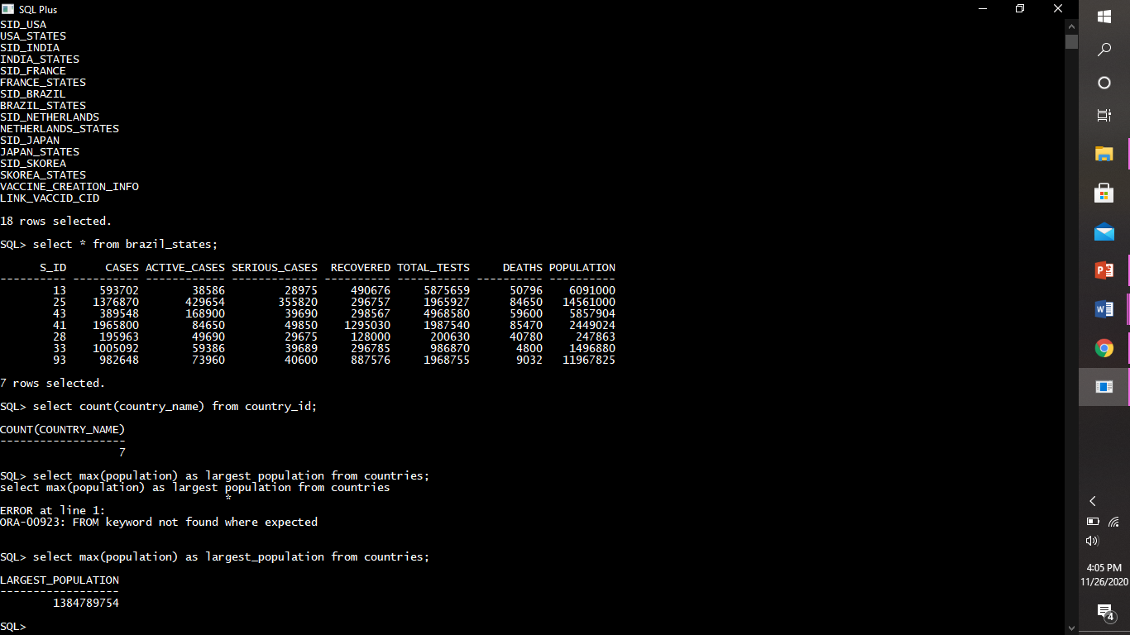

min:

Example: This query will display the minimum population from countries table.

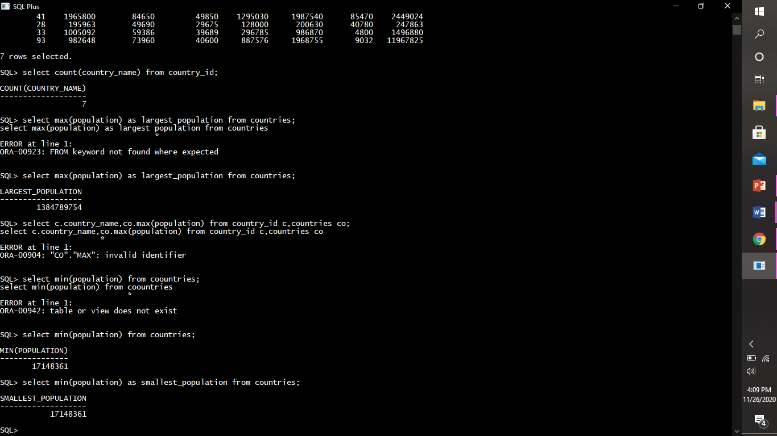

date & time functions: Date and time functions operate on a date and time input value and return a string, numeric, or date and time value.

Example:

1)Addmonths

This query will add 100 months in testing_date row from vaccine_creation_info table and display the records.

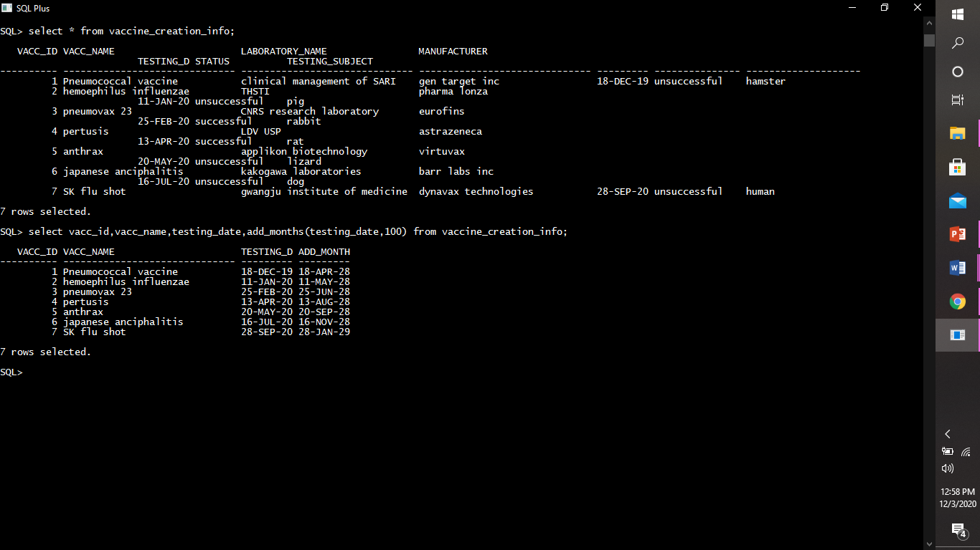

2)To_char

This query will display the years in words from vaccine_creation_info table.

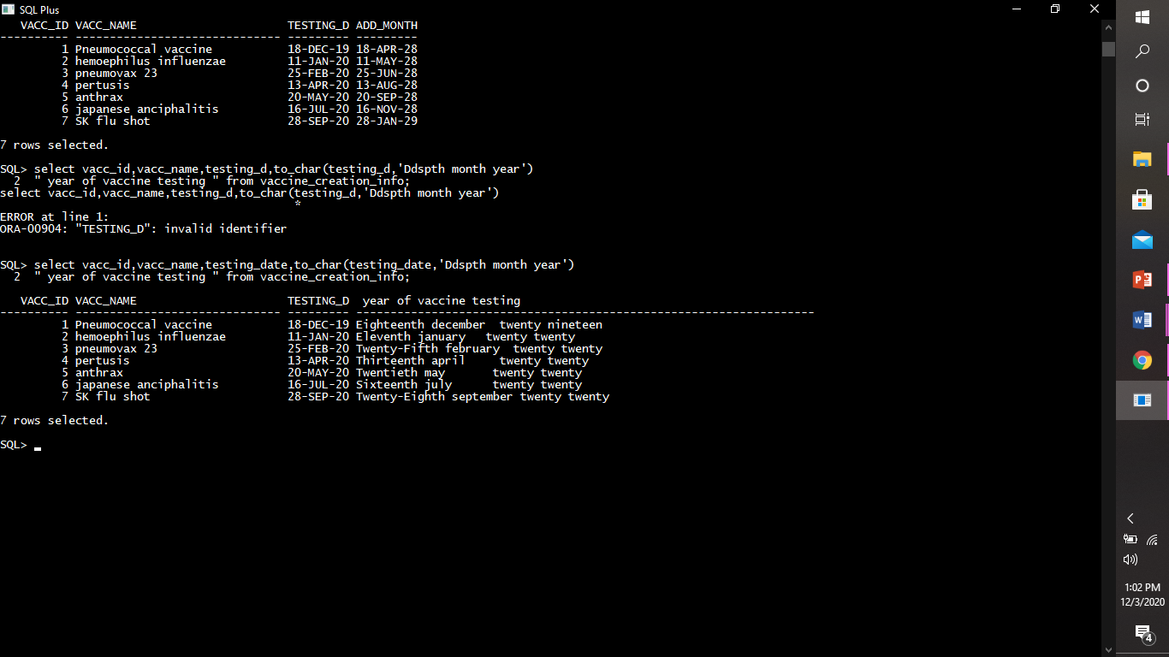

aggregate functions: SQL aggregation function is used to perform the calculations on multiple rows of a single column of a table. It returns a single value.

Example:

1)Sum

This query will add the population from countries table and display the records.

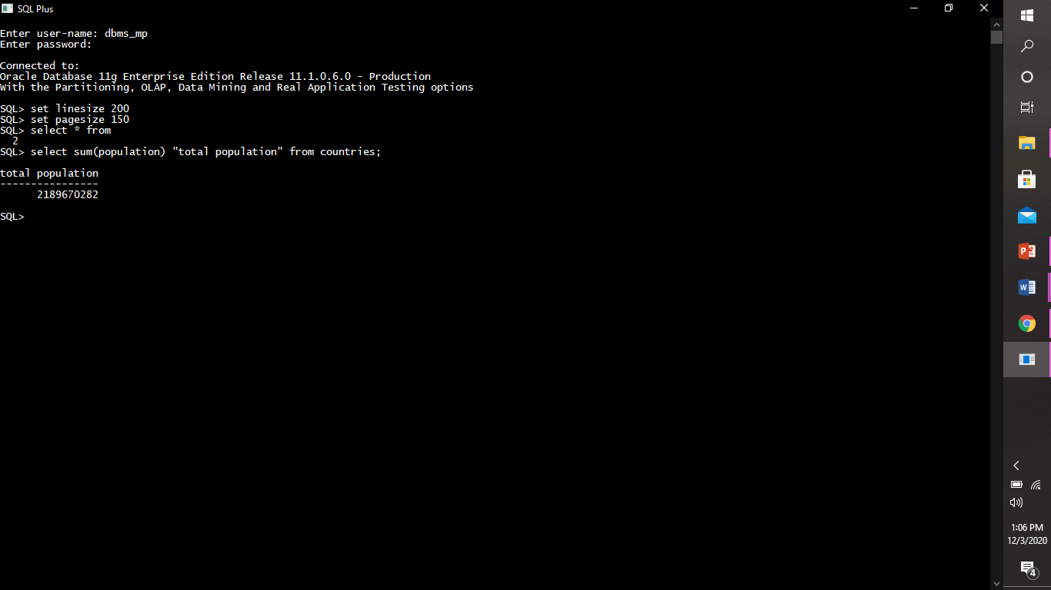

2)Avg

This query displays the average population from countries table.

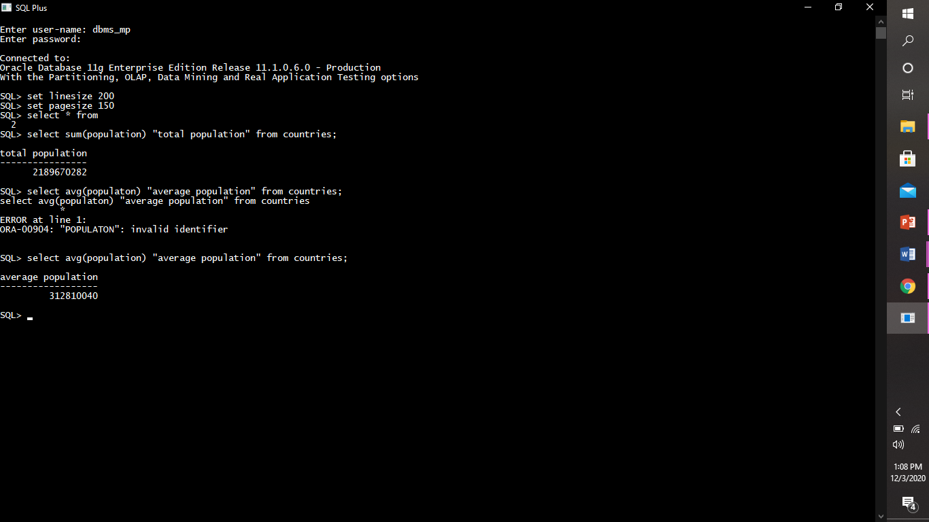

**clause.**

order by clause: The WHERE clause is used to filter records.The WHERE clause is used to extract only those records that fulfill a specified condition.

Example:

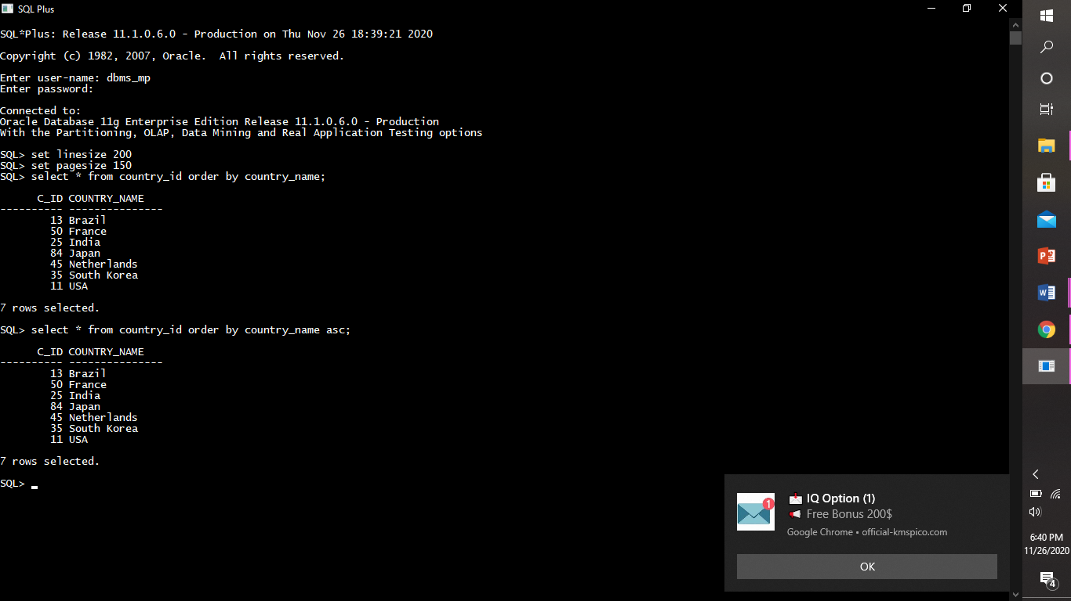

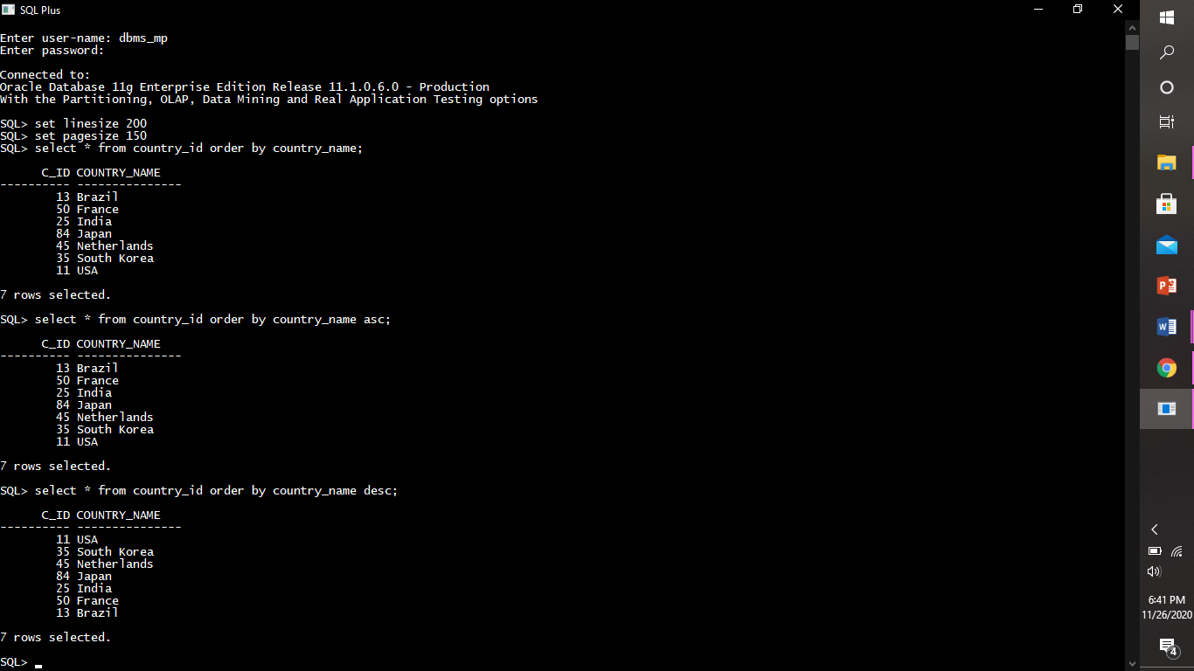

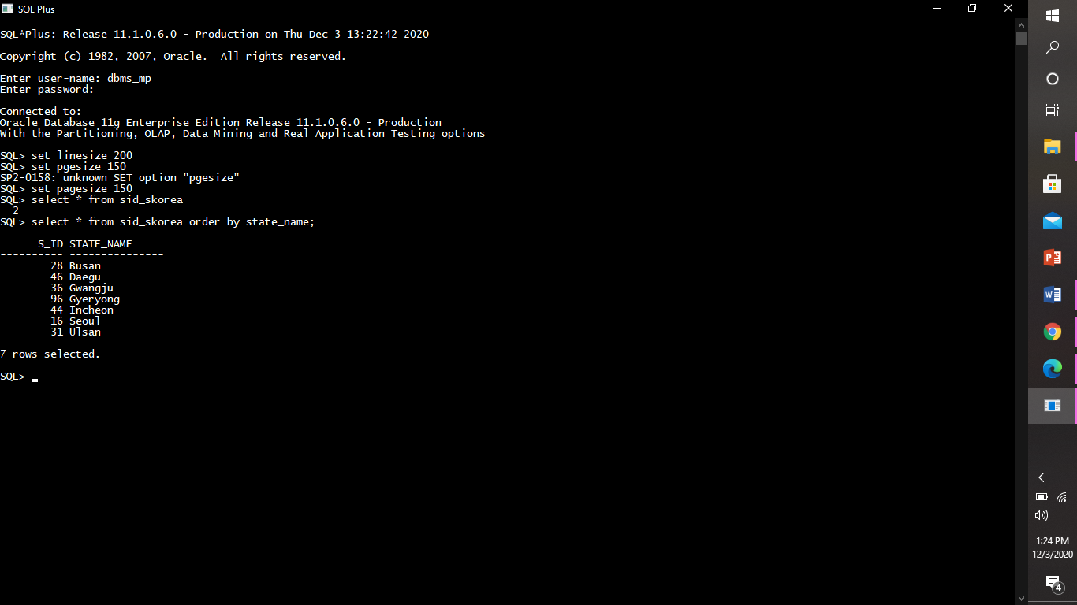

group by clause: The SQL GROUP BY clause is used in collaboration with the SELECT statement to arrange identical data into groups. This GROUP BY clause follows the WHERE clause in a SELECT statement. The GROUP BY statement is often used with aggregate functions (COUNT, MAX, MIN, SUM, AVG) to group the result-set by one or more columns.

Example:

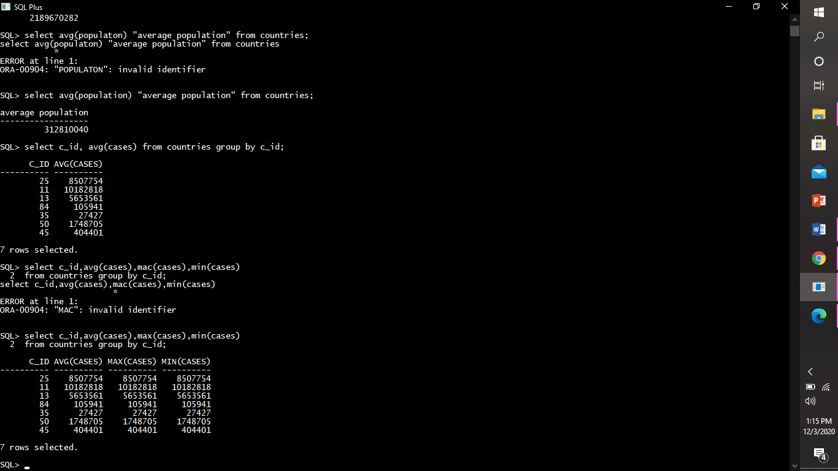

views.

In SQL, a view is a virtual table based on the result-set of an SQL statement. view contains rows and columns, just like a real table. The fields in a view are fields from one or more real tables in the database.

creating a view:

**SIMPLE VIEW:** Simple views can only contain a single base table.

***Example:***

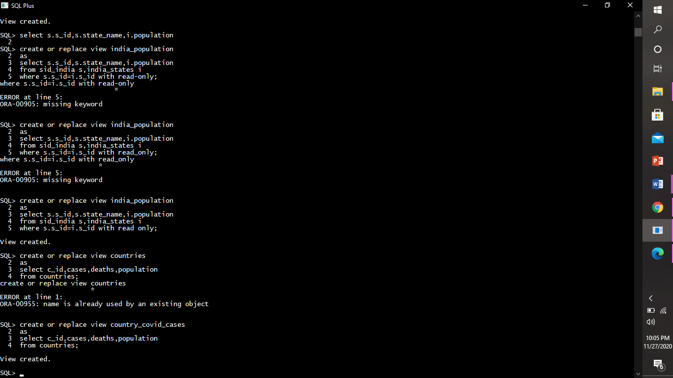

**COMPLEX VIEW:** Complex views can be constructed on more than one base table.

***Example:***

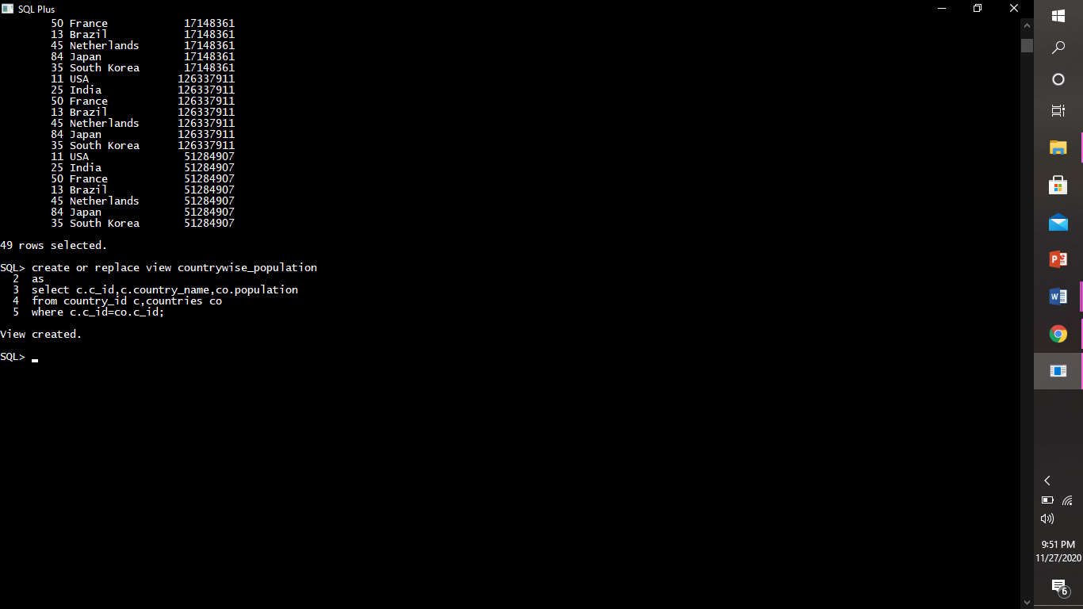

creating reAD ONLY view:

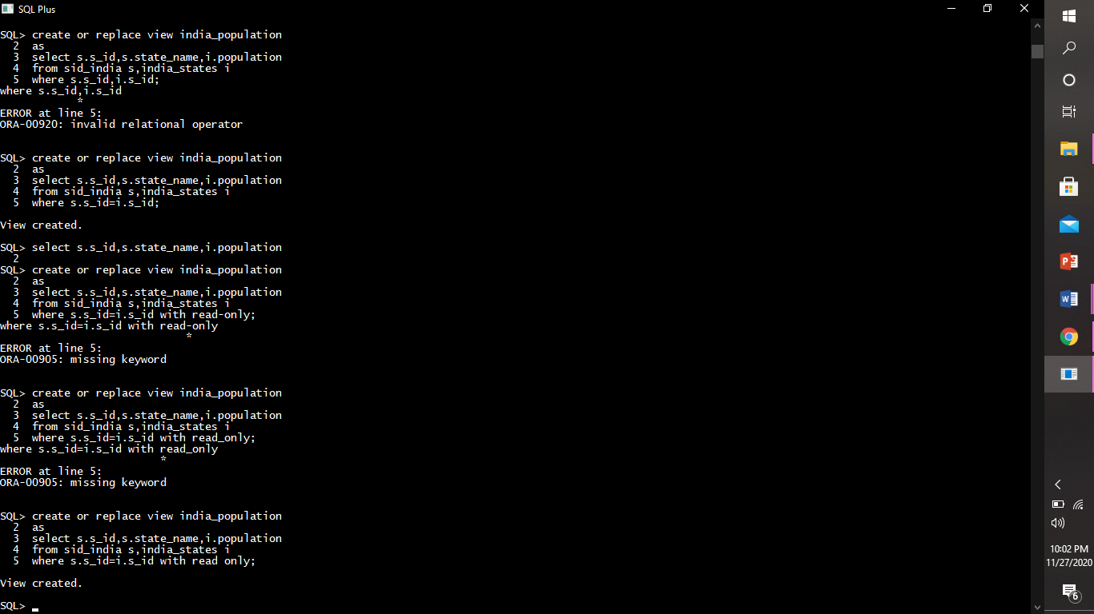

Displaying a view:

***Example:***

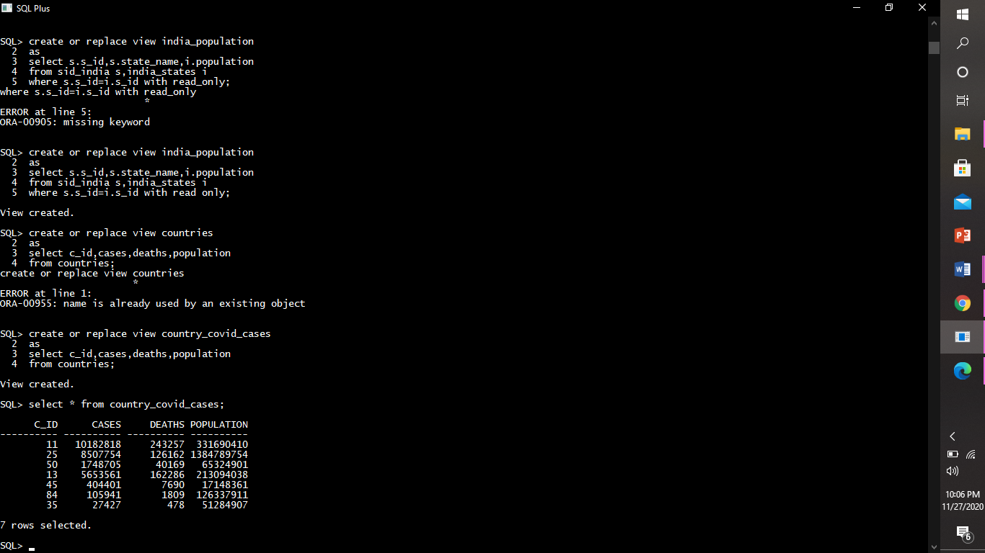

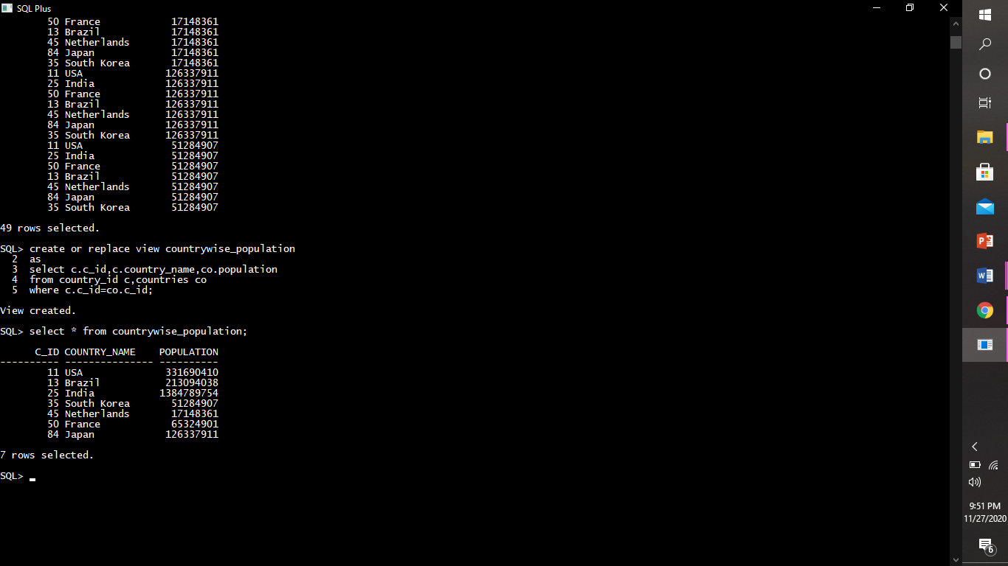

dropping a view:

***Example:***

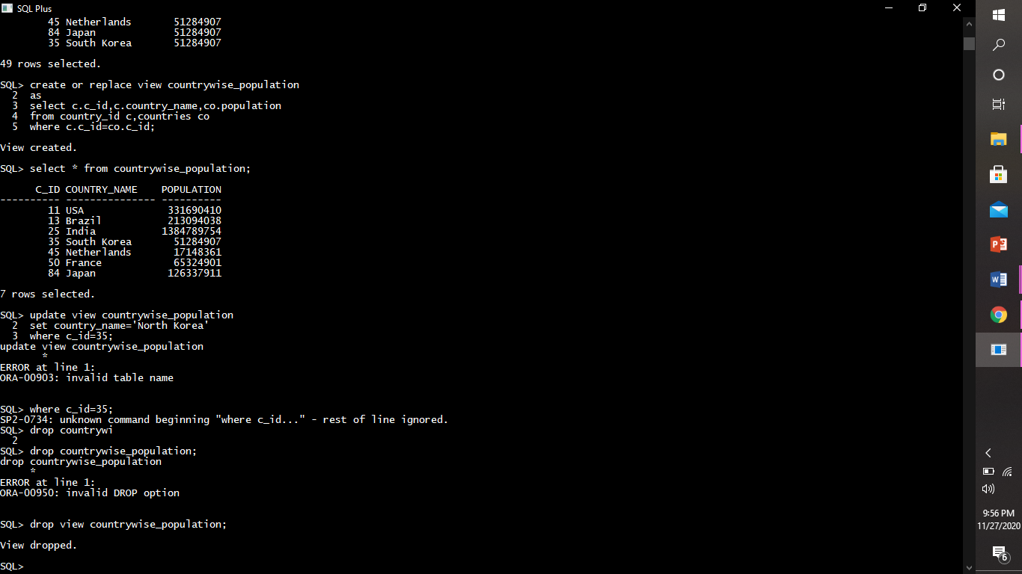

sequences.

A sequence is a set of integers 1, 2, 3, ... that are generated in order on demand. Sequences are frequently used in databases because many applications require each row in a table to contain a unique value and sequences provide an easy way to generate them.

We have created a dummy table seq_ex to implement sequence.

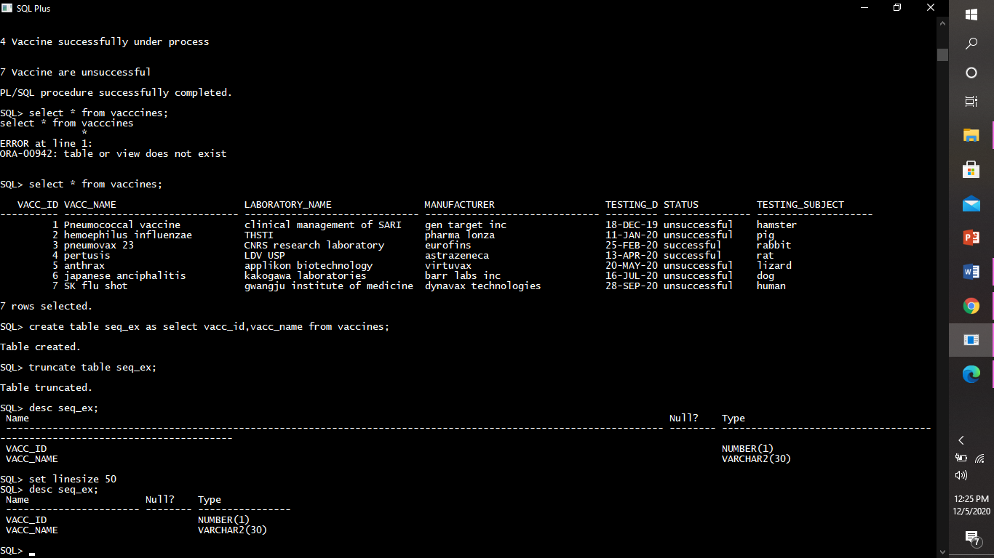

creating sequences

Creating a sequence which will start by 1, increment by 1, with maximum value 10.

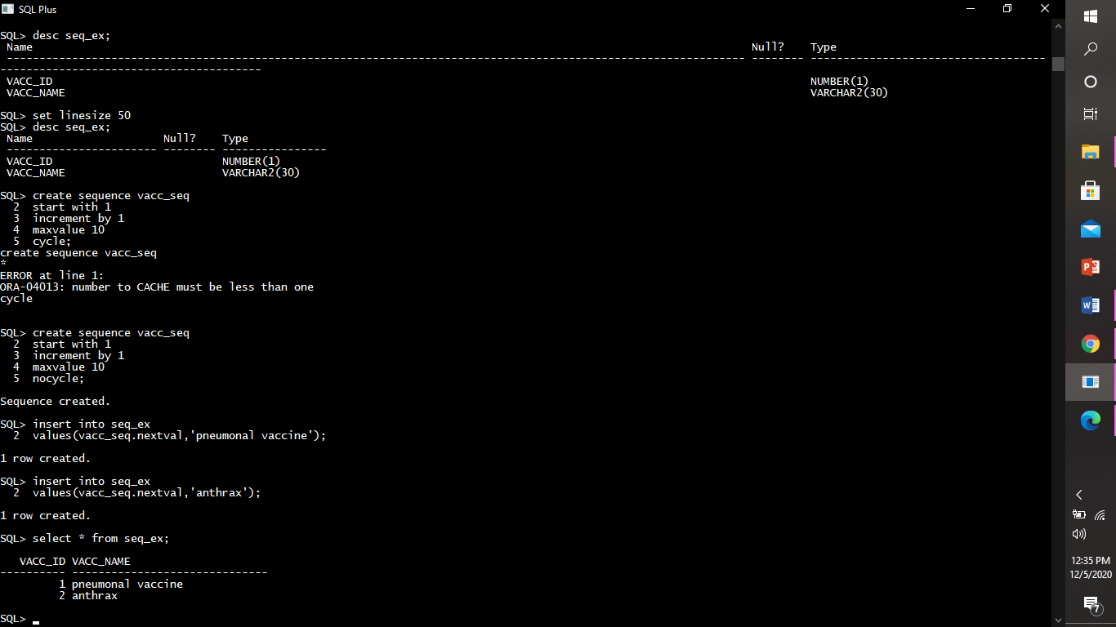

USING SEQUENCES

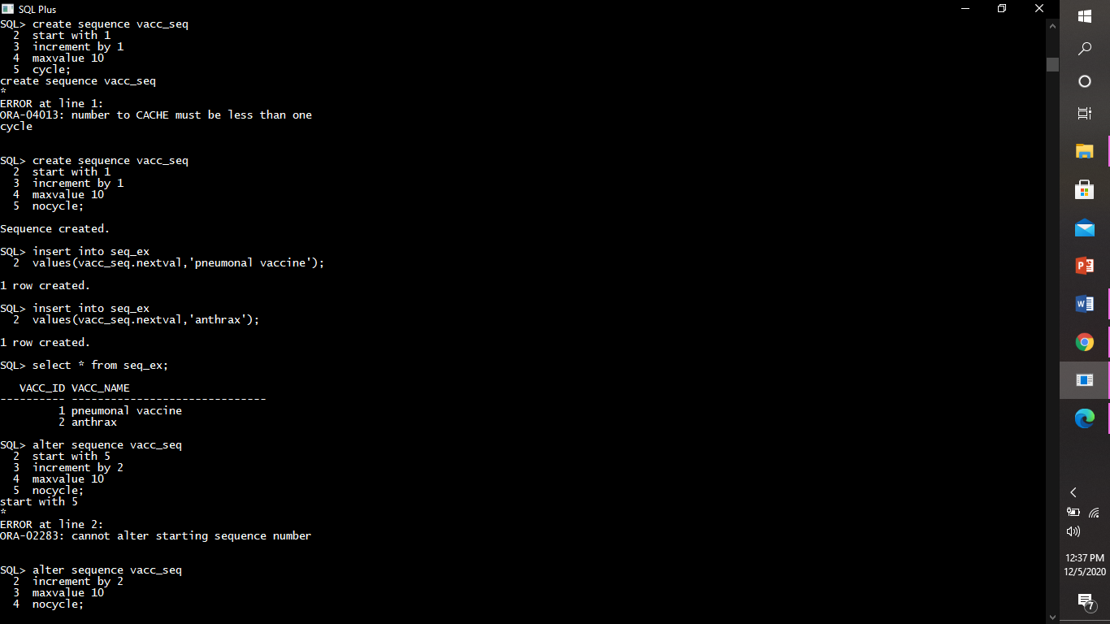

altering sequences

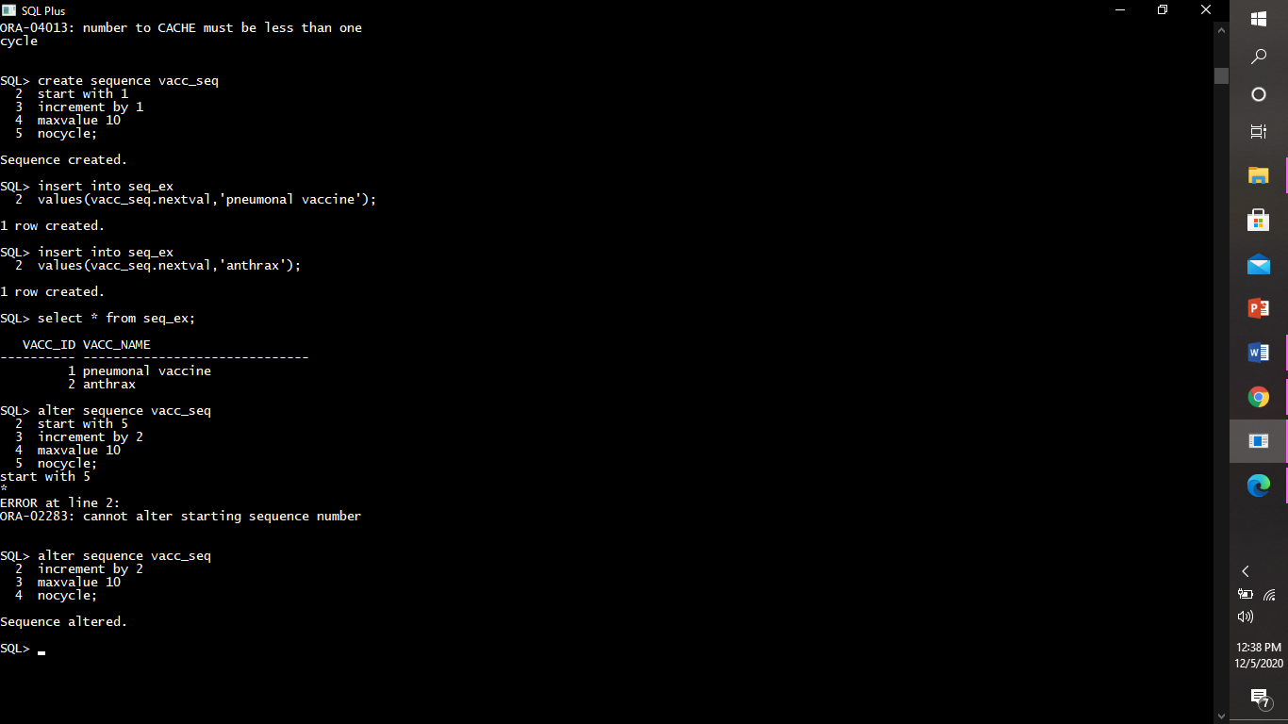

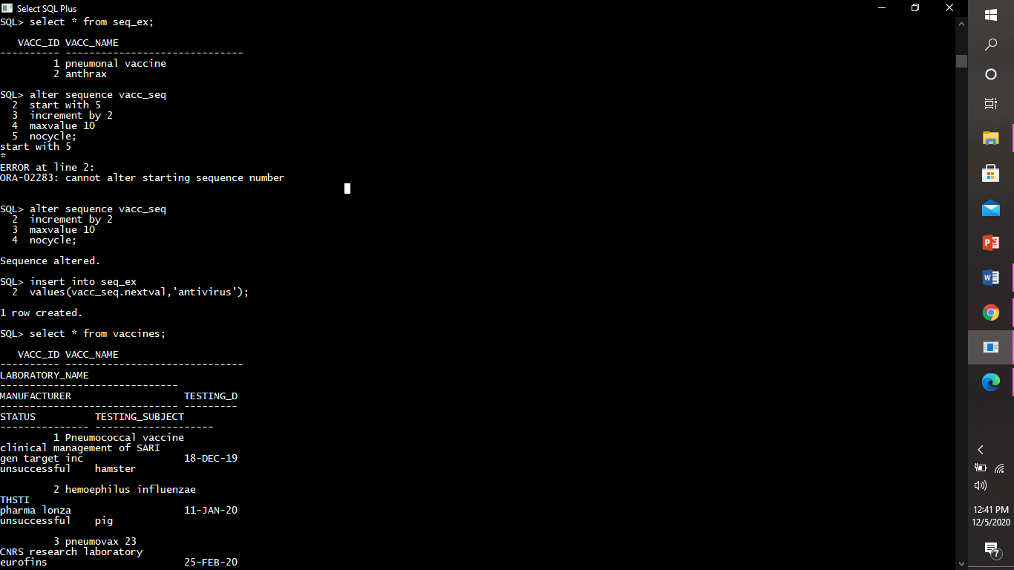

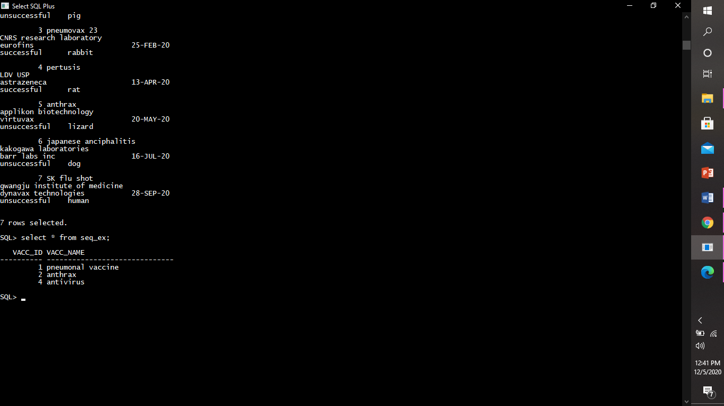

dropping sequence

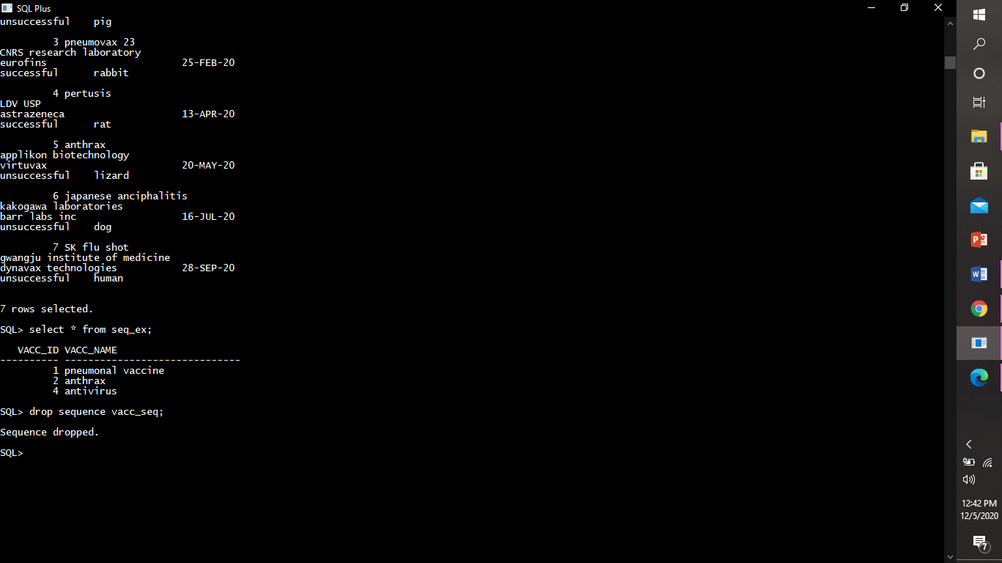

indexes.

Indexes are used to retrieve data from the database very fast. The users cannot see the indexes, they are just used to speed up searches/queries.

creating a index : The create index  command is used to create indexes in tables (allows duplicate values).

types :-

1)simple column index: A single-column index should be created when retrieval will be executed using one column only as the key.

***Example:***

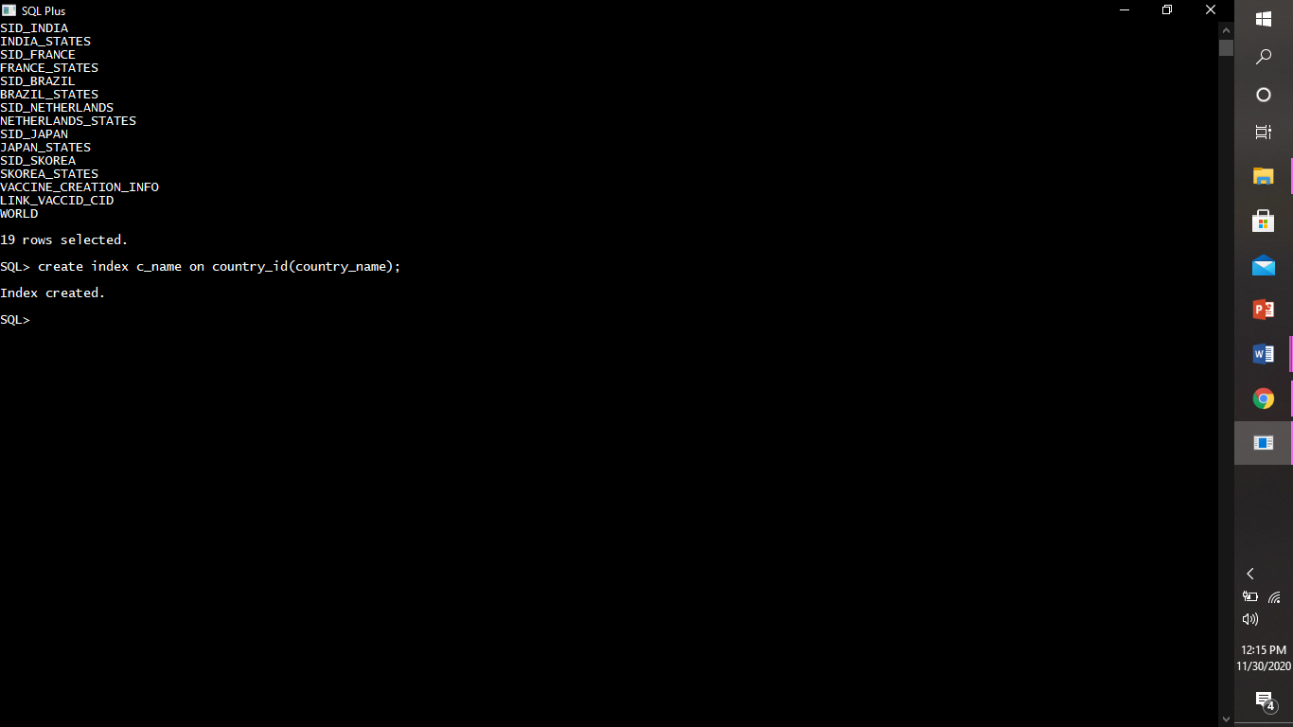

2)unique column index: Unique indexes are indexes that help maintain data integrity by ensuring that no two rows of data in a table have identical key values. When you create a unique index for an existing table with data, values in the columns or expressions that comprise the index key are checked for uniqueness.

***Example:***

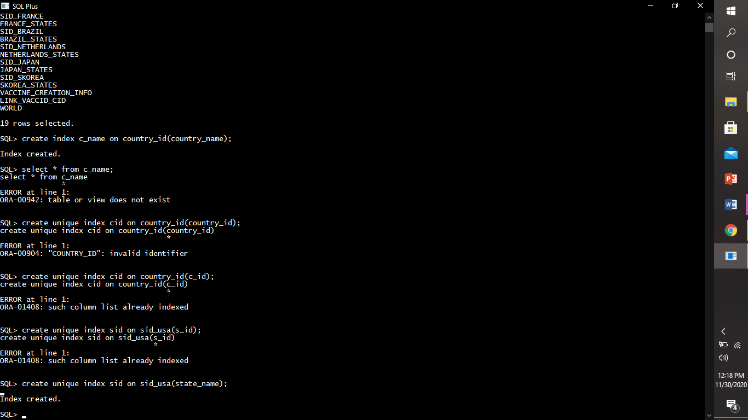

3)composite column index:A Composite Index Is An Index Which Is Created On Multiple Columns In A Table.

***Example:***

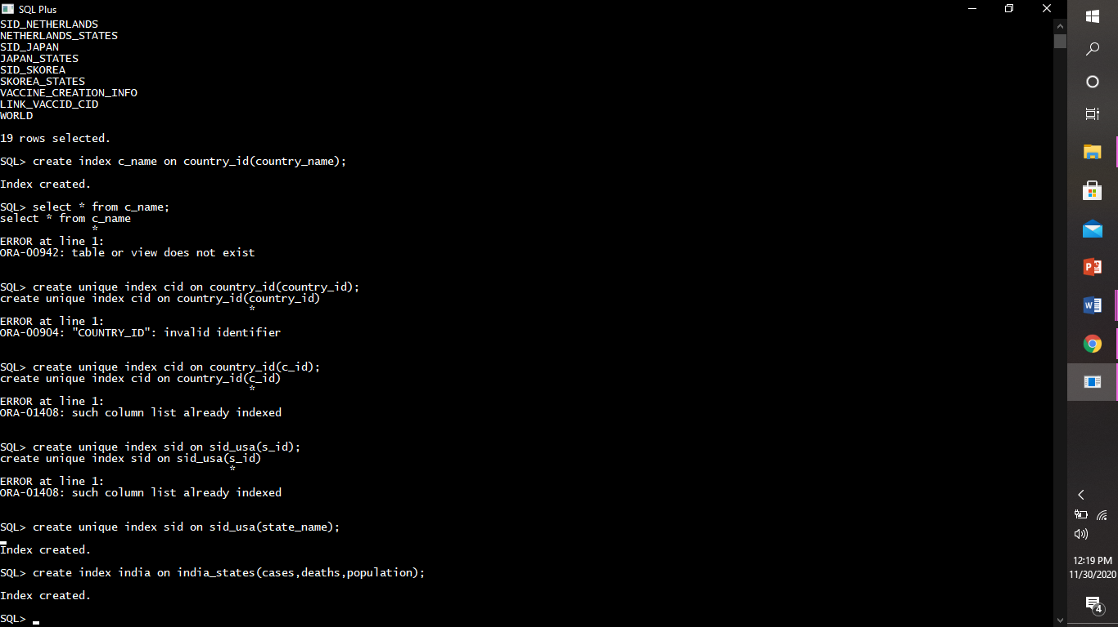

droping index: The Drop index command is used to delete an index in a table.

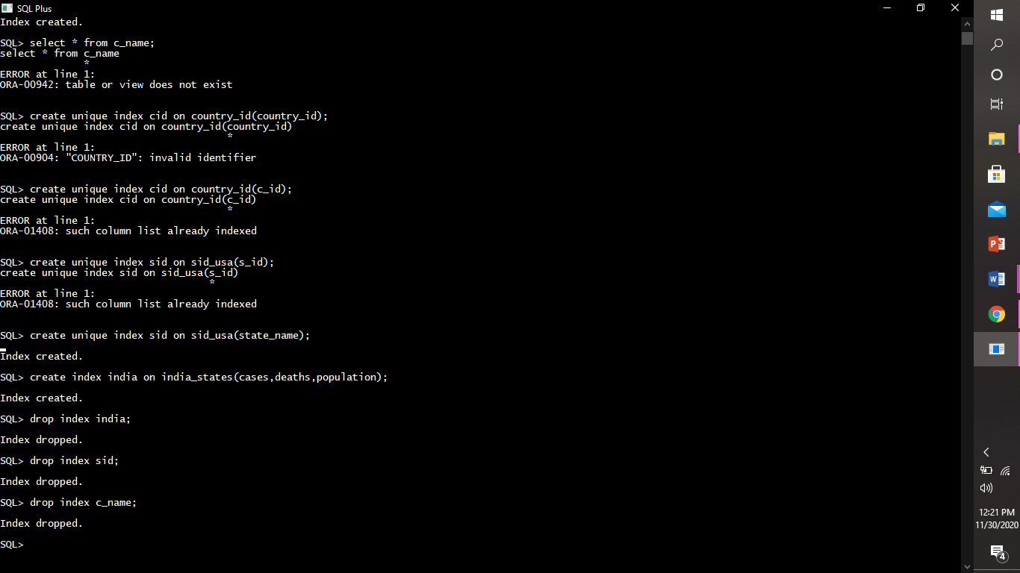

synonyms.

A **synonym** is an alternative name for objects such as tables, views, sequences, stored procedures, and other database objects. A synonym will make easy to access database objects owned by other users. Synonyms are used when you are granting access to an object from another schema.

creating synonyms

***Example:***

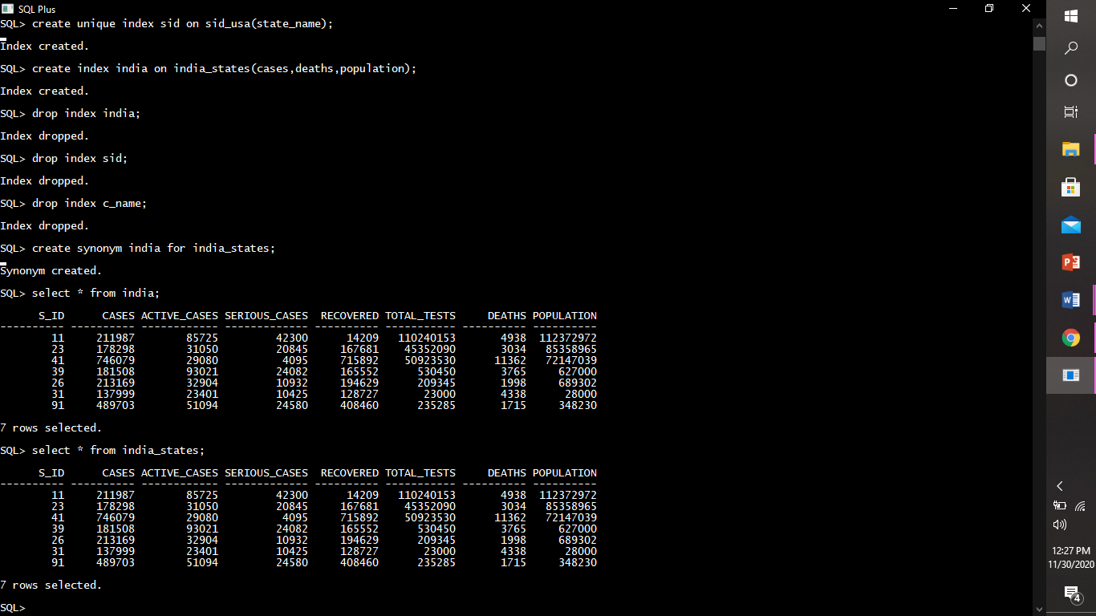



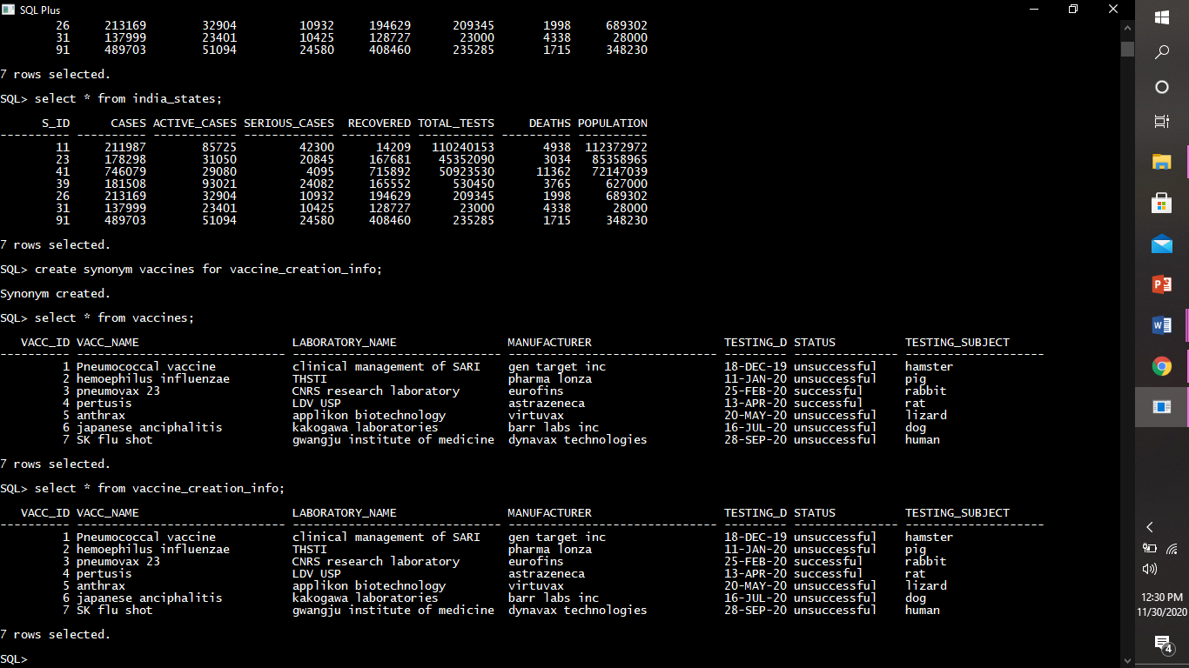



dropping synonyms

***Example:***

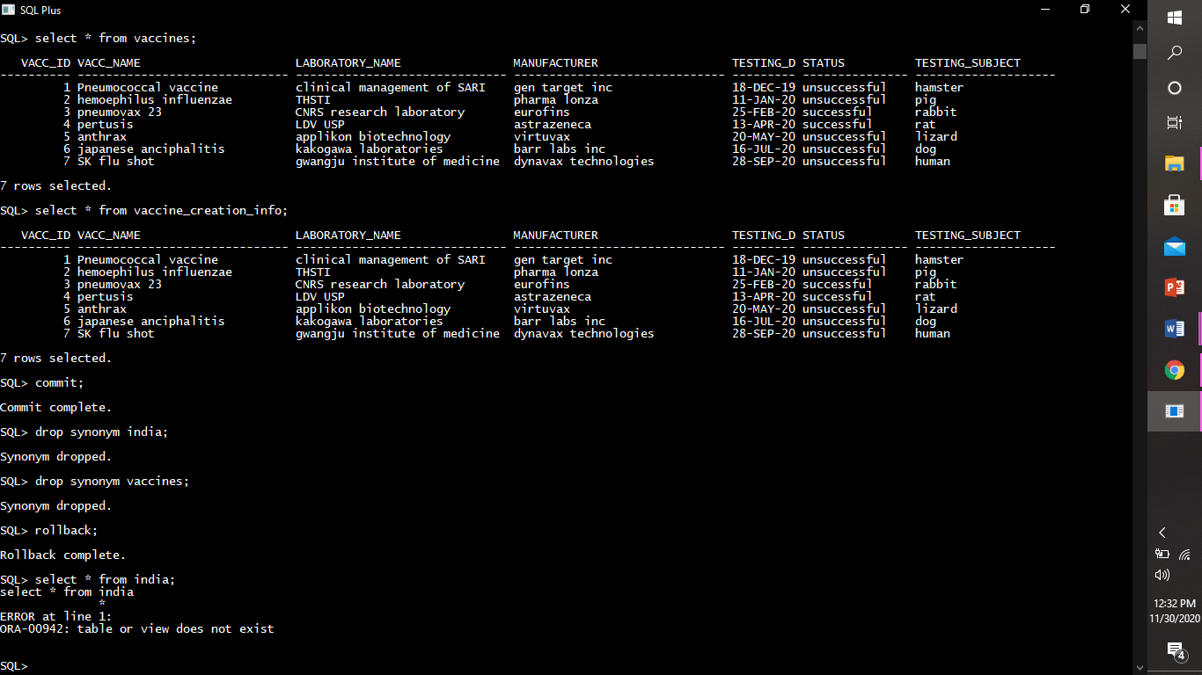

pl/sql programming

exeption handling: An exception is an error condition during a program execution. PL/SQL supports programmers to catch such conditions using EXCEPTION block in the program and an appropriate action is taken against the error condition.

* There are two types of exceptions −
* ***Pre-defined exceptions:*** PL/SQL provides many pre-defined exceptions, which are executed when any database rule is violated by a program. For example, the predefined exception *NO_DATA_FOUND* is raised when a *SELECT INTO* statement returns no rows.
* Example for predefined exception no_data_found.

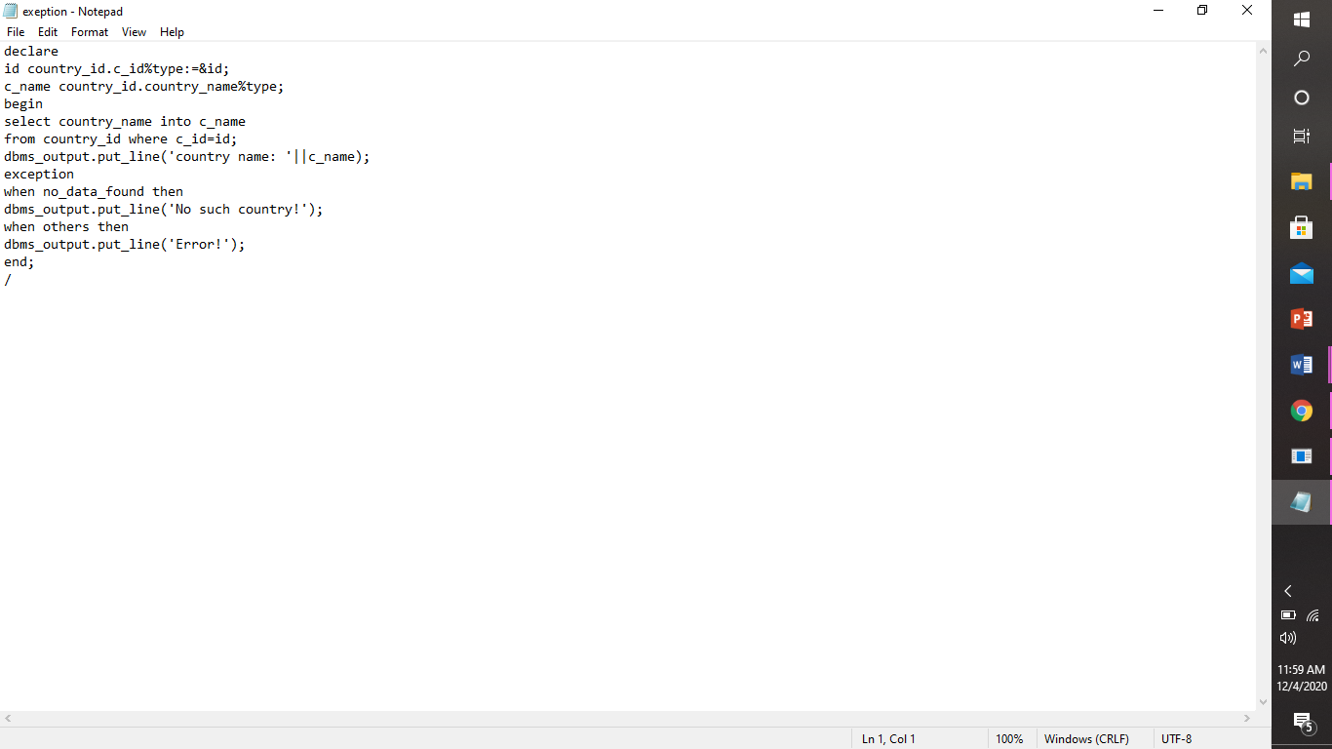

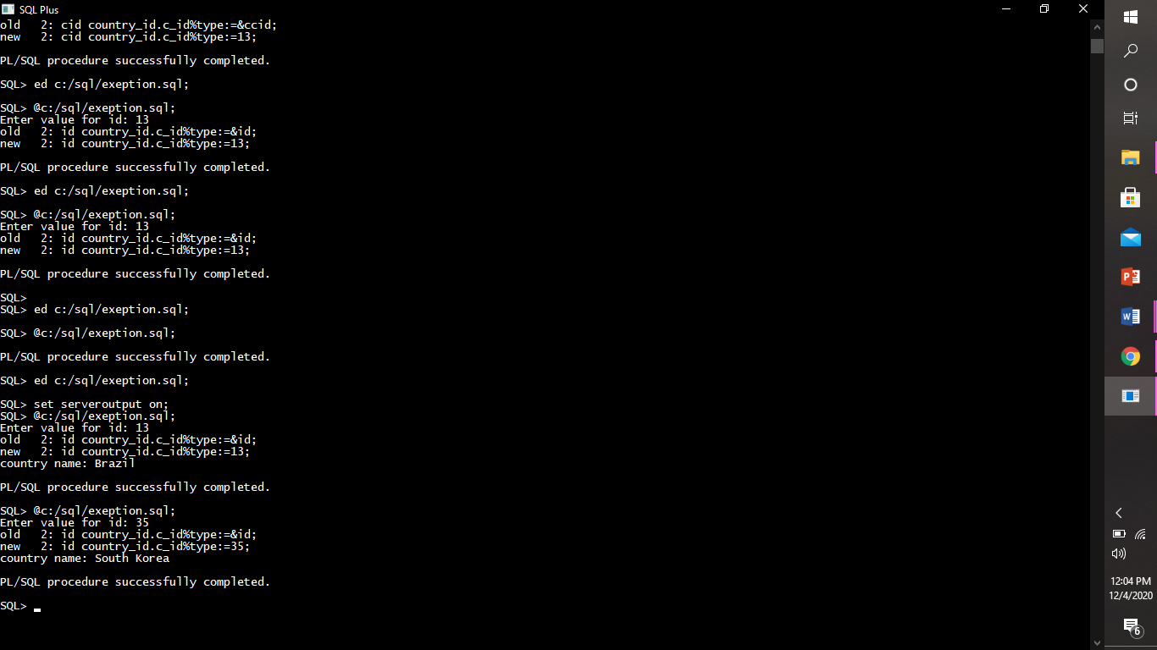

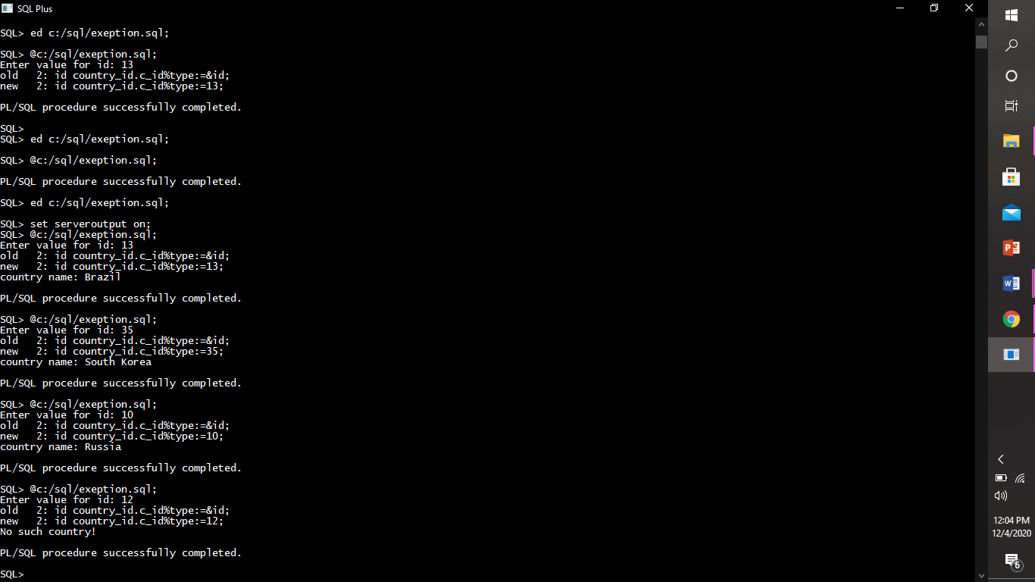

* Example for predefined exception too_many_rows.

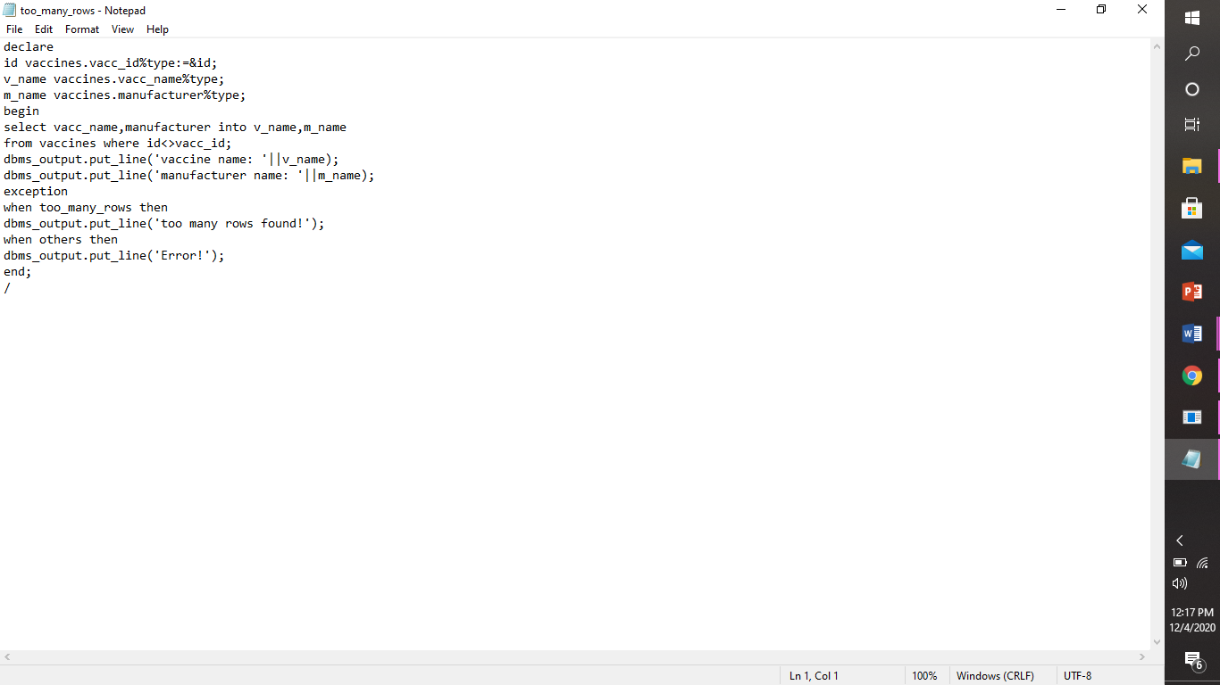

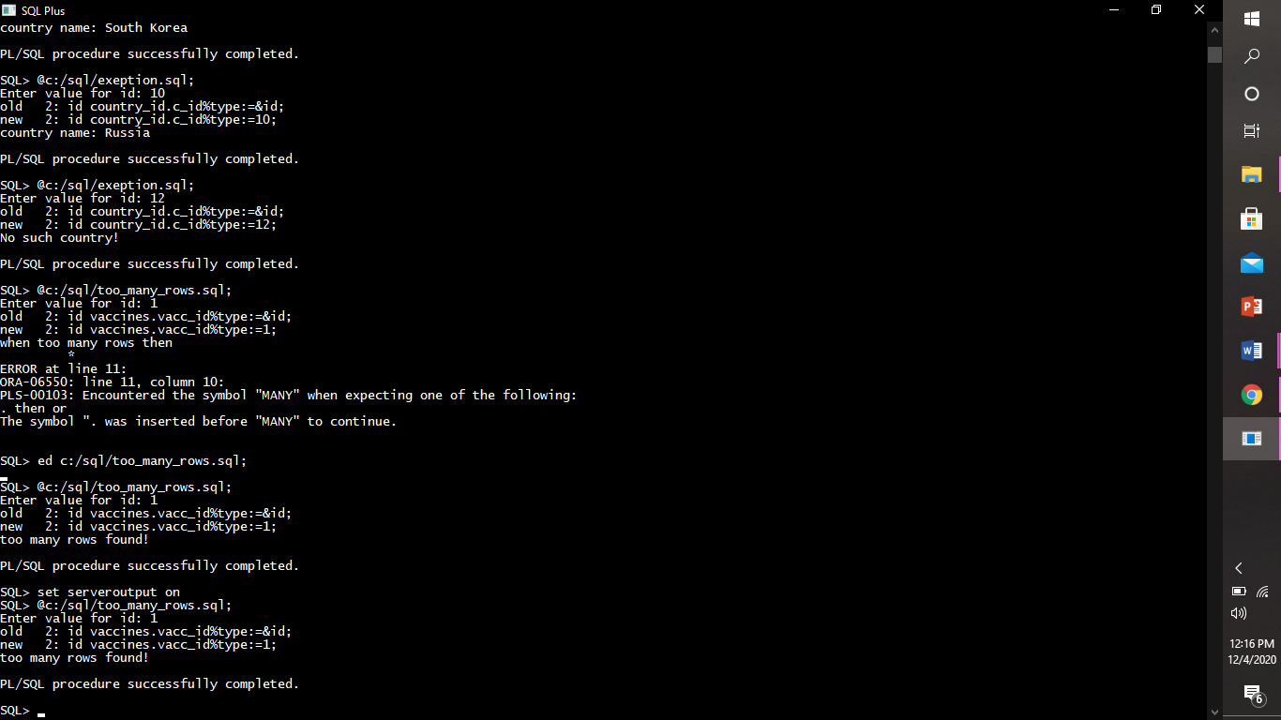

* ***User-defined exceptions:*** PL/SQL allows you to define your own exceptions according to the need of your program. A user-defined exception must be declared and then raised explicitly, using either a RAISE statement or the procedure *DBMS_STANDARD.RAISE_APPLICATION_ERROR*.

***Exapmle:***

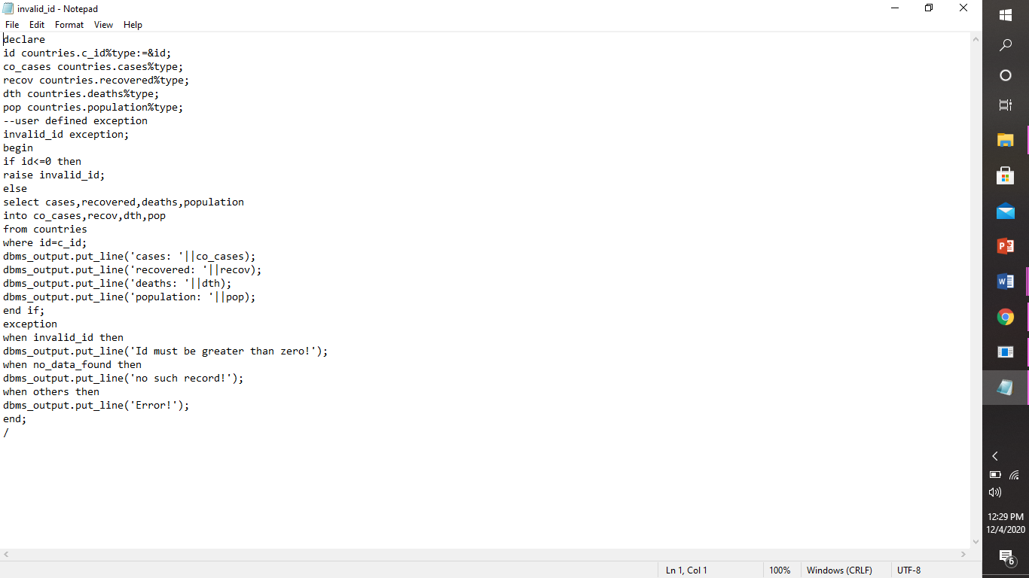

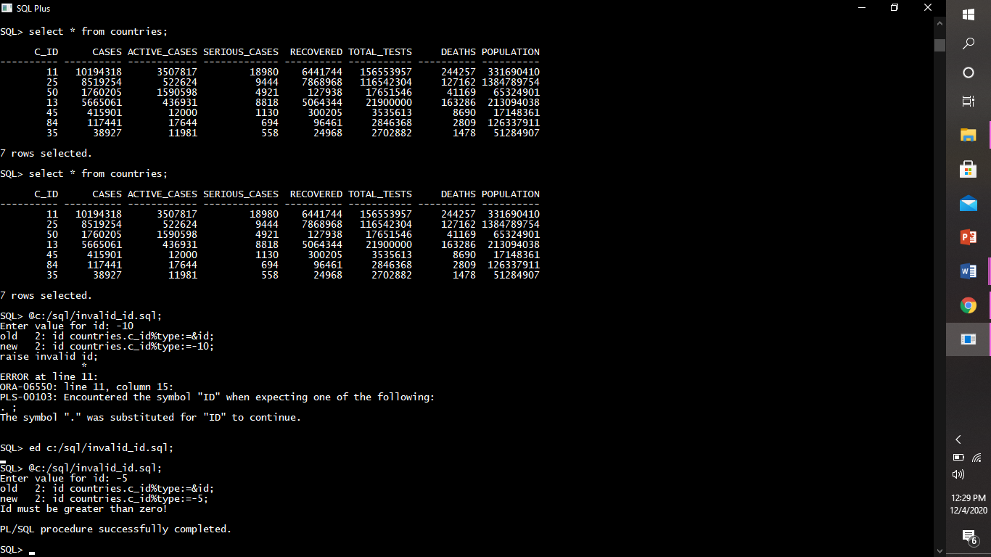

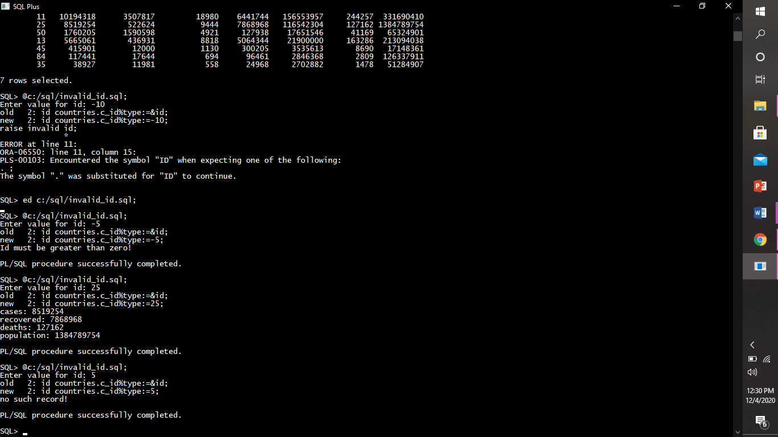

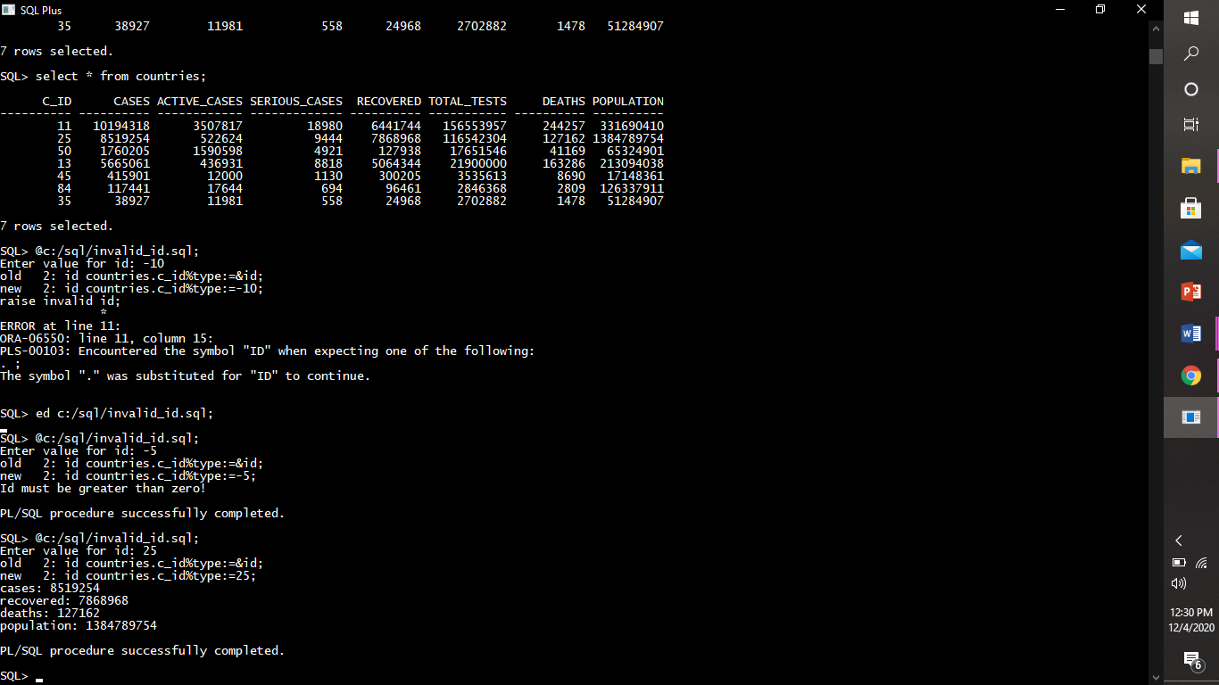

* cursors

A cursor is a temporary work area created in the system memory when a SQL statement is executed. A cursor contains information on a select statement and the rows of data accessed by it. This temporary work area is used to store the data retrieved from the database, and manipulate this data.

types:

* explicit cursor: Explicit cursors are programmer-defined cursors for gaining more control over the **context area**. An explicit cursor should be defined in the declaration section of the PL/SQL Block.

*Example:*

1. Cursor to print all countries’ record.

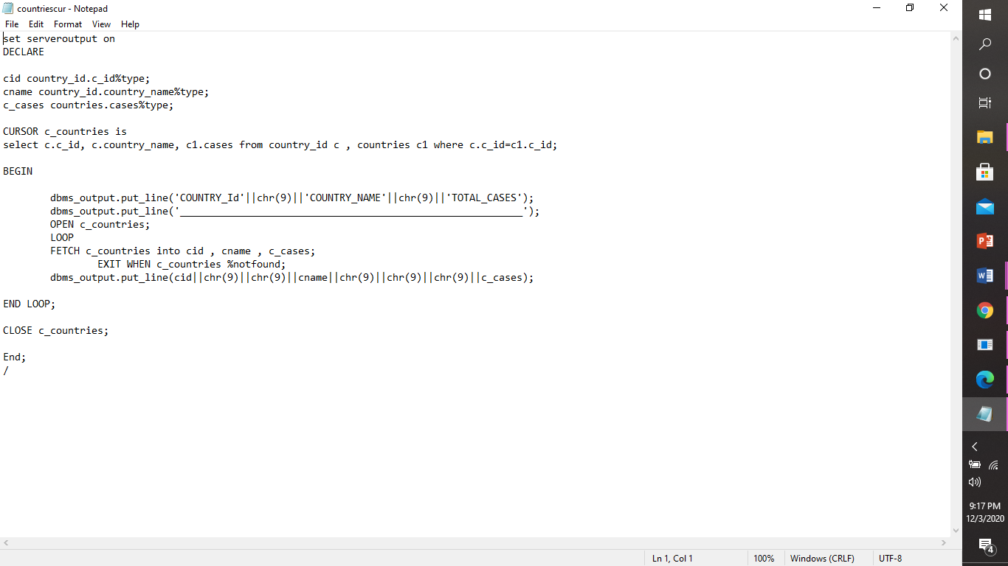

OUTPUT:

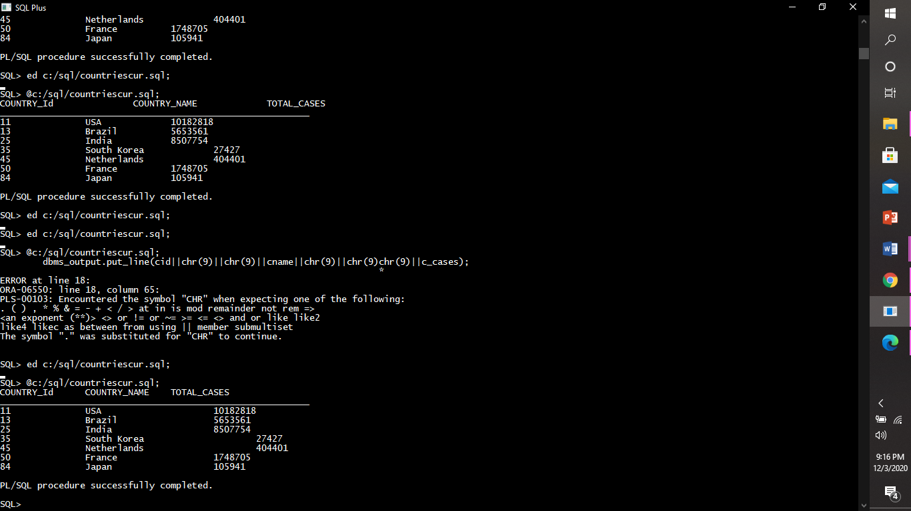

1. Cursor to update cases in countries and world table.

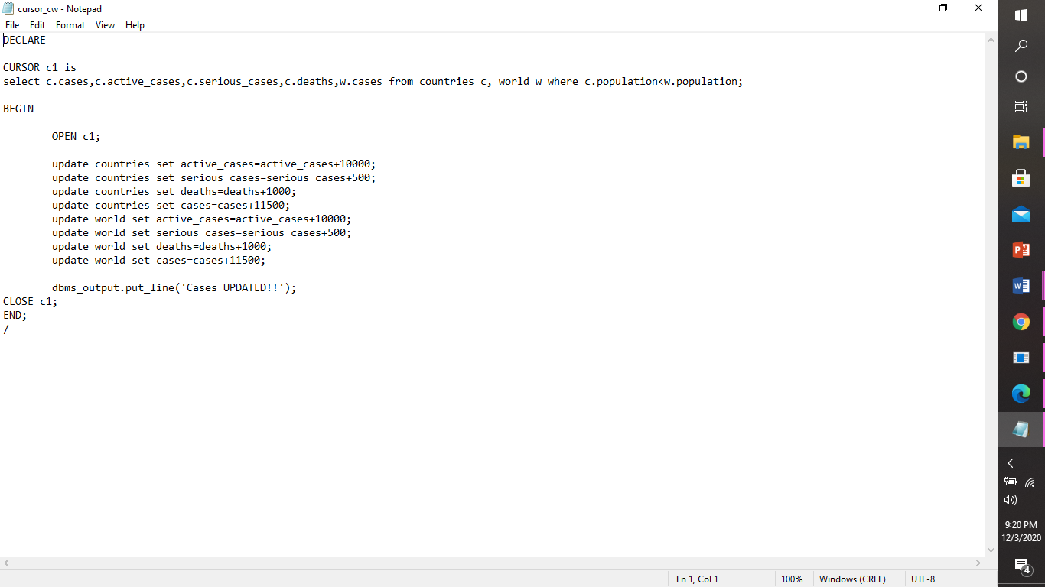

OUTPUT:

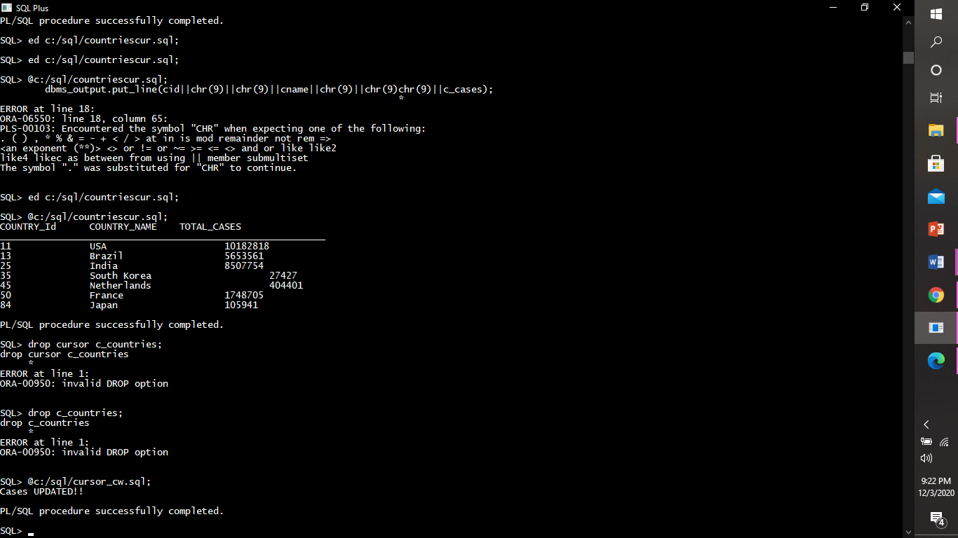

3.) Cursor to print data of vaccine_creation_info table in a formatted manner.

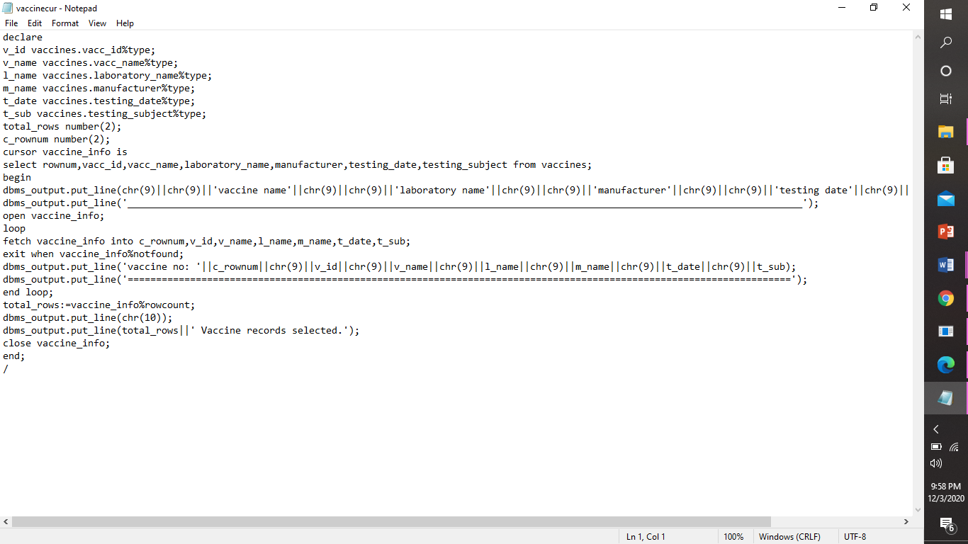

OUTPUT:

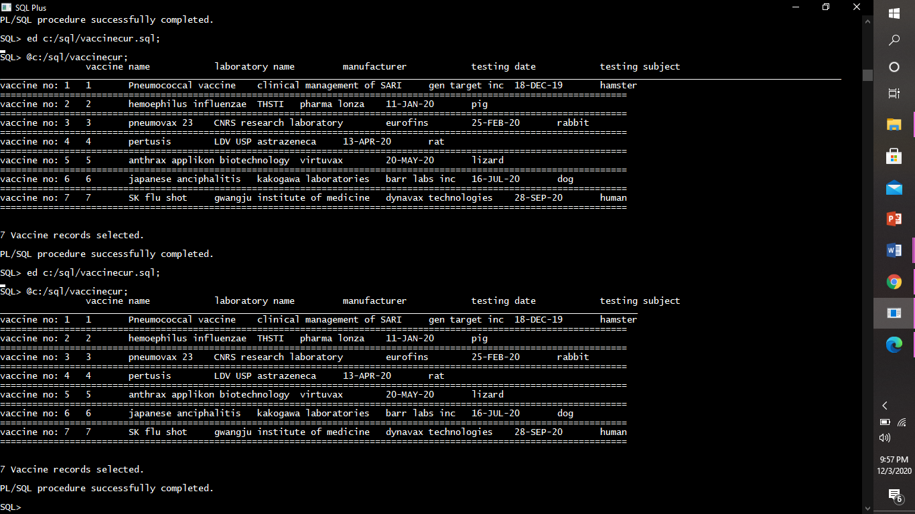

1. Cursor to print vaccine status.

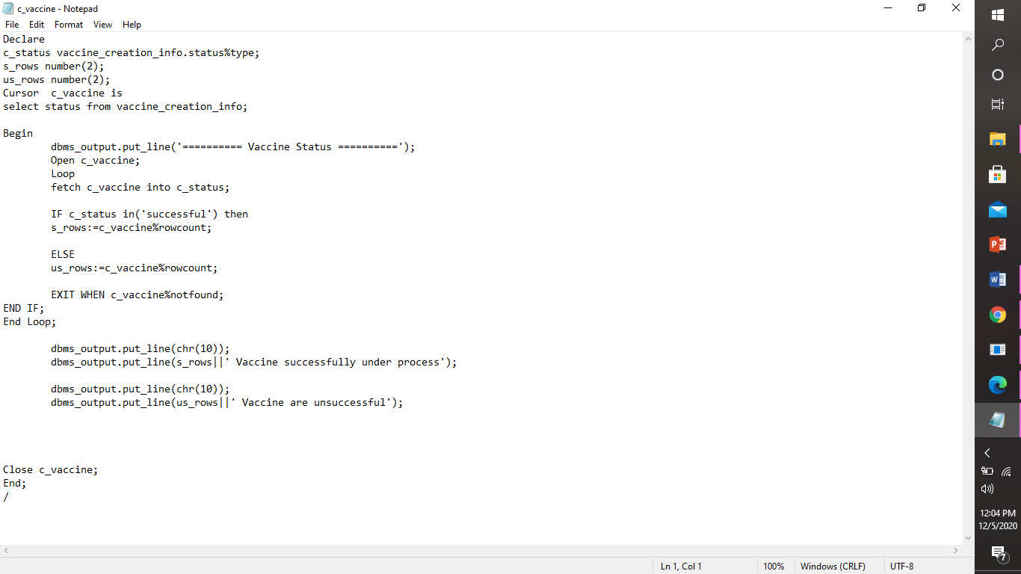

Output:

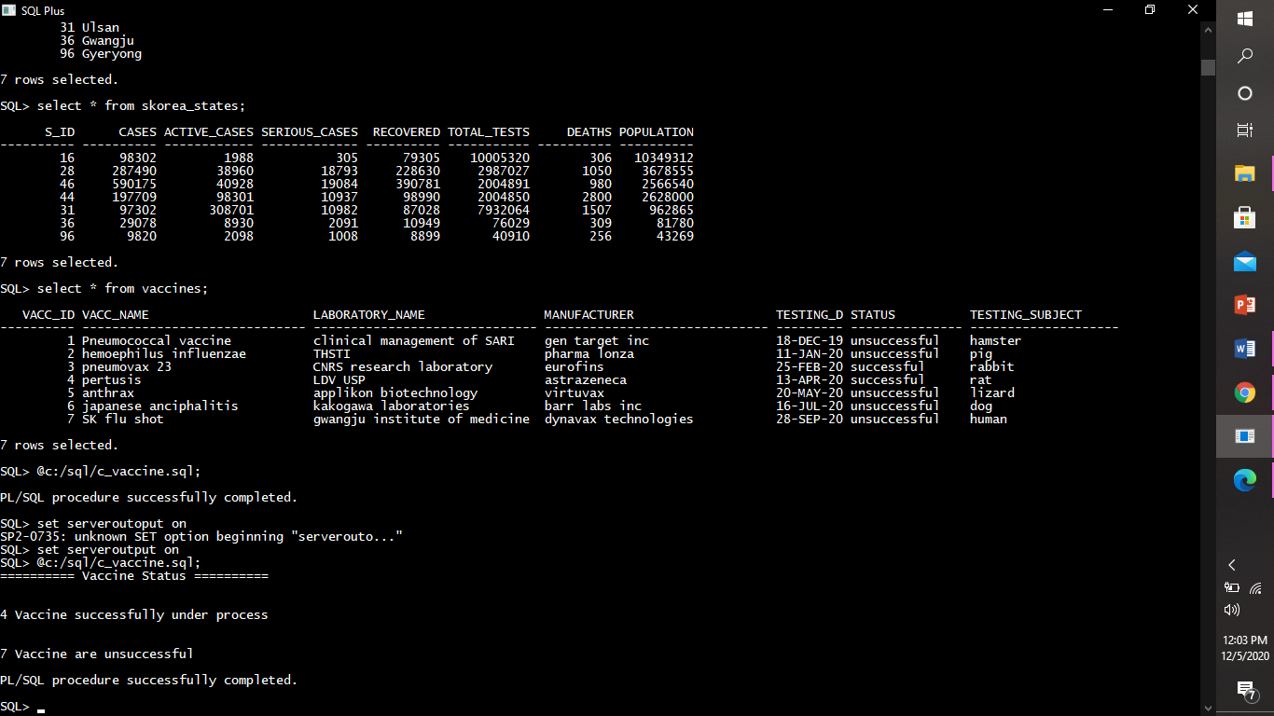

* procedures

A Stored Procedure is a type of code in SQL that can be stored for later use and can be used many times. Stored Procedures are created to perform one or more DML operations on Database.

*Creating a Procedure:*

* Procedure to insert record in country_id table.

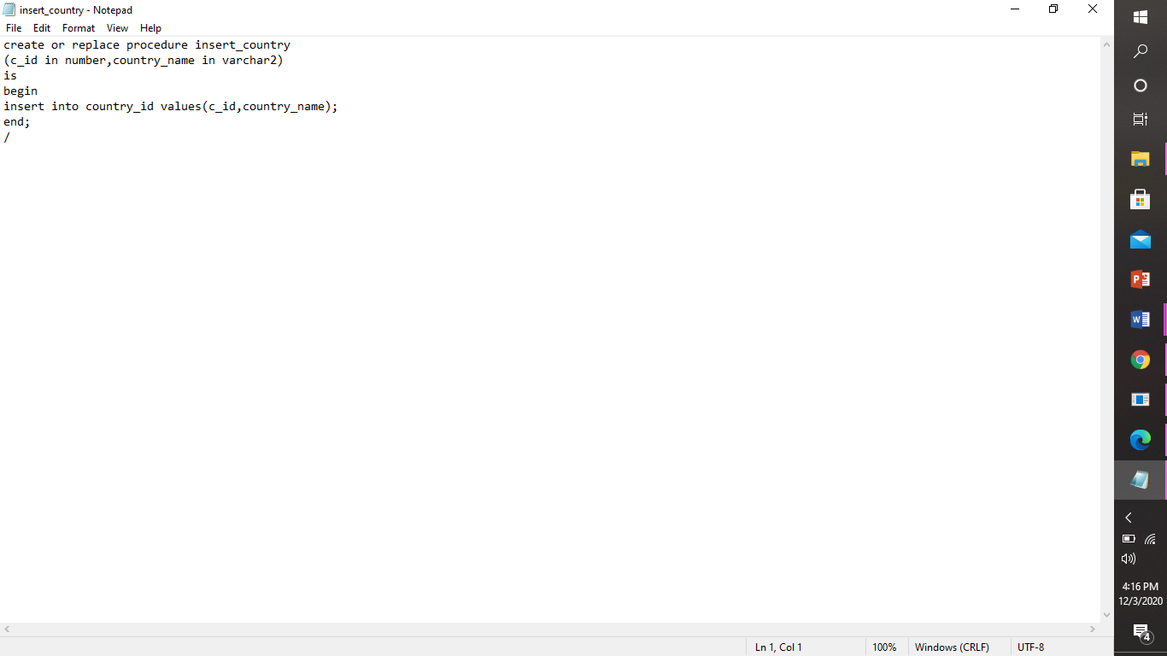

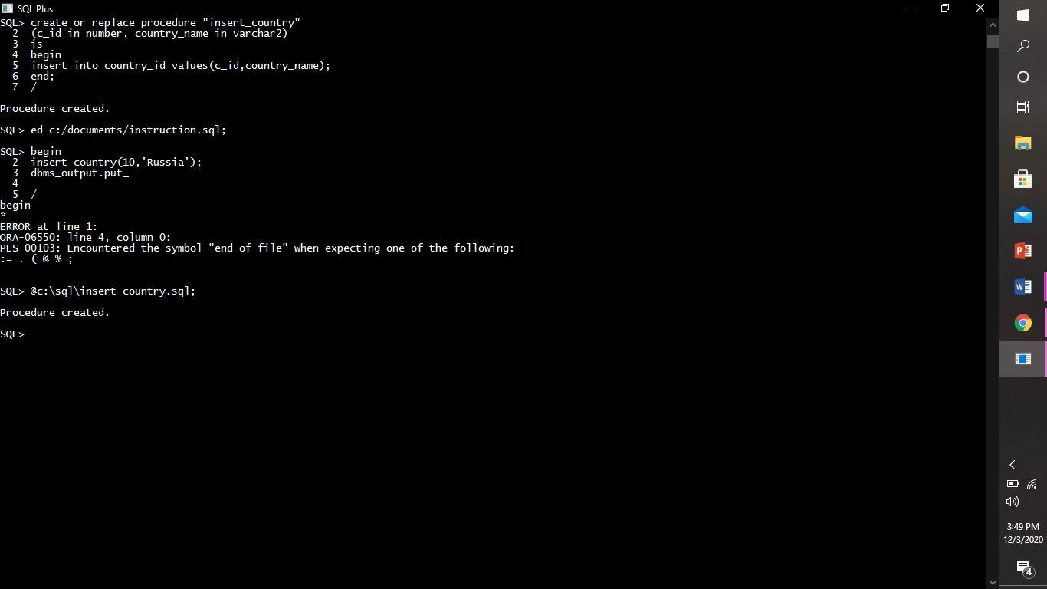

* Pl/sql block to use insert_country procedure

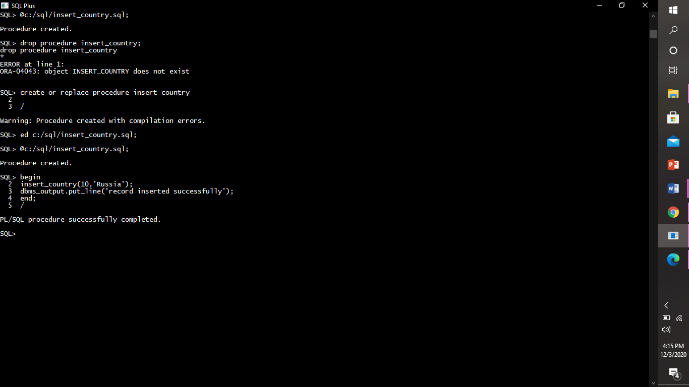

* Procedure to display covid instructons

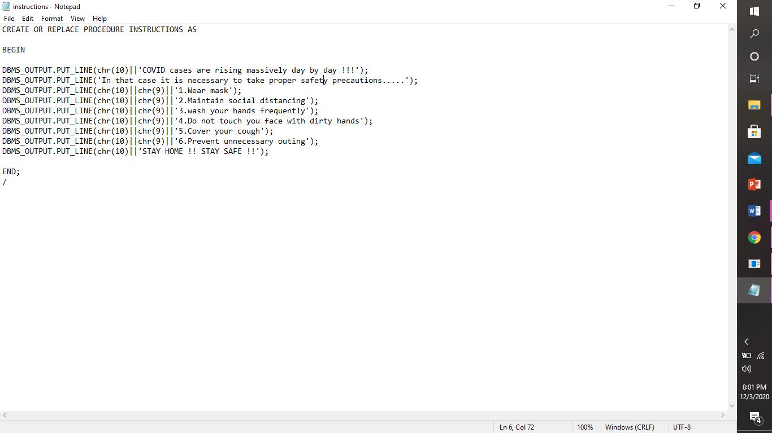

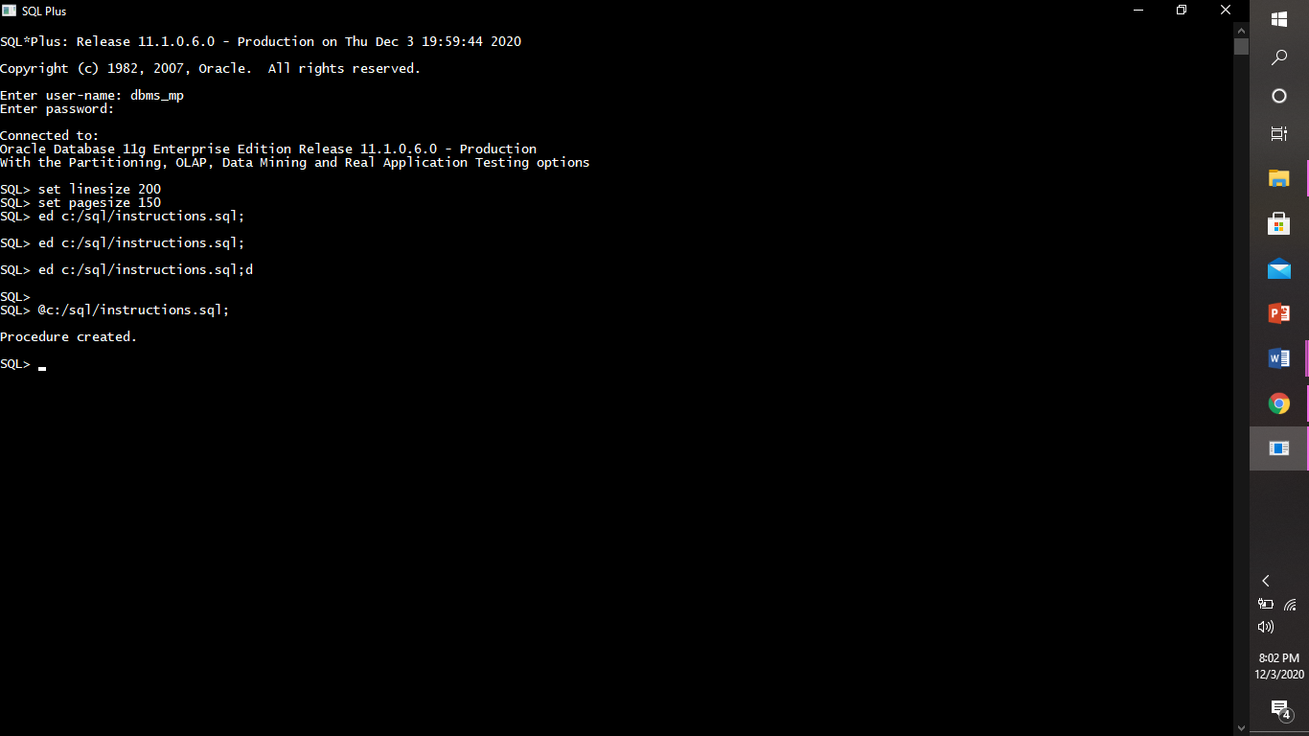

* Output of the procedure

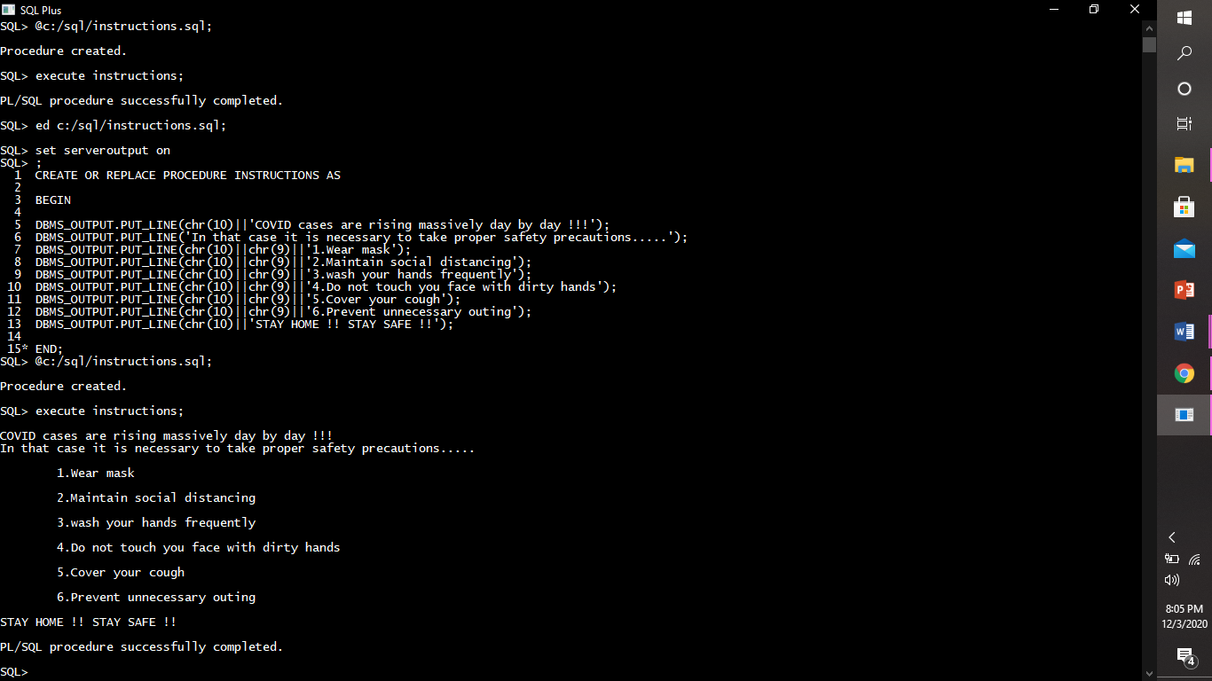

* Dropping the procedure:

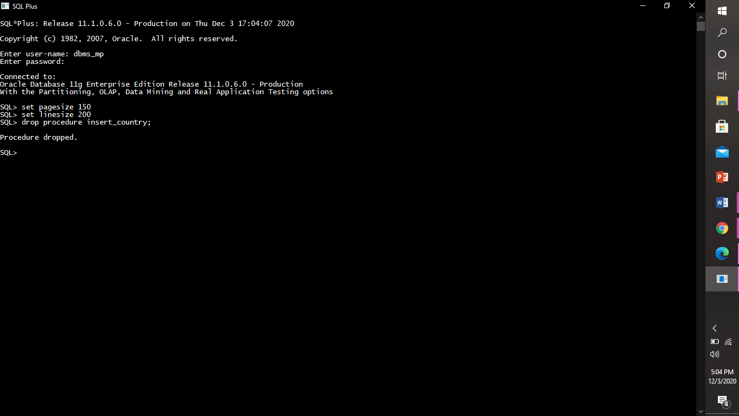

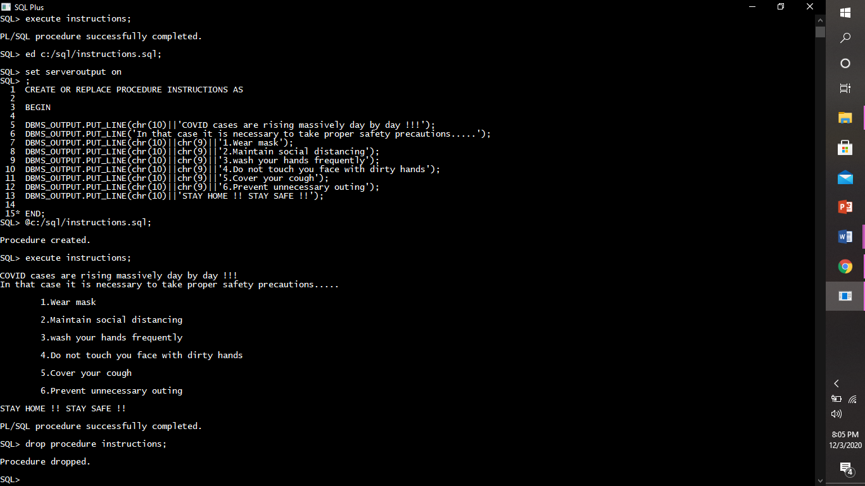

* functions

A **function**is a group or set of SQL and PL/SQL statements that perform a specific task. A function and procedure is a named PL/SQL Block which is similar. The major difference between a procedure and a function is, a function must always return a value, but a procedure may or may not return a value.

*Creating And Executing a function:*

Example 1:

* Function to count total number of countries.

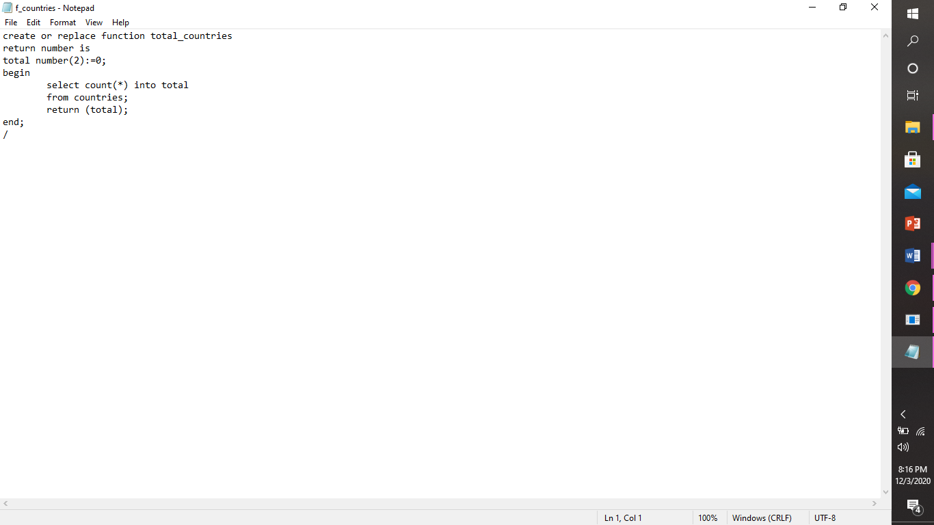

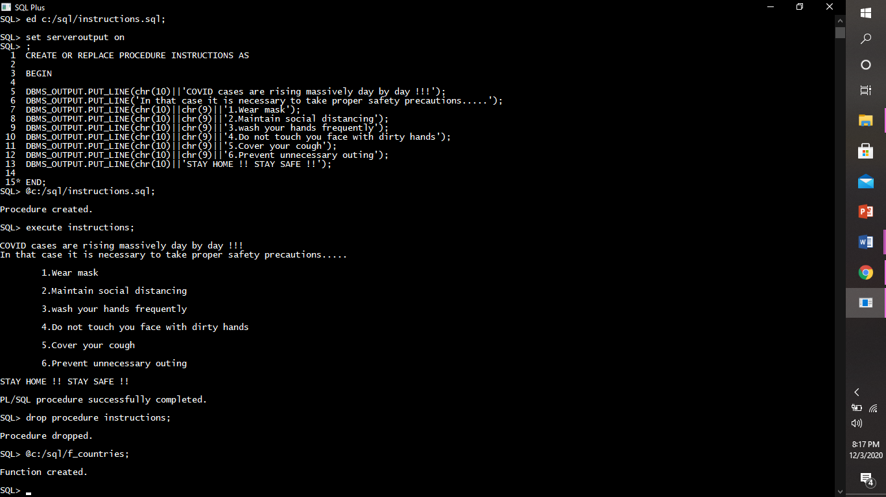

* Calling function

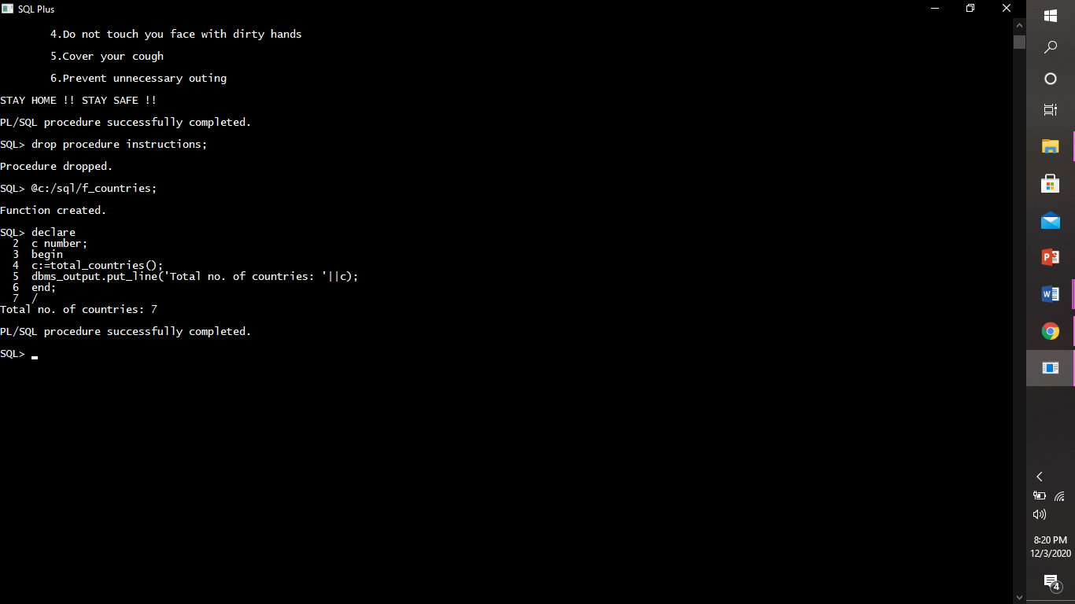

* Drop function

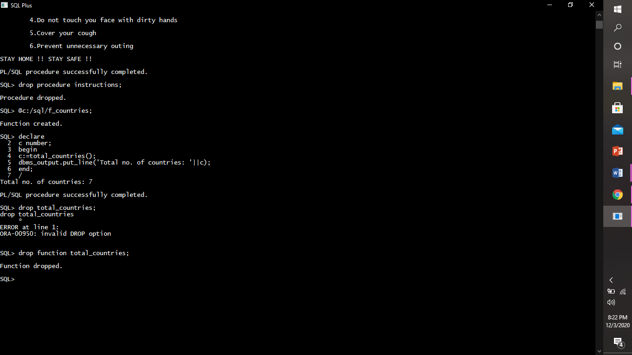

Example 2:

1. Function to display avg, population.

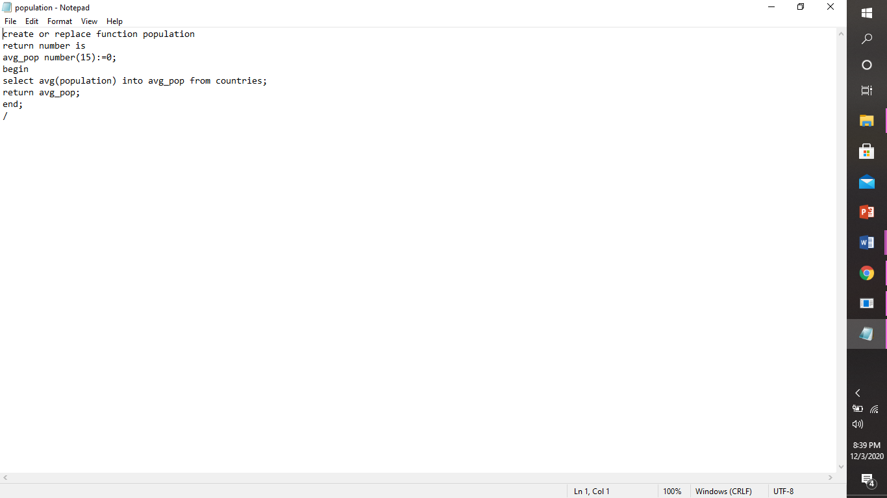

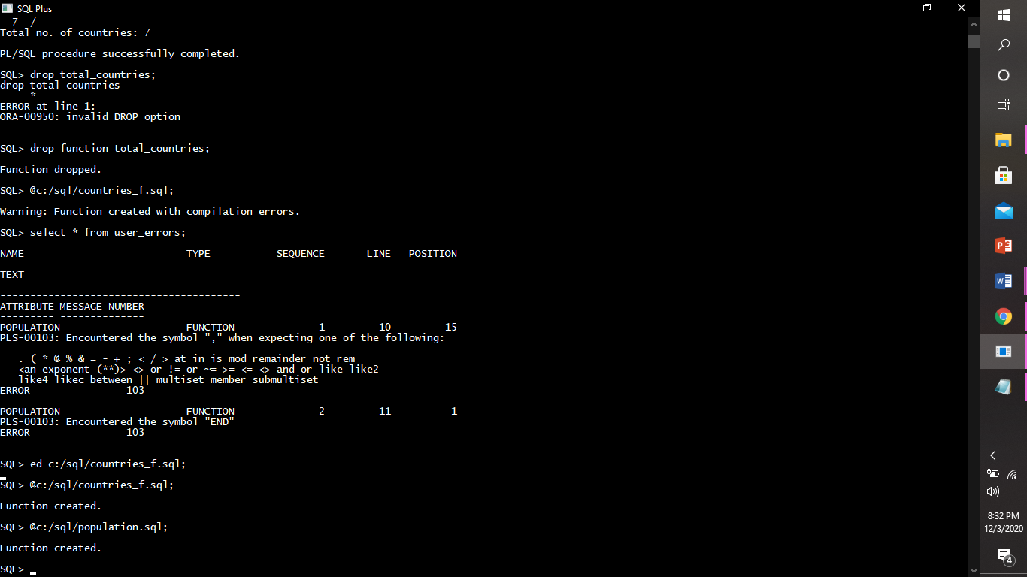

1. Calling function

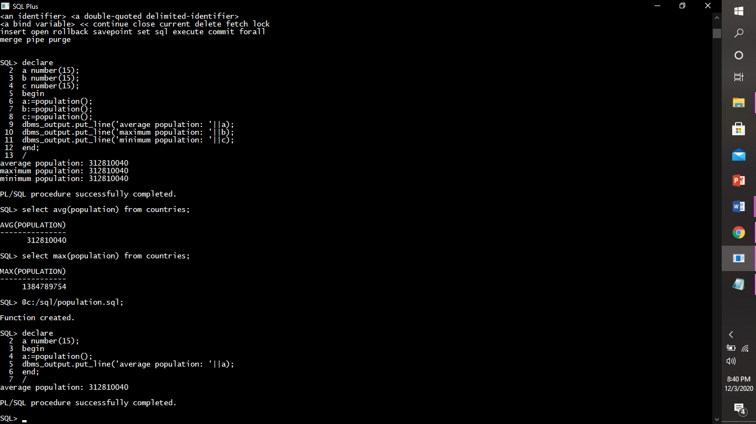

* triggers

A Database Trigger Is A Stored Pl/Sql Program Unit associated With A Specific Database Table. Oracle Executes. A Database Trigger Automatically When A Given SQL Operation (Like Insert, Update Or Delete) Affects The Table.

* Types of triggers:

1)row level trigger: If the statement FOR EACH ROW is present in the CREATE TRIGGER clause of trigger, the trigger is a row trigger. A row trigger is fired for each row affected by an triggering statement.

Example:

1. Create A Row-Level Trigger On Table Brazil_States Which Will Store The Deleted Rows In Another Table D_Tab And Updated Tables In Another Table U_Tab.

First the tables d_tab and u_tab were created in the database.

Creating a trigger

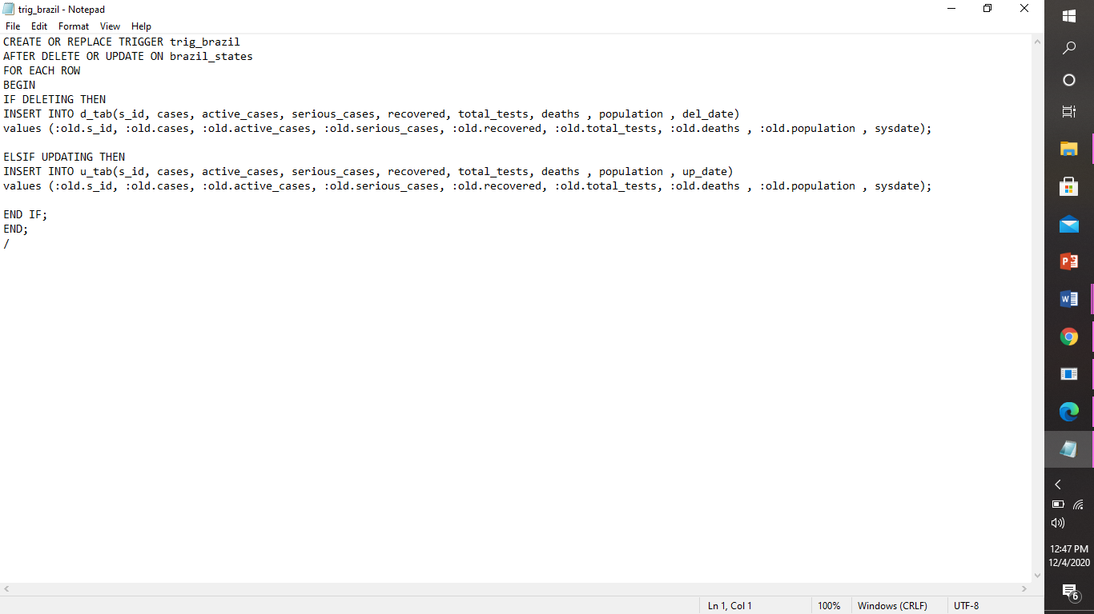

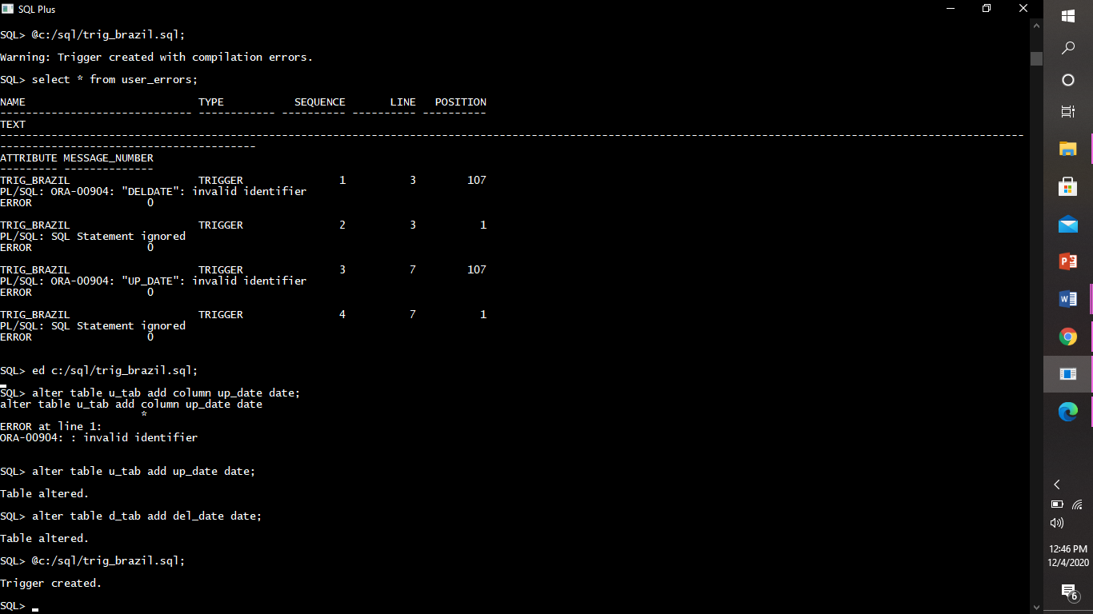

Triggering a trigger

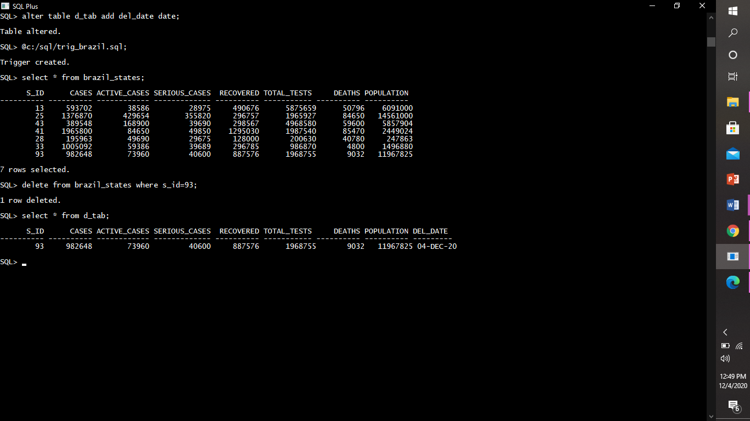

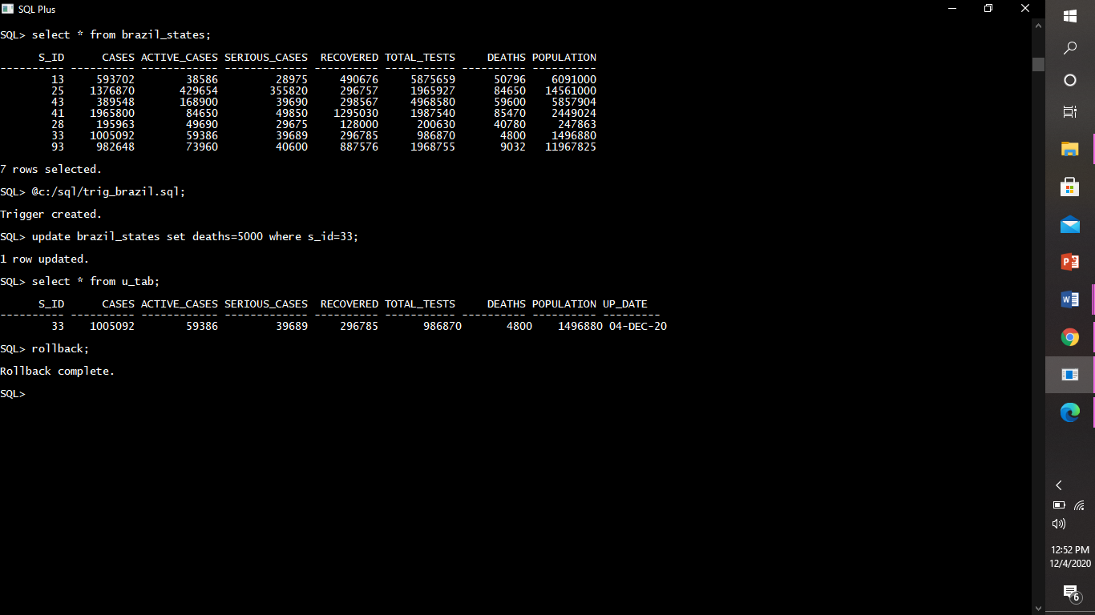

Enabling and disabling trigger.

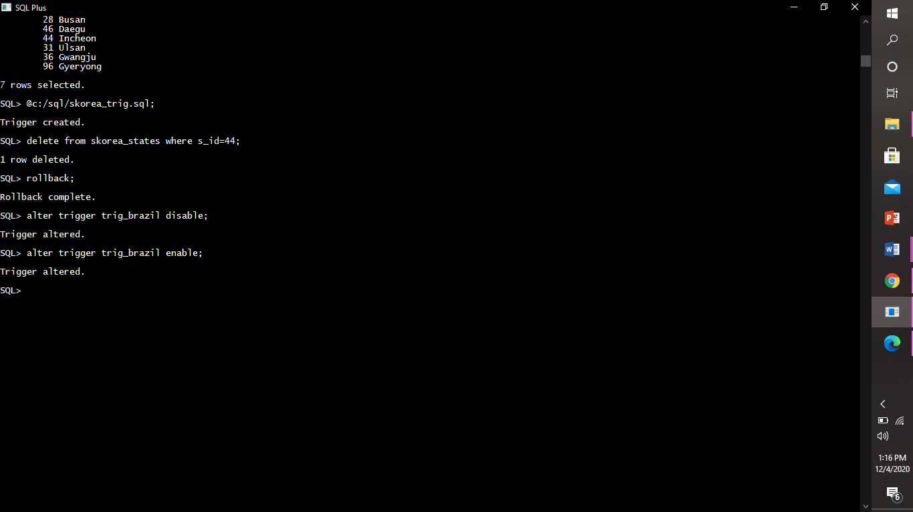

Dropping trigger.

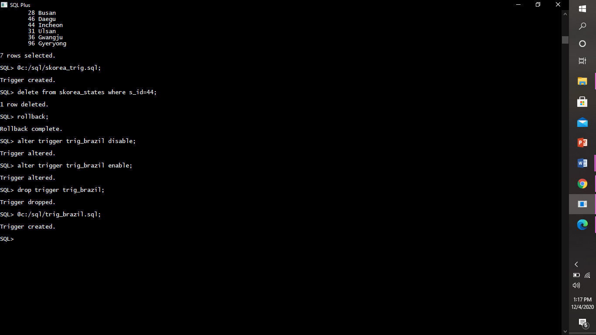

1. Row level trigger for the skorea_states table that would fire for INSERT or UPDATE or DELETE operations performed on the skorea_states table. This trigger will display the difference between the old values and new values of covid cases:

Creating a trigger

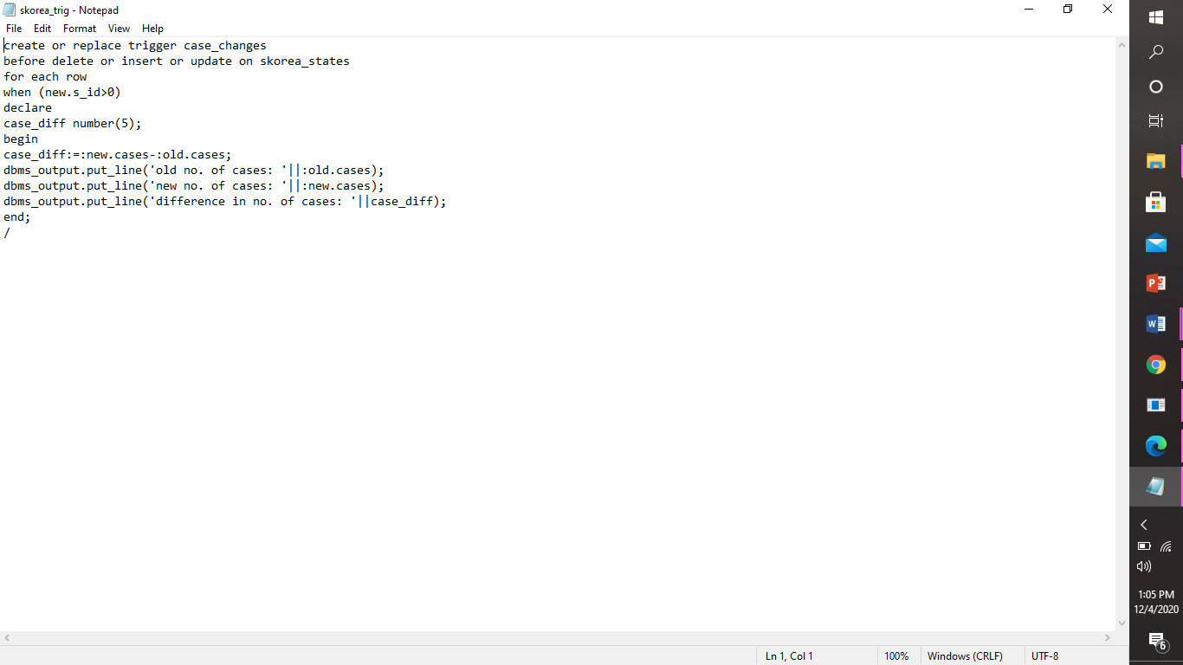

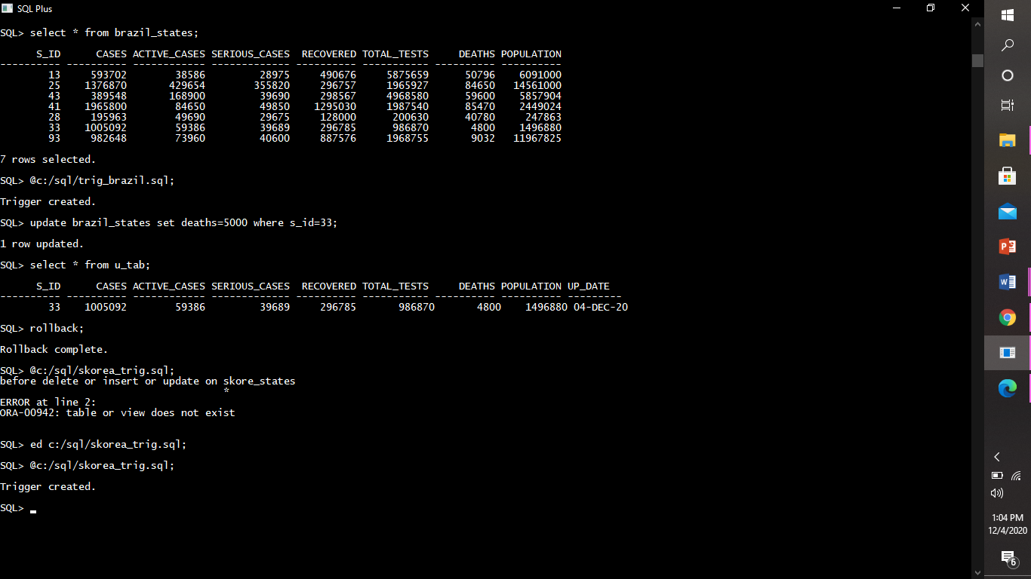

Triggering trigger

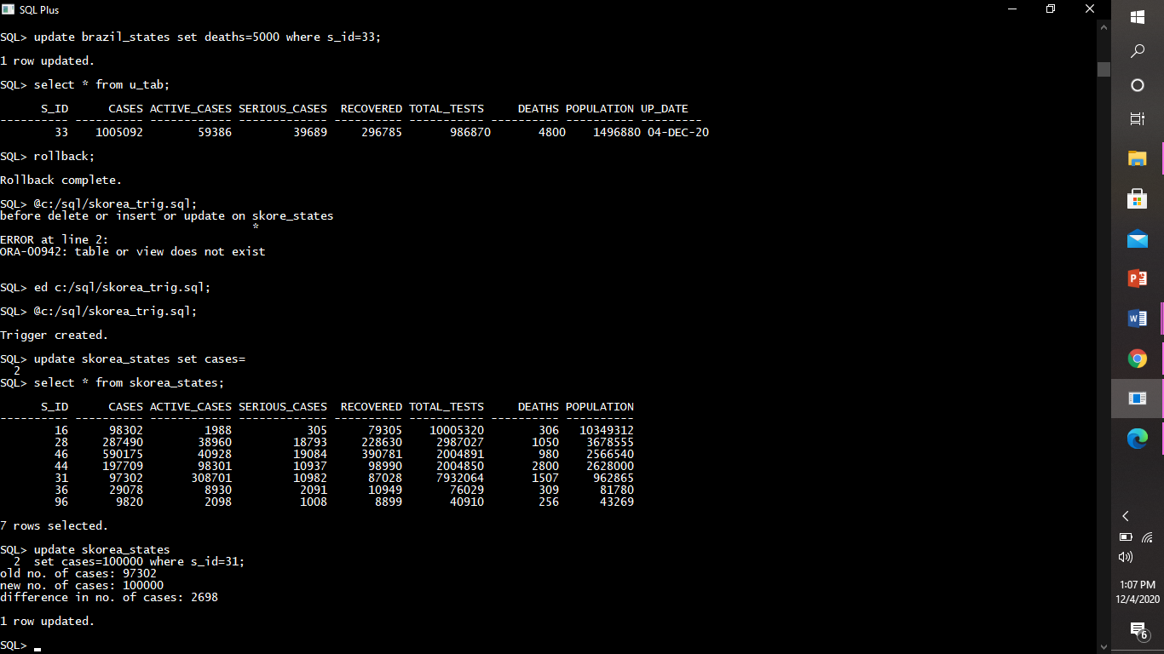

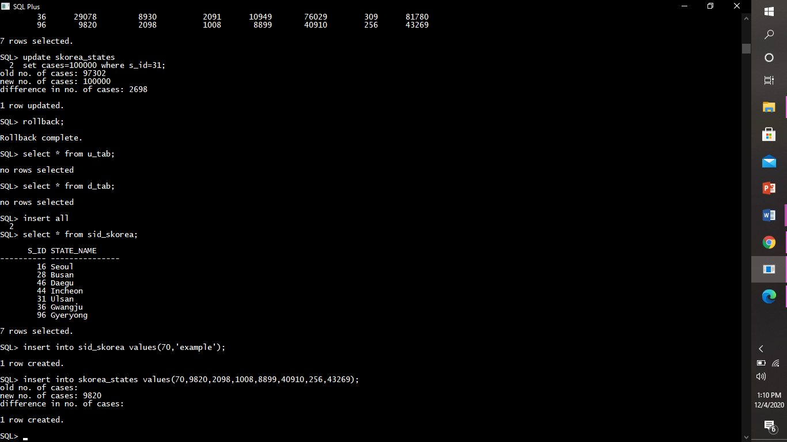

2)statement level trigger: A statement trigger, however, is fired only once for the triggering statement, regardless of the number of rows affected by the triggering statement.

Example:

1. Creating a statement-level trigger on table sid_france’ which will allow the DML operations between a specific time only.

Creating trigger

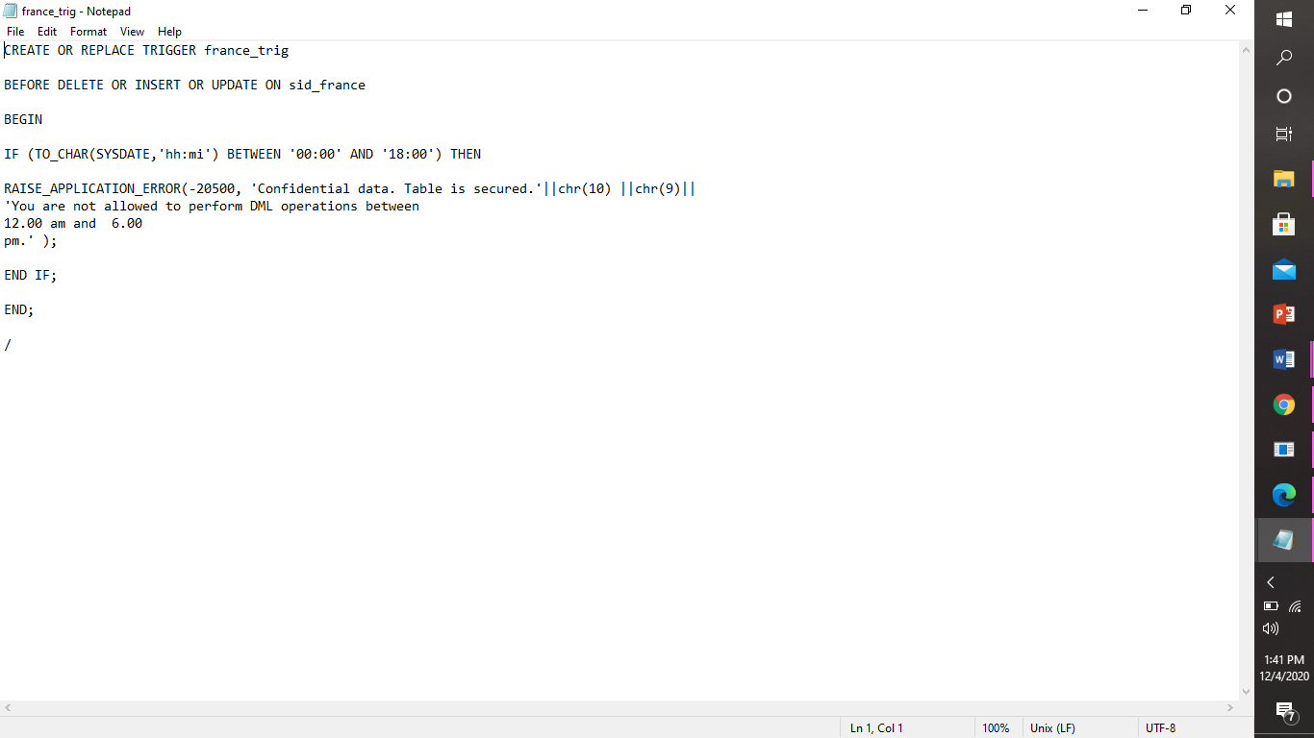

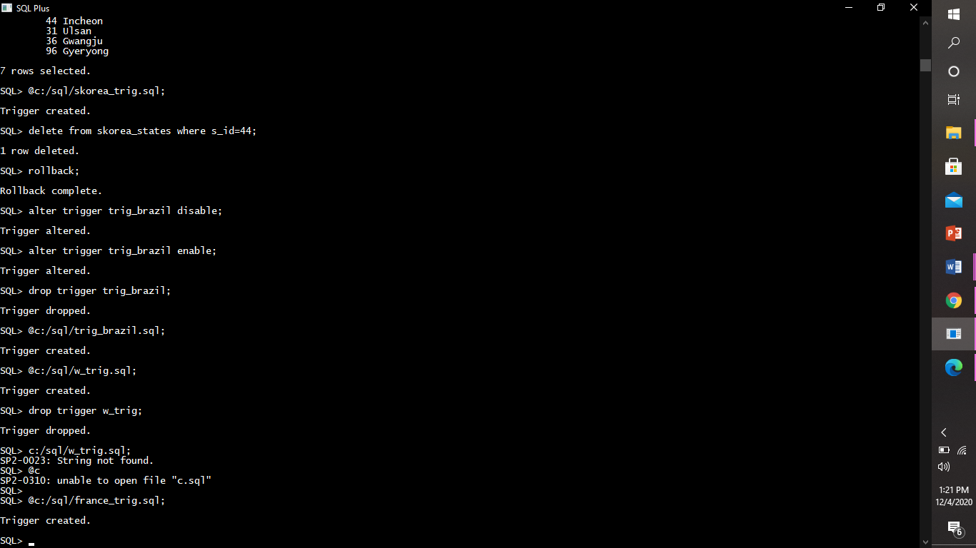

Triggering a trigger

Triggering by deleting

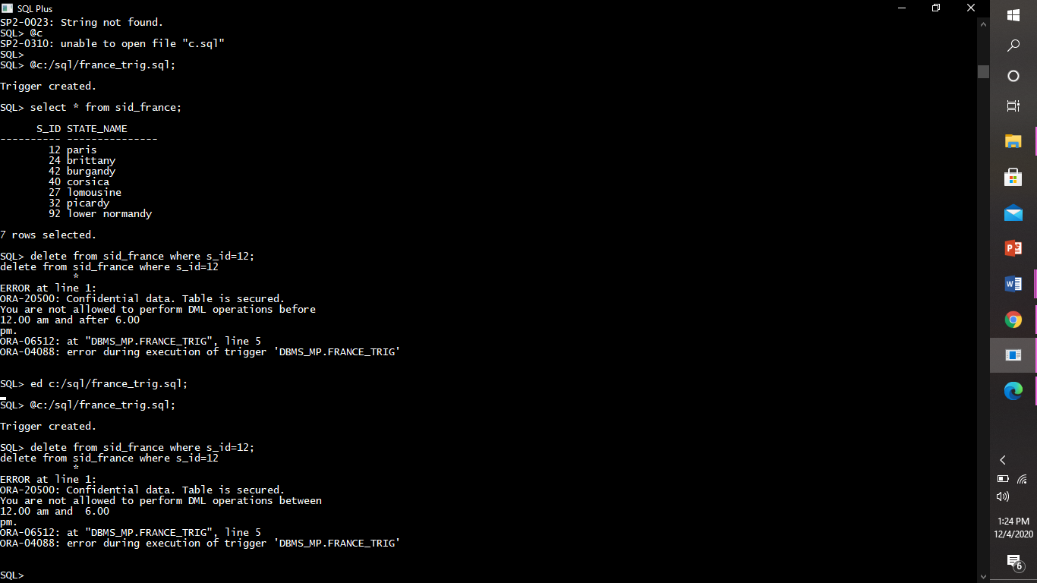

Triggering by inserting

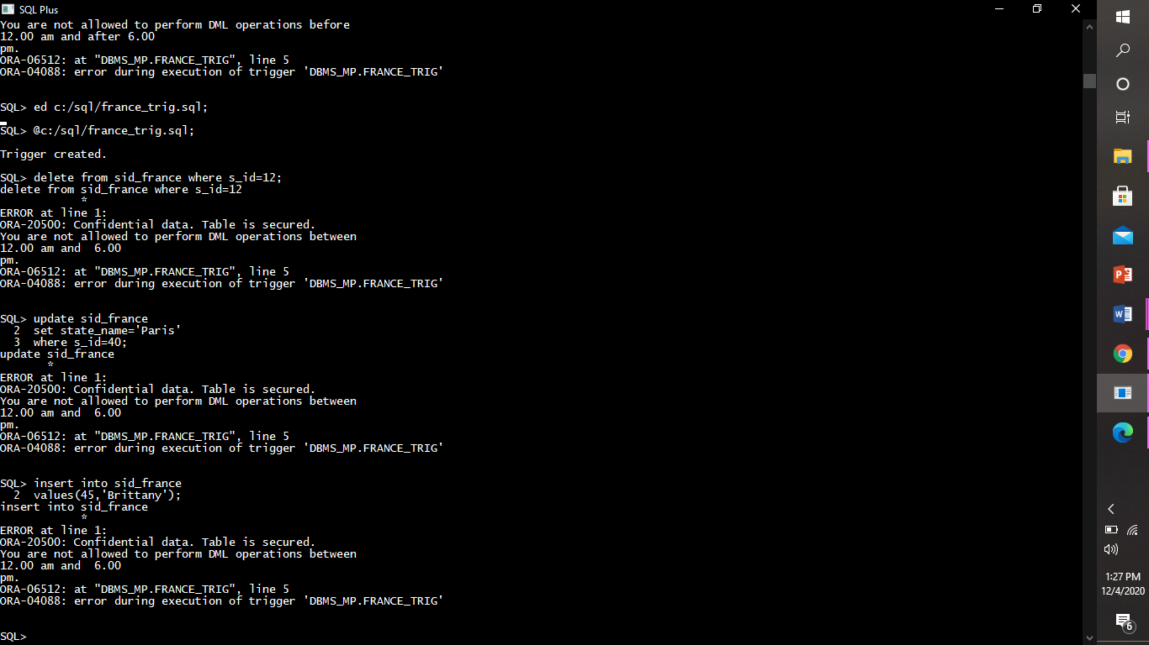

Triggering by updating

